Valley of Peace Lutheran Church
Sunday, July 5, 2026 - Sunday, July 12, 2026

Sunday, July 5  9:30 am Worship  Wednesday, July 8  No Pray Without Ceasing  3:00 pm VOP Staff Meeting  4:00 pm Loaves & Fishes  5:30 pm Wildfire Lay Member Meeting  7:00 pm Wildfire Wednesday Worship  Thursday, July 9  7:30 am Java for Mama & Papa  10:00 am Text Study (Luke 10:38-42) | Saturday, July 11  10:00 am Marv Lofquist Visitation  11:00 am Marv Lofquist Funeral  12:00 pm Marv Lofquist Reception  Sunday, July 12  9:30 am Worship  10:30 am Faith & Neighboring Practices: Neighborhood Walk
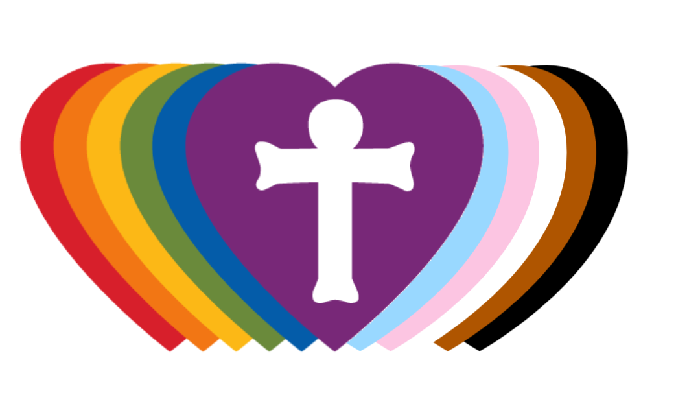
Our Mission  Living in God’s love and compassion, we are called and sent by God to be disciples of Jesus Christ, as the  Holy Spirit works through us for healing, justice, and peace. | Valley of Peace is committed to  Racial Justice and is a Reconciling  in Christ Church. | Contact Us  763-588-4611  www.valleyofpeace.org  4735 Bassett Creek Drive,  Golden Valley, MN 55422

Altar Flowers given on 7/5 by The Osborn Family
in celebration for our Valley of Peace Family!

Wildfire Wednesday Worship THIS WEDNESDAY!

Join Wildfire Churches for a vibrant evening of worship on the 2nd Wednesday of each month at
7:00 pm!

All are welcome as we gather for music, Holy Communion, and reflections from Wildfire Rostered Leaders. Together, we’ll give thanks for God’s creation and celebrate the beauty, abundance, and wonder of this season. Come be renewed in community, prayer, and the Spirit’s presence among us.

Our next Worship Service will be at Valley of Peace on July 8 at 7:00 pm!
Hope to see you there!

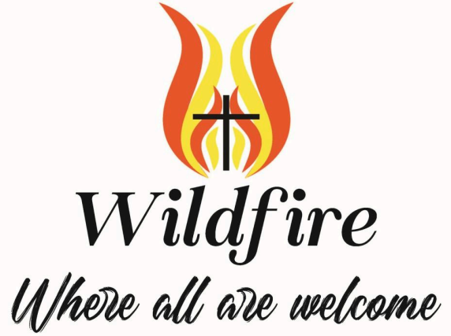

Marv Lofquist Funeral

A funeral service for Marv Lofquist will be held Saturday, July 11, at Valley of Peace Lutheran Church. Visitation will begin at 10 AM, with the funeral service starting at 11 AM. A reception will follow immediately following the service. The service will be live-streamed.

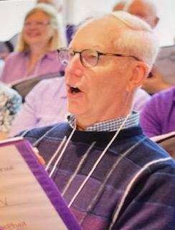

Vacation Bible School (VBS)

Monday, August 10th -Thursday, August 13th

This year at Faith-Lilac Way Lutheran Church located at 5530 N. 42nd Ave. Robbinsdale, MN 55422.
Valley of Peace provides dinner for the students & families on Monday, August 10th from 5:15-6:00 pm.
Donations & Volunteers are needed to make this a successful event!

Many, many thanks in advance!

Sincerely,
CYF

Questions? Contact numbers: Lona F. 651-260-7602 or Joan M. 651-485-6315

- Please bring your donations to Faith-Lilac Way by 4:00 pm.
- Donations in crockpots or non-disposable containers should have a name label.
- We will return cleaned crockpots and containers to Dan’s office for pick-up.
- Sign up sheets are on the bulletin board outside the narthex.
- In addition to volunteers for serving, donation needs include taco beef, taco chicken, refried beans, nacho doritos, shredded lettuce, shredded cheese, salsa, and sour cream.

A Pastoral Word from Presiding Bishop Yehiel Curry for the Nation’s 250th Anniversary



Dear church,

As we look toward the 250th anniversary of the Declaration of Independence, many of us will celebrate with fireworks, parades and barbecues. Independence Day often brings us together with family and friends. Yet there is more that connects us than our communal celebrations. We are also connected through a common vision.

Signed in 1776, the Declaration of Independence proclaims a vision of equality for all people. While there were other nations pushing for equality at the time, the declaration was and is a monumental document in the way it names the aspiration so boldly. As we observe and celebrate the 250th anniversary of that signing, we also affirm the vision of freedom and equality it casts. We can be grateful.

And with contrition and humility, we acknowledge all the ways we have failed to embody that vision. As members of this church, we are called to “pray, participate in, and advocate for civic life in the United States that reflects God’s activity and call, which seek both the well-being of all people and a creation marked by justice and peace” (ELCA social statement Faith and Civic Life, p. 89).

As Lutherans, we know the importance of naming realities for what they are. As citizens, we confess the ways we have not yet realized the vision of the Declaration of Independence and, more importantly, as Christians we confess the ways we have participated in or been complicit in failures to live into the vision God provides. This vision is rooted in creation and redemption. God crafts each person in God’s own image and sends Jesus Christ to redeem us, setting us free to follow Christ’s new commandment to love one another.

The history of the United States is complex, and all too often we have fallen short of our stated values. Indigenous peoples across this land have been forced to cede their ancestral homes and pushed to reservations. Women and men have been prevented from voting because of their sex and race and spat on and jailed when they demanded their rights. Japanese American families were interned during World War II. Queer and transgender people’s lives are obstructed by federal and state orders.

There is a photograph of Elizabeth Eckford, one of the nine Black teenagers who integrated Little Rock Central High School in Little Rock, Ark., in 1957. Books under her arm, she faces forward as angry white people crowd behind her. She was just trying to go to school.

Holding both the failures and the vision in our hearts and minds, I invite us to ask ourselves, “What does it mean to celebrate a promise that is real and yet still unfolding? What does it mean to be a people who always live in ‘the already but not yet’”?

This is a central question for us not only as we mark the anniversary of the signing of the Declaration of Independence but also in our daily lives as people of faith. The prophets repeatedly remind us of the vision God casts for all of creation, and they call us to account when, as God’s own people, we fall short.

When we fall short, we remember we are rooted in the resurrection of Jesus Christ. We think, speak and live out faith through God’s future. God’s future is resurrection. As a church, we are turned not only to the past but to the future God is making possible right now through us as we love and serve others.

As Lutheran Christians, we believe that God calls us to:

• Remember our connection to each other through baptism, as Scripture teaches us: “We, who are many, are one body in Christ, and individually we are members one of another” (Romans 12:5).
• Name sin for what it really is and to repent of it, as the Augsburg Confession and the catechisms remind us.
• Serve the common good in society as “earthly measures toward God’s intention” (Faith and Civic Life, p. 11).

As we celebrate 250 years of the Declaration of Independence, we can hold gratitude and humility, possibilities and shortcomings. We continue to live in the already and the not-yet.

And we hold fast to the most important promise of all: the presence of God with us, the power of the resurrection of Christ, the accompaniment of the Holy Spirit and the ever-unfolding grace of God.

We celebrate this occasion neither as a perfect nation nor as a perfect church but as a people held in God’s grace and called into community in service to all neighbors and for the sake of the world God so loves.

In Christ,


The Rev. Yehiel Curry
Presiding Bishop
Evangelical Lutheran Church in America

Public Discipleship Formation for Such a Time as This
A Summer & Fall Faith Journey for Our Church

What if faith wasn’t meant to stay private?
Many of us are searching for something more.
More purpose.
More impact.
More connection
More ways to live out our faith in a world that feels heavy, divided, and uncertain.

Some of us feel it deeply right now - a quiet urgency, or even a loud one - that this moment is asking something of us as Christians.

What does it mean to truly follow Jesus... today?

You’re Invited

This summer and fall, our church is launching a discipleship experience designed especially for:
- People who want to grow in their faith
- Church Members who are wondering how faith connects to the challenges facing our world
- Those who are newer, returning, or not yet deeply involved
- Anyone longing for deeper connection and real community

You do not need to have all the answers.
You just need a willingness to show up

What This Journey Offers

Together, we will:
- Build meaningful relationships within our church
- Deepen our understanding of Jesus’ life and teachings
- Explore what it means to love our neighbors in real, tangible ways
- Learn how faith calls us to respond to injustice, not ignore it
- Take part in a shared experience that brings faith to life beyond Sunday mornings

This is not just about learning. It’s about becoming.

When: Sundays, August 9, 16, and 23 (Two additional dates will be determined by the group)
10:30am to noon
Where: Fellowship Hall (Snacks and drinks provided)

Please sign up at the table in the Narthex on Sunday mornings, or email Lona Froyum at
lmfroyum@gmail.com

Deepening the Valley: Shaping the Future of Our Worship
Join us for the launch of our new Deepening the Valley conversation series, hosted by the Worship & Music team. These casual, open forums are designed to help us envision how we do worship and music together in the future.

- First Event: Sunday, July 17, immediately following the worship service
- Location: The Sanctuary
- Launch Topic: Introducing more inclusive language into our services—exploring how our words, metaphors, and images can help everyone feel genuinely welcomed, honored, and seen.
This is a friendly space for everyone — no special preparation or expertise is needed. The Worship & Music team wants to invite your voice, insights, questions, and stories into our future worship decisions. Come share your perspective and help us envision our community's future together!
Looking Ahead
This series will continue to explore critical areas of our faith community's life together. Future topics already on the horizon include:
- Worship Service Times: Assessing our Sunday schedule to best serve our community's changing needs.
- Offering Plates: Reflecting on how we practice stewardship and passing the plate in a digital age.
- Older Youth in 4theKids: Expanding our 4th Sunday services to involve and engage our older youth.
We Need Your Ideas!

What other worship or music topics should we explore together? We want your voice in this process. Please reach out to Sara Blood at 763-228-6272 (text or voicemail) or saranoelblood@gmail.com with your recommendations, ideas, and feedback.

July Mission of the Month

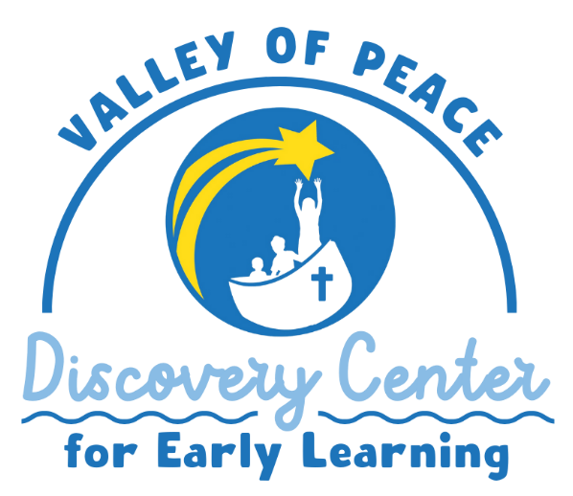
Our own Valley of Peace preschool offers children and parents a loving, caring environment in which to grow, learn, play and worship. As an outreach ministry of VOP, our church early learning center has been a place of joy and discovery for nearly 30 years!

This month we are placing Valley of Peace Discovery Center on our Mission of the Month calendar for the month of July!

We got a head start by doing some weeding and garden clean up in June, and now the children could use some additional things for outdoor play.

Please consider a donation towards the purchase of the fun things shown below!

Our goal is $450 – your contribution can go in the offering plate or be done online on the VOP website.

And always, prayers for children, staff and families are helpful every day!

Thank you from your VOP Social Ministry Team!



Faith & Neighboring Practices

The VoP Faith & Neighboring Practices Team is planning a neighborhood walk following services on July 12th (~10:30AM). The walk will take approximately one hour with a debrief meeting at the conclusion of the walk.

As we tour our neighborhood we’ll be watching for and discussing signs of gathering, community, or hospitality; signs of pain, struggle, or challenges; signs of creativity, creation, or renewal; and signs of joy, celebration, or gratitude; AND hopefully we’ll meet a few neighbors along the way.

If you’re interested in going on the walk or want to learn more about Faith & Neighboring Practices, please contact Pat McGraw at 651-260-2318 or apmcgraw@msn.com.

Blessing Box Needs

This may be hard to believe, but the Blessings Box here at church is still being used A LOT! When I stopped by on Tuesday with supplies, the box was almost empty. It's wonderful that we can be helpful to our neighbors in need AND we need your help to keep up with the demand.

Here are some suggestions: cans or boxes of soup, macaroni and cheese, rice, noodles, jars of spaghetti sauce, cereal (either individual boxes or regular size) or any other non-perishable foods. We also need things like shampoo, soap, feminine hygiene products, toilet paper, toothpaste and toothbrushes.

If you would like me to go shopping for you, please let me know! I would be so happy to help.
My email is sally.danielsherron@gmail.com Thank you, thank you, thank you!!

North Memorial Hospital Merger Public Forum

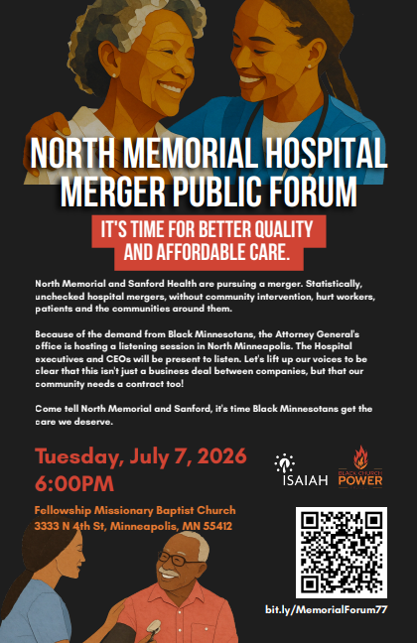



Birthdays:
7/5: Angela Crofoot; 7/6: Kris Miller;
7/7: Tom Anderson; 7/8: Pat Hepner; 7/11: Sean Campbell;

Anniversaries:
7/12: Beth & Ben Brandt, their 18th;
7/12: Lynn & Ken Schneider, their 40th;

We invite you to take the announcements home with you and remember in prayer:

The Lutheran Church of Christ in Nigeria/our Congregation partner-LCCN, St. Luke Cathedral, Mayo-Gwoi, Jalingo, Nigeria and Pastor Talmon Yakaba

The children and youth of Valley of Peace and the members of the congregation who pray for them daily.

The congregation of Valley of Peace, that we extend an open welcome to all people and model in our community the reconciling ministry of Jesus Christ.

Those who have health concerns or are receiving treatment.
Prayers for Elaine Lofquist and family with the passing of Marv Lofquist on June 15, 2026.
—-----------------------------------------------------------------------------------
Prayer requests are listed with permission.
If you would like to be included in the prayers please contact the church office. Names will be included for 4 weeks unless otherwise asked for. Confidential prayer support is also available.
—-----------------------------------------------------------------------------------
