Valley of Peace Lutheran Church
Sunday, June 21, 2026 - Sunday, June 28, 2026

Sunday, June 28
9:30 am Worship

Wednesday, July 1
No Pray Without Ceasing
3:00 pm VOP Staff Meeting
6:30 pm Food for the Journey: VoP Summer Connects Group

Thursday, July 2
7:30 am Java for Mama & Papa
10:00 am Text Study (1 Samuel 3:1-21)

Friday, July 3
AGCDC Closed

Sunday, July 5
9:30 am Worship


Our Mission  Living in God’s love and compassion, we are called and sent by God to be disciples of Jesus Christ, as the  Holy Spirit works through us for healing, justice, and peace. | Valley of Peace is committed to  Racial Justice and is a Reconciling  in Christ Church. | Contact Us  763-588-4611  www.valleyofpeace.org  4735 Bassett Creek Drive,  Golden Valley, MN 55422

Altar Flowers given on 6/28 by Barb & Paul Mikelson to celebrate
their 55 wonderful years of marriage and building a most wonderful family!

Food for the Journey: VoP Summer Connects Group

Join us on Wednesday, July 1 at 6:30 pm for our next meeting of Food for the Journey. We will be meeting for Session 2: Centering Prayer Experience centering prayer—a simple Christian practice of consenting to God’s presence and action within. It builds resilience by training us to release stress and return gently to God.

From Barb Mikelson regarding Session 1:
“Four of us met this evening for a restorative, hopeful, thought provoking, and heartfelt conversation.
I found it so encouraging to know that we four have a common need for community, for love, for peace and for joy. And Shennon brought her homemade bread-mmmmm!

Come and join in on this uplifting conversation on July 1!
We do need connection and community more than ever at this time!”

Wildfire Wednesday Worship

Join Wildfire Churches for a vibrant evening of worship on the 2nd Wednesday of each month at
7:00 pm!

All are welcome as we gather for music, Holy Communion, and reflections from Wildfire Rostered Leaders. Together, we’ll give thanks for God’s creation and celebrate the beauty, abundance, and wonder of this season. Come be renewed in community, prayer, and the Spirit’s presence among us.

Our next Worship Service will be at Valley of Peace on July 8 at 7:00 pm!
Hope to see you there!

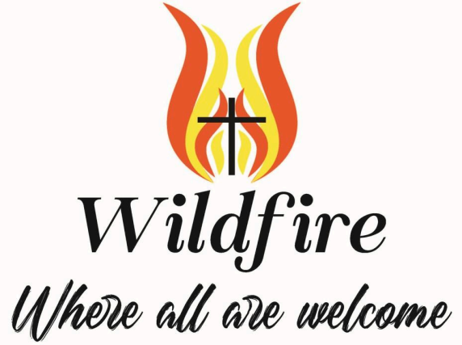

Public Discipleship Formation for Such a Time as This
A Summer & Fall Faith Journey for Our Church

What if faith wasn’t meant to stay private?
Many of us are searching for something more.
More purpose.
More impact.
More connection
More ways to live out our faith in a world that feels heavy, divided, and uncertain.

Some of us feel it deeply right now - a quiet urgency, or even a loud one - that this moment is asking something of us as Christians.

What does it mean to truly follow Jesus... today?

You’re Invited

This summer and fall, our church is launching a discipleship experience designed especially for:
- People who want to grow in their faith
- Church Members who are wondering how faith connects to the challenges facing our world
- Those who are newer, returning, or not yet deeply involved
- Anyone longing for deeper connection and real community

You do not need to have all the answers.
You just need a willingness to show up

What This Journey Offers
Together, we will:
- Build meaningful relationships within our church
- Deepen our understanding of Jesus’ life and teachings
- Explore what it means to love our neighbors in real, tangible ways
- Learn how faith calls us to respond to injustice, not ignore it
- Take part in a shared experience that brings faith to life beyond Sunday mornings

This is not just about learning. It’s about becoming.

When:
Sundays, August 9, 16, and 23 (Two additional dates will be determined by the group)
10:30am to noon
Where:
Fellowship Hall
Snacks and drinks provided

Please sign up at the table in the Narthex on Sunday mornings, or email Lona Froyum at
lmfroyum@gmail.com



Birthdays:
7/1: Joe Thom; 7/2: Joe Broin; 7/2: Erik Daniels; 7/2: Ingrid Daniels; 7/2: Craig Wiltzius;
7/3: Jim Crofoot; 7/4: Arwen Campbell; 7/4: Josh Ruffin; 7/5: Angela Crofoot;

Anniversaries:
6/30: Kayla & Ethan Oas, their 19th;
7/4: Natalie & Josh Ruffin, their 6th;

We invite you to take the announcements home with you and remember in prayer:

The Lutheran Church of Christ in Nigeria/our Congregation partner-LCCN, St. Luke Cathedral, Mayo-Gwoi, Jalingo, Nigeria and Pastor Talmon Yakaba

The children and youth of Valley of Peace and the members of the congregation who pray for them daily.

The congregation of Valley of Peace, that we extend an open welcome to all people and model in our community the reconciling ministry of Jesus Christ.

Those who have health concerns or are receiving treatment.
Prayers for Elaine Lofquist and family with the passing of Marv Lofquist on June 15, 2026.
—-----------------------------------------------------------------------------------
Prayer requests are listed with permission.
If you would like to be included in the prayers please contact the church office. Names will be included for 4 weeks unless otherwise asked for. Confidential prayer support is also available.
—-----------------------------------------------------------------------------------
