Valley of Peace Lutheran Church
Sunday, June 21, 2026 - Sunday, June 28, 2026

Sunday, June 21
9:30 am Worship

Wednesday, June 24
No Pray Without Ceasing
3:00 pm VOP Staff Meeting
5:00 pm Blacktop Bash

Thursday, June 25
7:30 am Java for Mama & Papa
10:00 am Text Study (Joshua 4:1-9)

Sunday, June 28
9:30 am Worship


Our Mission  Living in God’s love and compassion, we are called and sent by God to be disciples of Jesus Christ, as the  Holy Spirit works through us for healing, justice, and peace. | Valley of Peace is committed to  Racial Justice and is a Reconciling  in Christ Church. | Contact Us  763-588-4611  www.valleyofpeace.org  4735 Bassett Creek Drive,  Golden Valley, MN 55422

Altar Flowers given on 6/21 by Sally Daniels Herron in celebration of her daughter,
Maren’s birthday AND the planned birth of her 4th grandson, Nils, both on June 26th!

BlackTop Bash

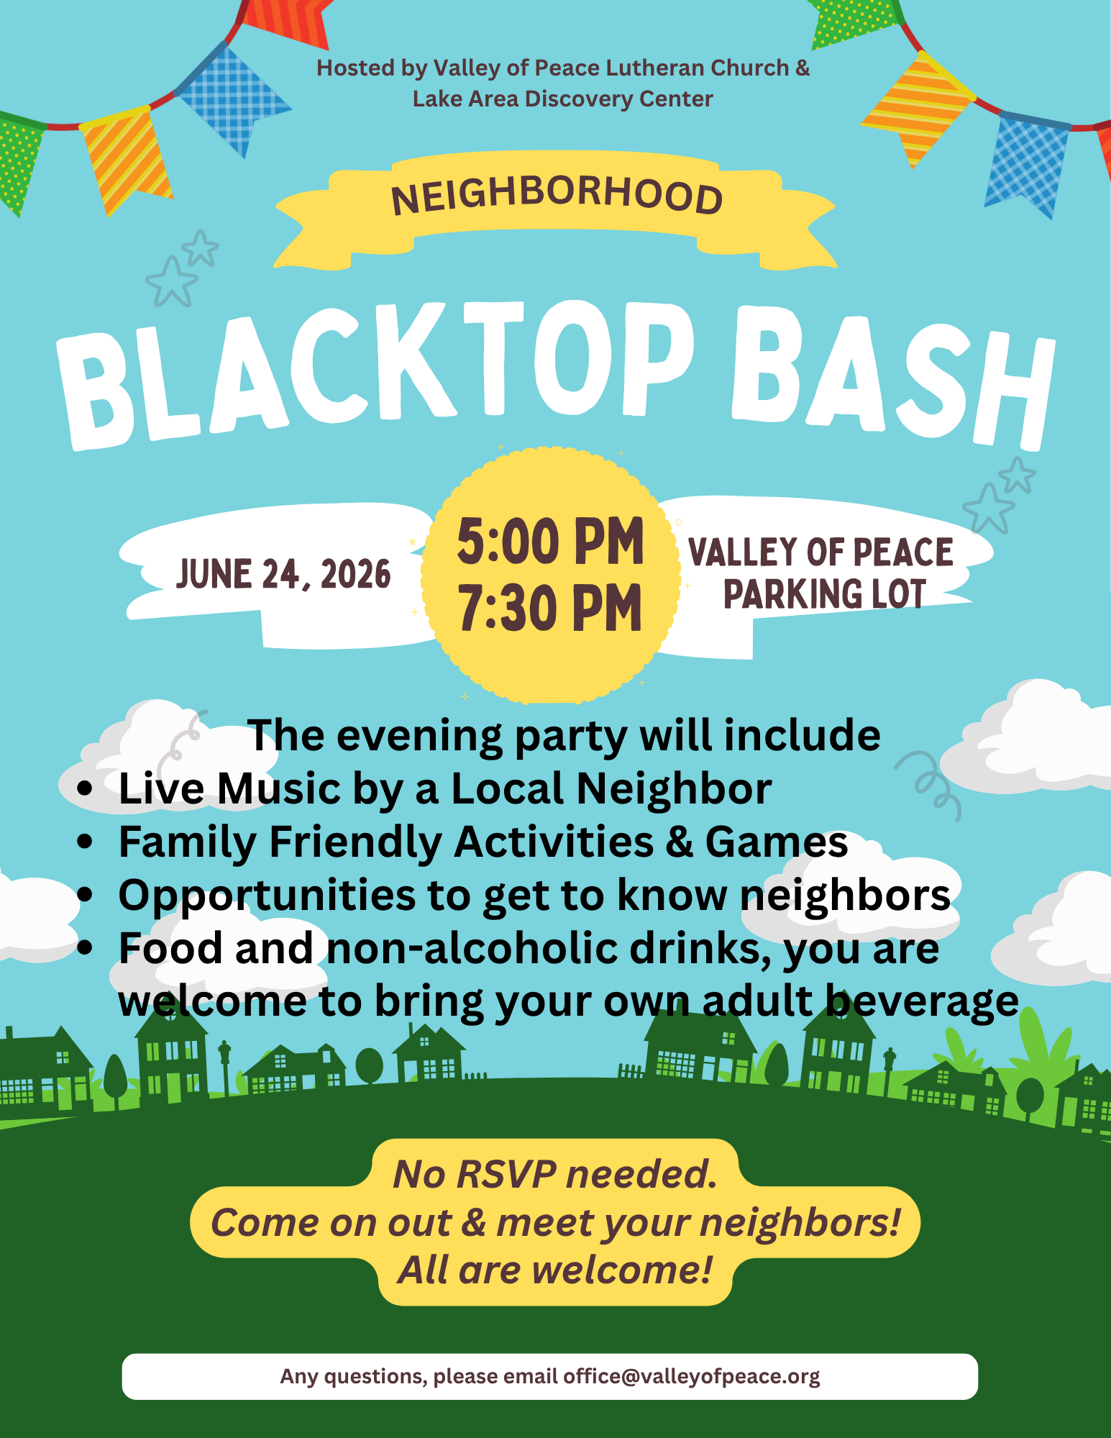

Vacation Bible School (VBS)

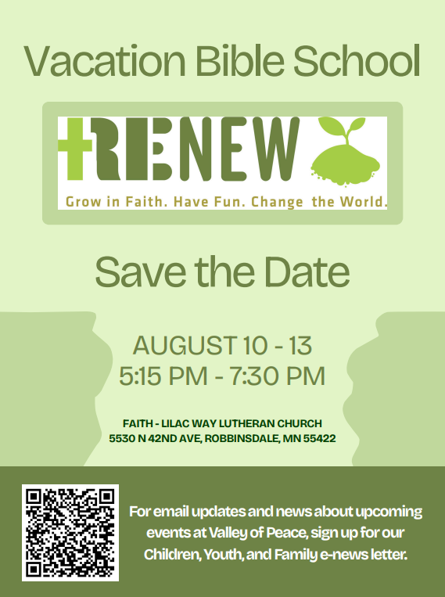

Supply/Material List Needed
Small compostable pots
Radish Seeds
Dirt
Stickers (especially hearts and flowers and plants)
Wildflower Seeds
Cardboard egg cartons (clean)
Newsprint/newspapers, printer paper (can be used/wrinkled)
Printer paper (can be used/wrinkled)
Old screens from windows/doors
Crayons (old preferred: will have paper peeled away)
Old watercolor sets
Disposable plastic tupperware (yogurt/margarine/sour cream marked with recycling number 2 or 5 only)
Basil seeds
Pillow cases (washed)



Birthdays:
6/21: Joe Cherra; 6/22: Scott Johannes; 6/23: Hadley Boesen; 6/23: Lilly Brummel; 6/23: Owen Brummel; 6/23: Ann Dybvig; 6/24: Sinclaire Edwards; 6/25: Anna Halvorson; 6/25: Devin Durant; 6/25: Jacob Stepanek; 6/26: Colin Foy; 6/26: Skip Humphrey; 6/27: Peter Rodman Rudolph;

Anniversaries:
6/24: Kirsten & KC Kessel, their 37th;
6/26: Ruth & Jon Larson, their 39th;
6/26: Judy Greeninger & Alex Balint, their 27th;
6/27: Barb & Paul Mikelson, their 55th;
6/27: Phoebe & Rolf Nelson, their 56th;

We invite you to take the announcements home with you and remember in prayer:

The Lutheran Church of Christ in Nigeria/our Congregation partner-LCCN, St. Luke Cathedral, Mayo-Gwoi, Jalingo, Nigeria and Pastor Talmon Yakaba

The children and youth of Valley of Peace and the members of the congregation who pray for them daily.

The congregation of Valley of Peace, that we extend an open welcome to all people and model in our community the reconciling ministry of Jesus Christ.

Those who have health concerns or are receiving treatment.
Prayers for Elaine Lofquist and family with the passing of Marv Lofquist on June 15, 2026.
—-----------------------------------------------------------------------------------
Prayer requests are listed with permission.
If you would like to be included in the prayers please contact the church office. Names will be included for 4 weeks unless otherwise asked for. Confidential prayer support is also available.
—-----------------------------------------------------------------------------------
