ANNUAL REPORT
Sunday, May 17, 2026

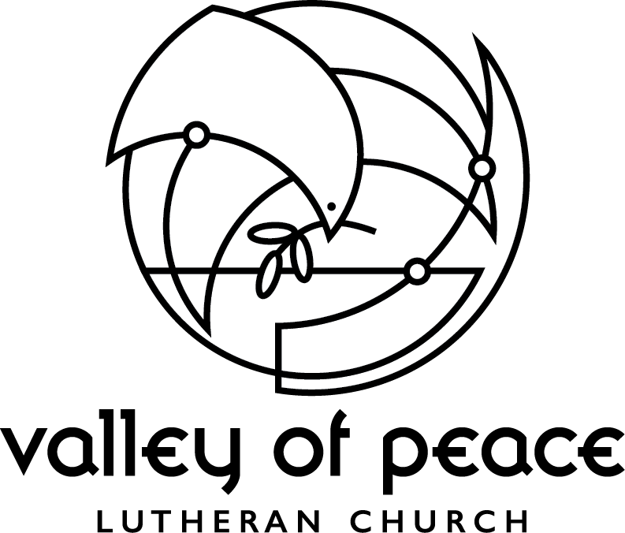

THE MINISTRY OF VALLEY OF PEACE
EVANGELICAL LUTHERAN CHURCH
Living in God’s love and compassion, we are called to be disciples of Jesus Christ,
as the Holy Spirit works through us for healing, justice, and peace.

Annual Report to the Congregation May 17, 2026

Table of Contents
Secretary’s Minutes of the May 18, 2025 Annual Meeting……………………..……...……..3
Secretary’s Minutes of the October 26, 2025 Meeting…………………...…………..………5
Secretary’s Minutes of the February 1, 2026 Semi-Annual Meeting…………………..……...7
President’s Report…………………………………..……………………………….…...…8
Pastor’s Report……………………………………………………………..……..………...9
Treasurer’s Report……………………………………..…………………………..………12
Audit Report……………………………………………………..…………………..……12
Team Reports
Adult Faith Formation……………………………………….…………………….……...14
Children, Youth & Family……………………………..……………………………….….16
Hospitality……………………………………………………...……………………..…...18
Property………………………………………………………………………………..….19
Racial Justice…………………………………………………………………………..…..21
Social Ministry…………………………………………………………….…………..…...23
Stewardship…………………………………………………………………………..…....25
World Missions…………………………………………………………………………....25
Worship & Music…………………………………………………………………….…....26
Worship Arts………………………………………………………………………….…..28
Task Force Reports
Rejoice & Renew Capital Campaign……………………………………………….……....28
Lower Level Task Force……………………………………………………………............29
Faith & Neighboring Practices………………………………………………………….....31
Standing Committees
Altar Care………………………………………………….………………………….…..34
Every Meal………………………………………………….…………………………….34
Personnel Committee……………………………………..………………………….…....34
Integrated Auxiliary Organizations
Endowment & Memorial Trust……………………………………………….……….…..35
Community Partners
All God’s Children Discovery Center………………………………………….……....…...38
Lake Wapogasset….…………………..…………………………………………..……….39
Wildfire…………………………………………………………………….………...……41
Minneapolis Area Synod ELCA & Churchwide
Bishop Jen Nagel Report……………………………………………………...…………...43
Presiding Bishop Yehiel Curry Report………………………………………….…………45
Membership Statistics…………………………………………………………….....……………46
New Business Agenda for May 17, 2026 Annual Meeting…………………………...……………47
Valley of Peace Staff……………..……………………………………………………………….48
Minutes of the May 18, 2025 Annual Meeting of the Congregation

Call to Order
Outgoing President Skip Humphrey called the meeting to order at 11:24 a.m.
Pastor Ashley opened the meeting with prayer.

Secretary’s Report
Skip Humphrey asked for a motion to waive the rule requiring the reading of the minutes of the congregational meetings of the past year and to dispense with the reading of the minutes. Joe Thom made the requested motion, and Paul Mikelson seconded the motion. All were in favor, none opposed, and the motion was passed. Skip Humphrey then asked for a motion to approve the minutes. Shennon Jay made the motion, and Dee Kendall seconded it. All were in favor, none opposed, and the minutes were approved.

Update on the Capital Campaign
Paul Mikelson gave us an update on the Rejoice and Renew Campaign. The second year of the campaign began in April. Thus far $1,292,412 has been pledged and we are only $7,588 away from reaching the goal of $1,300,000. There are still two years left in the campaign. One gift is contingent on the goal being reached and that gift will be $50,000.

New Business
- Dave Gilyard gave an update on the building projects which include plans for work on the kitchen, restrooms, and storage on the lower level. In March the plans were approved by the Executive Committee. The architects have the plans, and the hopes are that they will be able to send them out to general contractors for bids by mid-June and then a choice will be made of a company to use for the project. Joe Thom reported on the heating and mechanical issues. Demolition has started and the boiler room is clear. Issues are being worked through regarding a piece of asbestos to be disposed of and an oil tank. Work is moving forward.
- Skip Humphrey remarked that he was astounded and impressed by the congregation when he read the annual report. He said that amid much change God has blessed us. Skip thanked everyone for choosing him to be president of the congregation for the past year.

New Business (cont.)
- Shennon Jay gave a report on the Synod Assembly (the name was changed from Synodical to Synod). Concerns addressed were the safety of children, making the youth gathering accessible, the rights of indigenous women, and support for immigrants.
- Barb Mikelson presented information on the land acknowledgement statement that the Racial Justice Team drafted. The land just next to our church adjacent to the creek originally belonged to the Native Americans and it is the idea that something visible should be placed in the area to recognize the native history. Barb read from the Racial Justice Team Report regarding honoring the spirit of the Native people and the spirit filled people of Valley of Peace that are united next to Bassett Creek. Shennon Jay made a motion to accept the statement as read by Barb and Joe Thom seconded the motion. Skip reported that the motion was carried.

Election of Officers
Outgoing President Skip Humphrey read the ballot for the election of new officers. There was only one person listed for each position, so no discussion was needed. The spelling of Pat Hepner’s name was corrected. Skip asked for a motion to accept the new officers, and Barb Mikelson made the motion. Sally Daniels Herron seconded the motion. All were in favor, none opposed, and the motion was passed.

Pastor Ashley addressed the meeting. She said the congregation should reach out to the outgoing Council members to thank them for their service. She had the new Council members stand and be acknowledged. She asked the new officers to accept their duties and then installed them.

Outgoing President Skip Humphrey officially handed the duties of Council President over to Shennon Jay.

President Shennon Jay asked for a motion to adjourn the meeting. Steve Hoge made the motion, and Leslie Gilyard seconded it. All were in favor, none opposed, and the motion was approved.

The meeting was adjourned at 11:53 a.m.

Chrys Johnson, Secretary

Minutes of the October 26, 2025 Meeting of the Congregation

Call to Order
President Shennon Jay received confirmation from Paul Mikelson that there was a quorum for the meeting. Shennon called the meeting to order at 11:43 a.m.
Pastor Ashley opened the meeting with prayer.

Capital Campaign Update
Paul Mikelson presented an update on the Rejoice and Renew activity which began approximately a year and a half ago. The goal for the Rejoice and Renew Campaign was $1.3 million.
- There were 86 pledges made and 58 of these were to be given over a three year period. By April of 2027 all the pledges should be paid.
- As of the end of September a total of $861,813 has been pledged. One donor agreed to donate $50,000 at the time we meet our goal.

Lower Level Renovation Project
Dave Gilyard, chair of the Lower Level Improvement Team, reported on their progress and recommendations. First he introduced the other members of the team – Sally Daniels Herron, Pete Mikelson, Sten Pearson, and Dan Weatherman. Dave thanked them for all their work on this project.
- Four general contractors were consulted and 3 of them were in the same general price range. D J Kranz Company was chosen to be the General Contractor for the VoP Lower Level Renovation Project.
- Two bids were received on the kitchen equipment and installation. Boelter Food Equipment & Supply was chosen as the contractor for purchasing and installation of all kitchen equipment and appliances for the kitchen renovation.
- A restroom will be added in the southeast corner of the lower level.

Lower Level Renovation Project (cont.)
- A storage area will also be added. New flooring and finishing in the Fellowship Hall is also planned to be addressed.
- The Memorial Trust Fund will donate $10,000 to the renovation project.
- The plans are to replace the stove in the kitchen with induction pods which will be stored in a locked cabinet. There will also be 2 conduction ovens. A coffee nook is also in the plans.
- Dave said that the demo will start at the end of November. The paperwork has already been submitted, and we have received a conditional permit from the Hennepin County Health Department.
- The target date for completion of the renovations is March 15.
- A question was raised as to why the cost of the windows in the Fellowship Hall is quite low. The windows will be solid, and they will not be models that can be opened.
- Only 1 restroom is planned for the lower level due to the cost.
Treasurer’s Report
Joe Thom reported that the Council approved the amount of $650,000 for the Renovation Project. This will take more than the amount we have available from the capital campaign. The additional funds will be taken from the Dorothy Sanford Fund, which has approximately $630,000 available. The amount of $650,000 is more than the proposed $629,826 total in order to complete the projects in case any additional costs come up. Paul Mikelson brought up the fact that there is also $20,000 of interest in the Money Market account.

President Shennon Jay asked for a motion to approve the amount of $650,000 to complete the Lower Level Renovation Project. Barb Mikelson made the motion, and Jim Jasper seconded the motion. All were in favor, and the motion was approved.

Shennon Jay asked for a motion to adjourn the meeting and Joe Thom made the motion to adjourn. Christine Weatherman seconded the motion. All were in favor, and the motion was approved. The meeting was adjourned at 12:05.

Respectfully submitted,

Chrys Johnson
Recording Secretary

Minutes of the February 1, 2026 Semi-Annual Meeting of the Congregation

Call to Order
President Shennon Jay declared a quorum and called the meeting to order at 11:32 a.m.
Pastor Ashley opened the meeting with prayer.

New Business
Shennon announced that the purpose of the meeting is to hear a proposal for the 2026 Operating Budget. She shared some stewardship updates.
- There are 113 households that have made pledges and 14 new member units who may be making pledges for the year.
- At this time, it is estimated our income for the year will be $341,891 and that is $200 short of the budget. Stewardship Chair Paul Mikelson requested that each giving unit consider increasing their giving by 2 to 3 percent this year.
- Paul Mikelson reported that only $4,147 is needed to meet the Rejoice and Renew goal.

Joe Thom, Treasurer, presented and explained the plans for the budget. The amount is $418,548. Joe said that the amount for expenses is what is being approved. Revenue cannot be approved since that number is only an estimate.
- Actual giving in 2025 was nearly $30,000 more than in 2024.
- Joe expressed thanks to all who give to VoP.
- The budget for 2025 was for a deficit, but we overcame it.

Joe explained how the partnership between All God’s Children and Lake Area Discovery Center affects the budget. LA will give Valley of Peace $65,000 annually and this amount will go up when the enrollment goes up.

Joe explained that the budgeted amount being voted on today is just for expenses.
- The amount for Grounds and Maintenance has been reduced because the new furnace and boiler equipment are more efficient.
- Contracted Building Services are higher because LA does not pay janitorial expenses.

Joe asked for questions and, there being none, President Shennon Jay asked for a motion to approve a budget of $418,548 for the year 2026. Tom Ewald made the motion to approve the budget and Pat Hoyt seconded it. All were in favor, none opposed, and the motion to approve the budget was approved.

Steve Hoge made a motion to adjourn the meeting, and Jim Jasper seconded the motion. All were in favor, none opposed, and the meeting was adjourned at 12:02 p.m.

The foregoing is considered to be a true and accurate record of all items discussed. If any discrepancies or inconsistencies are noted, please contact the writer immediately.

Chrys Johnson

President’s Report

Great things happen when we work together as a community. This has been a year of significant transition. All God’s Children Learning Center transitioned to All God’s Children Discovery Center and the partnership with Lake Area Discovery Center has been fully realized. Each weekday little ones are learning, growing, and experiencing God’s love in our building. The HVAC replacement, Fellowship Hall changes, and kitchen renovations are completed. Valley of Peace has been working toward the lower level updates for many years, and we can all celebrate this milestone. The number of individuals that have given time, talent, and resources to accomplish this shows the abundance with which our community is blessed.

Thanks to our staff and many volunteers, we continue to worship, study and learn as adults and children, and find ways to share meals throughout this year. Our building users - AA, Scouts, Girl Scouts, and All God’s Children have continued to meet and use our space. Additionally we have hosted and participated in several meetings/events for other organizations throughout the year. We have served our neighbors in need through long established relationships such as Noble School and Prism. Also, as was recently required to keep our neighbors safe, we have served in small, quiet, yet impactful ways. This is a community that serves our larger community, and I personally am very proud to be a part of Valley of Peace.

Our community has grown in the midst of our changes. Like Ȟaȟá wakpádaŋ (Basset Creek) VoP will always be flowing and changing. New people are bringing different experiences and new ideas to our community. We will continue to explore new ways of being church thanks to each individual. Praise be for the discoveries to come.

Looking forward there will always be new challenges to meet, and I am extremely optimistic about our ability as a community to uncover beautiful opportunities in whatever arises. This optimism is partly due to the experience of facing challenges with the vast resource of our relationships at VoP. Let me challenge each and every one of you to strengthen your connections at VoP. Stay for coffee and sit with someone you don’t know well. Invite someone for a walk or a cup of coffee. Join or lead a VoP Connects group this summer. Volunteer to usher, serve communion, and/or explore a task force or team that interests you. You are a vital part of our church and we grow stronger with each relationship. Thank you for trusting me to lead and thank you for being church with me.

Shennon Jay

Pastor’s Report

“See, I am about to do a new thing; now it spring forth, do you not perceive it?”
Isaiah 43:19

In this last year I have found myself returning to these words from Isaiah. This has been a year of holy transformation for us at Valley of Peace; of building, of becoming, and bearing witness to God’s new thing unfolding among us.

Building for the Future
One of the most visible signs of this new thing has been the work on our church building. The updates to our kitchen, lower level, HVAC system, music office, youth room (still under construction), and outdoor lawn space have been more than construction projects; they have been acts of faith. We have invested not only in lights, appliances, and paint, but in our shared future as a community committed to hospitality, welcome, and connection.

I extend deep gratitude to all who helped, and are still helping, to bring these projects to life. Thank you to those who planned and dreamed, those who gave financially, those who coordinated details, those who showed patience and flexibility along the way. Your commitment reflects a deep love for this community and a vision for what God is continuing to do at Valley of Peace.

New Partnerships in Ministry
This year also marked an important transition as we welcomed a collaboration with Lake Area Discovery Center and opened All God’s Children Discovery Center. This partnership is a gift, an embodiment of our call to nurture faith across generations. Each day, as children fill our building with energy, curiosity, and joy, we are reminded that God is doing a new thing in the lives of these young people and their families and it is an honor to be with them on this faith journey.

I give thanks to God for the expertise and leadership of the Lake Area Discovery Center Staff and for the AGC Staff at Valley of Peace. In particular, thank you to Lisa Sutter, AGC Director, for her flexibility, leadership, and hard work this last year. And, thank you to the many Valley of Peace members who have worked hard to nurture these relationships and have volunteered many hours of care to welcome this collaboration.

Community Connections
We have also thoughtfully discerned and expanded our reach into the wider community through our involvement with Faith & Neighboring Practices, a program from the Minneapolis Area Synod. Thank you to this team for their commitment to nurture spiritual practices and to see how God is already at work in our neighborhood!

It is also through this work and our networks that so many Valley of Peace people have responded with care, support, and advocacy in the first few months of this year. Thank you to those who delivered meals and goods, hosted families, checked in with neighbors, offered financial support, and prayed for those hurting in our communities.
And, thank you to many people who continue their deep advocacy work with Isaiah, and in particular, those who were part of the Palm Sunday Path from Valley of Peace!

I am also grateful for our Wednesday Prayer Group, Pray Without Ceasing. This has been a meaningful way to gather in community and share our longings and hopes with one another. We light candles, join in song, and turn to God in prayer.

Staff Transitions and Gratitude
This past year also brought some transitions among our staff.

I give thanks for Sally Daniels Herron, who faithfully served as our Interim Ministry Support Coordinator.
Sally brought steadiness, care, and a deep commitment during a time of transition, and her presence was a true blessing to our staff and congregation. And, thank you to the volunteers who helped care for the office space as well!

We are also delighted to welcome back Kelsey Pierson into this role following her family leave. Kelsey’s return brings familiarity, warmth, and a deep understanding of our shared ministry, and we are grateful to have her back among us.

In our ministry with children, youth, and families we also had a time of transition. We give thanks to God for the work of Pace Warfield, whose time at Valley of Peace ended in December. Early in the new year, we were excited to welcome Dan Miller as our Director of Children, Youth, and Family (CYF) ministries. Dan has already begun to build relationships, foster energy, and bring thoughtful leadership to this vital area of our life together. We look forward with hope and anticipation to all that will grow in the seasons ahead!

And, I continue to give thanks to God for Beth Brandt, Christine Weatherman, and Mariana Duffney. Beth Brandt is in her sixth year serving as our Organist, Pianist, and Accompanist. Beth will take a sabbatical this summer and we look forward to hearing what rises up for her in this space and time. Christine Weatherman is in her second year serving as our Director of Music and we give thanks to God for her gifts, joy, and kindness. And Mariana Duffney serves as our Financial Consultant, and I am so grateful for her expertise and leadership, especially with all that has happened over the last few years!

Valley of Peace, you are so fortunate to have the staff you have to serve with you in this season. Please continue to hold them in prayer and join me in celebrating their gifts!

A Community Alive with Energy
Perhaps one of the most joy-filled movements of this past year has been the energy surrounding new members and renewed engagement. We have welcomed new faces into our community and at the same time, we have seen long-time members deepen their connection and participation.

Together, we are rediscovering what it means to be a community rooted in faith and committed to one another. It is through community practices, like gathering for worship, engaging in small groups and serving our neighbors that we are learning again that faith is not something we carry alone; it is something we practice together.

Thank you for being a valued member of this community. Thank you for your prayers, your support, your voice, and your presence. You matter here and you are part of the new things God is doing in our midst. Thank you!

God is indeed doing a new thing at Valley of Peace. I can feel it and I hope you can feel it as well. Thank you for being part of this body of Christ and your willingness to be shaped by the Spirit.

It is a joy and an honor to serve alongside you and I look forward to all that is to come in the next year!

Yours in Christ,
Pastor Ashley

Treasurer’s Report

Valley of Peace had a strong financial year in 2025. Member contributions exceeded the prior year by ~$34,000. In addition, pledge fulfillment to the Rejoice and Renew campaign continued, we received $339,000 in 2025 and reached $941,000 for the life of the campaign.

The 2025 expenses approved by the congregation was $401,137, and we ended the year with a deficit of $1,448.

Income for the year totaled $397,777 which was above budget estimates as a result of strong member giving.

Expenses for the year totaled $399,225 which was in line with the budget for the year.Also at the end of 2025, Valley of Peace had over $659k invested with Thrivent from the Dorothy & Lee Sanford estate.

Many thanks to the finance team, which includes Dave Gilyard, Steve Hoge, Matt Stetler, Pam Syverson, Judy Greeninger, and Pastor Ashley.

Joe Thom, Valley of Peace Treasurer

Audit Team Report
With this report, the Audit Team presents its audit of the financial books and records of the congregation.

Church: Valley of Peace Lutheran Church
Synod: Minneapolis Synod

For the period beginning and ending: January 1, 2025 through December 31, 2025

The audit objectives related to the internal audit of financial books, records and operations include determination that:

Purpose of the Audit
• All assets and liabilities recorded in the congregation's books and records are supported by
appropriate independent documentation (i.e., bank statements and vendor invoices).
• All general ledger balances are appropriately reconciled to their underlying assets (i.e., bank statements) and liabilities (i.e., accounts payable).
• Expenses are appropriately approved and supported by the appropriate documentation.
• Proper segregation of duties is in place for all key financial transactions and are not being
circumvented.
Valley of Peace Financial Controls and Guidelines

• Financial statements for VOP will be prepared within 5 days of the EOM.
• Financial statements will include transaction details for the month to reconcile with the book and bank balances.
• The person creating the financial statements will not be the same person signing the checks.
• The Treasurer will review all financial statements, invoices and documentation in the monthly folder and sign off.
• Invoices/documentation will be provided and approved for all disbursements.
- Routine operational invoices are assumed to be approved via the congregation's approval of the annual budget.
• Checks/cash will be properly safeguarded in a locked cabinet or safe.
• The Treasurer will match the Bank Deposit receipt with the deposit slip and follow up on any discrepancies.

The 2025 books were audited, and we feel confident that the books and records of the congregation continue to be materially accurate in all respects.

This report was respectfully submitted by the following audit team members:
Matt Stetler and Pat Hepner

Adult Faith Formation Team Report

Adult Forum
We had a marvelous lineup of topics and presenters in 2025-26 for Adult Faith Formation. Our general themes were Bible Study, Current Events and Our Christian Response, Justice, and “potluck”- a variety of topics.
Highlights from each of these themes included the following:

Bible Study Topics
- The Book of Revelation (8 sessions) – Pastor Laurie Eaton and Ruth Larson
- Cringeworthy Bible Verses – Pastor Wes Syverson
- Historic Jesus – Paul Mikelson
- Luke 15 – The Lost Chapter – Pastor Peter Geisendorfer-Lindgren
- Words that Act - the Bible’s Wisdom, Comfort, Hope and Resolve – Pastor Wade Wacholz
- What to Say and Not Say when Someone is Hurting – Pastor Karen Geisendorfer-Lindgren
- What is Compassion? – Pastor Wes Syverson

Current Events and Our Christian Response Topics
- Update from the Churchwide Assembly Gathering – Pastor Ashley Osborn
- Christian Nationalism – Pastor Chris Bellefeuille
- Climate Change – Ann Dybvig
- Disaster Aid – Pastor Michael Stadie
- Tapestry Update – Pastor Melissa Melnick Gonzalez

Justice Topics
- Prism – Jason Wittak
- Rapid Response Team – Ann Dybvig, Nancy Rogness
- Isaiah Update – Lona and Dale Froyum
- Global Health Ministries – Sam Buegler
- MLK’s Letter from the Birmingham Jail- Paul Mikelson
- Global Refuge – Pastor Kirsten Kessel

Potluck Topics

- Meditation – Pastor Tom Ewald
- Illness and Faith Panel – Erik Daniels, Sandy Resick, Pastor Darcie Rodman
- Christmas Games - Jon Larson
- God Meetups during Adventures – Ted Olson
- Who Do You Want to Be When You Grow Old? (Part 2) - Jon Larson
- Angels – Barb Mikelson
- Building Brain-Healthy Habits – Sara Michel

Small Group Bible Study
In addition to Sunday Adult Forum, there are two small-group Bible study options for women and men this year. Coordinated by Elaine Lofquist, Rebecca’s Circle is a monthly meeting offering an opportunity for women to socially reconnect and followed the Bible study offered in Gather magazine. On Thursday mornings, a study of the week’s upcoming scriptures is led by Pastor Ashley Osborn, Pastor Laurie Eaton, Pastor Elizabeth Hermeier, or Pastor Wes Syverson.

Submitted by Jon Larson
Adult Faith Formation Committee Chair

Children, Youth & Family Ministries Team Report

Existing Programs

Children’s Faith Formation saw a particularly formative change in approach over the last year. Realizing that 30 minutes was not enough time to connect in a meaningful way between children and teachers, we extended Children’s Faith Formation to an hour long format with participatory lessons, crafts, and opportunities to get energy out. Concluding our “Cloud of Witnesses” curriculum in May, we started our “New Directions for Holy Questions” curriculum in the fall.
Confirmation and Youth: Meeting weekly, confirmation curriculum focused on learning about world religions as well as our own identity as Lutherans. Mentors included Barb Mikelson, Dale Froyum, Darcie Rodman, Jon Larson, and Sally Daniels Herron. In concert with House of Hope and Holy Nativity churches, our youth mission trip to Ashland, NC focused on hurricane relief, staying at a local church and assisting from July 20-26.

New Program
We started the CYF Greeter program in December. Hoping for greater opportunities to greet families new and old to Valley of Peace, we have been able to connect with parents about events, ongoing programming, our newsletter, and any questions they may have. With success we’ve seen here, it is our hope to continue to build these relationships and make families feel like a part of the community as soon as they walk into Valley of Peace and long after the service ends.

Events
Building on connections made over the course of the school year, Pace Warfield hosted “PJ Storytime with Pace” via Zoom. On Sunday evenings from June to August, participants were encouraged to join with pjs and a stuffed animal for a short bedtime story. VBS in 2025 was a joint effort with Wildfire churches and held at Cross of Glory from August 11-14.

Moving into fall and winter, we were able to ring in a beautiful start to the season with Rally Sunday on Sept. 7. With bouncy houses, food trucks, photo booths, and bubbles galore, we rejoined in community with the congregation as a whole. Continuing in that community, we held a Blessing of the Pets via Zoom on Oct. 5, as well as a very successful Chili Cookoff and Silent Auction on October 12, the proceeds of which were used for funding further CYF events.

Our Christmas Pageant for the year was written by Pace Warfield and music organized by Christine Weatherman, our Director of Music. Focusing on the origins of the Christmas carol “Silent Night,” it blended the story of the carol’s composition in 1818 with the story of Jesus’s birth.
Change in Staff
Following a transition from full-time ministry in concert between Valley of Peace and Elim to a part-time role as CYF director at Valley of Peace this previous spring, Dr. Pace Warfield parted ways with Valley of Peace in December. Dan Miller was installed as our new CYF director on February 8.

The Year to Come
Looking at the previous year in its challenges and transitions, I am reminded of the lifecycle of forests. Changes in leadership, as well as the unrest and fear we have felt in our community over the last several months of Operation Metro Surge in particular, can feel like a fire sweeping through to destroy everything we have built and grown. But much like a fire clears out brush that suppresses growth (nature is amazing, and I think God did a pretty good job), these hardships have helped to bring the importance of our community and place within it into sharp focus.
Even before starting as CYF Director, I could see how important the people of this world are to our youth, and I am gifted to see more of that every day. As the fire still rages around us, I see the forest that will continue to grow and use the experience of these hardships to nurture each other and our community. I am so very thankful to our congregation, our volunteers, and especially to our youth for this gift, and I look forward to all the growth we still have ahead of us.

Humbly and Joyfully,
Dan Miller (he/him/his)
Director of Children, Youth, and Family Ministries

Hospitality Team Report

Part of this year, we continued having the coffee cart out in the Narthex so that folks could get coffee and a treat after worship and not go into the Fireside Room. About midway through the year, based on several requests, we moved the coffee and treats back to the Fireside Room so folks could sit down and visit longer. We will stay at that for now and continue to reassess how that feels to both members and visitors.
We continue to send cards to our shut-ins on a monthly basis so that they feel included in small ways with the church. We use a variety of cards; some of them handmade. If you know of anyone who should be receiving a card, please let me know!

Our team stands ready to welcome new members to our congregation, including matching new members with a current VoP member mentor who helps make sure their questions get answered.

This has been a very busy year for our Blessings Box; many times completely emptied! Many thanks to Valley of Peace members generously donating non-perishable food items as well as things like Band-aids, tissues, feminine hygiene products, socks, shampoo, deodorant, etc.. During the winter months, we added mittens, hats and scarfs…many of them handmade! It has been very well received by our neighbors!
I want to thank our committee members, Julia Madison, Chrys Johnson, Margaret Wallace, Abby and Matt Stetler, Diane Hinderlie, Gina Privratsky, Lisa Thanghe, Lisa Rothschild and brand-new members, Lynn and Ken Schneider. Although not “official” members, Christine Weatherman and Sara Hoge send many, many cards, Nancy Rogness often helps with the Coffee Cart and Anna Halvorson volunteers at the Welcome Center. I am so grateful for their wonderful help! It is very much appreciated!

Respectfully submitted,
Sally Daniels Herron

Property Team Report

Several major projects have kept the Properties Team busy since the last May congregational meeting. They include:
-Mechanical systems replacement. This work included replacement of the original boiler, replacement of two air handlers, four air conditioning condenser units, new pumps, and the inclusion of a building automation system (BAS) to allow for control and energy reduction in operation of the systems.
-The contract was signed with Minify Energy in December of 2024. Work began in May of 2025 and largely concluded in the fall of 2025 at a final cost of $881,000 although final adjustments are still being made. Rebates totaling $39,530 were obtained that helped offset the initial expenditures. The project was paid for from the Rejoice and Renew Campaign. VoP’s Mechanical Team included Jim Jasper, Dave Gilyard, Pat McGraw, Steve Hoge, Skip Humphrey and Dan Weatherman. Dan acted as the project manager for VoP.
-Remodeling of classroom areas for the new preschool provider, Lake Area Discovery Center (LADC). Work included reconfiguration of classrooms, the addition of a preschool bathroom, and new cabinetry. Work was done by Ayars & Ayars Inc. from May to October of 2025 for approximately $180,000 with the cost being split evenly between LADC and VoP. Dan acted as the project manager for VoP.
-Installation of a trash enclosure by Hanson Brothers Fence in the amount of $7,400 in September of 2025. Dan Weatherman designed the enclosure and Steve Collin received bids and coordinated the construction.
-Landscaping of the parking level lawn which included regrading, sod, edging and mulch. Planting of mulched areas will be done by VoP volunteers sometime yet this year, partially using donated plants. Non-donated work was done in October by B.E. Landscape Designs, LLC for approximately $14,500. Dan acted as the project manager for VoP. The addition of a bike rack is in the works.
-Painting of the lower level hallways. Steve and Sara Hoge coordinated this work utilizing volunteers in August 2025.
-Kitchen remodel. The need for a health department approved kitchen for All God’s Children preschool and general updating for general VoP use necessitated this project. Work included updating the existing kitchen with an altered footprint, all new finishes, a code compliant exhaust hood with a new make-up air unit and exhaust fan, and stainless steel kitchen equipment. Included in the work was the addition of a new accessible toilet room and new vinyl wall base and painting in the Fellowship Hall. Relocation of the music office to the Sunday school office by volunteers allowed for chairs and tables previously stored in the stairway and hallways to be relocated to the now-vacated music office.

The architect was Miller Dunwoody and the food service equipment designer Rapids Foodservice Contract & Design. J.D. Kranz was the general contractor for the project which occurred from November of 2025 to April of 2026 for approximately $500,000. Food service equipment was provided and installed by Boelter for approximately $91,000. The project was paid for from the Rejoice and Renew Campaign.

The Lower Level Team consisted of Dave Gilyard, Sten Pearson, Sally Daniels Herron, Pete Mikelson, and Dan Weatherman. Dave was the project manager for VoP.

Upcoming work:
- This summer by the City of Golden Valley for renovation of Bassett Creek (Ȟaȟá Wakpádaŋ) will be apparent as the lawn area south of the parking lot will be planted with native vegetation.
-A team will be formed to look at options to repair or replace the electronic outdoor sign.
-The wifi, computer, and other data equipment will be moved from the janitor closet to an adjacent room with the equipment upgraded to improve wifi signal throughout the building and enhance computer security.

Respectfully submitted,
Dan Weatherman, Property Chair

Racial Justice Team Report

It has been a challenging year for all of us who care about justice and equity. We are grateful for so many individuals from Valley of Peace who have been involved in so many initiatives and activities to care for our neighbors and our state, and to engage our state and national leaders in actions and policies that are just and equitable for all people, especially those who are the most marginalized in our society. VOP members have supported people of color and immigrants in numerous ways - we have rallied and marched and protested, bought and delivered groceries, donated to PRISM, and filled our Blessing Box every week (to name a few).

Our Racial Justice group also continues to focus on education and building relationships through the following efforts:

-We continue to strengthen our connection with Tapestry Ministry in Richfield, a bilingual Spanish/English ELCA congregation. In recent months many of the Hispanic members of their church have been fearful. We have tried to be present with them by attending their Sunday afternoon worship services and dinners, to be financially supportive, and to pray for them. We look forward to more connection with Tapestry in the coming year, as we walk alongside this congregation that has experienced such trauma.
-It has been our goal to have some thoughts, ideas or resources related to justice and/or anti-racism in the Voice each month, and we will continue with this in the coming year.
-We are appreciative of the Adult Faith Formation Team, who regularly hosts speakers relating to justice, diversity or equity, offering our VOP members opportunity to learn and connect with ideas and organizations.

Looking ahead, watch for news on –
-More connection with Tapestry Ministry
-A visit to the Minneapolis American Indian Center to tour, visit their Two Rivers Art Gallery, and to learn
-A summertime small group with activities focused on justice
-Development of a way to honor and respect the importance of the land our church sits on and the creek that flows past to the Dakota people

We are very happy to have added some new members to our group, who bring their wealth of experience and ideas to our discussions.

Our community and world are far from perfect, and it will take intentional awareness and action from us all to make positive changes for our future and the future of our children. It is simply what God commanded of us in Micah 6:8 -
. . . to do justice,
to love kindness,
and to walk humbly with your God.

Respectfully submitted,
The VOP Racial Justice Team – Ann Dybvig, Marty Fergus, Dale Froyum, Kirsten Kessel, Barb Mikelson, Nancy Rogness, Lisa Rothschild, Carolyn Schueller, Mike Stadie

We welcome any and all congregation members to this important work! Just talk with any of us for more information.

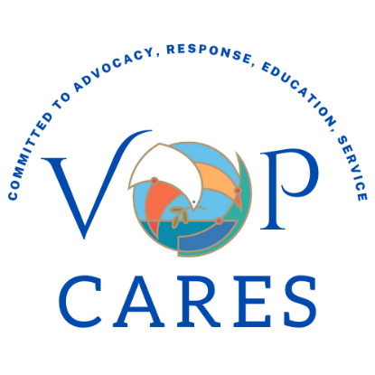

Social Ministry Team Report

Social Ministry is a vibrant, multi-faceted part of life at Valley of Peace, demonstrating the generosity and community involvement of so many of our members. Each month throughout the year we invite congregational support and participation with a designated ministry.

It is important to note that every one of our Mission of the Month initiatives supports, nourishes, assists and enhances the lives of individuals of every color and of many cultures in our community.

This is our commitment to Racial Justice at work!
The organizations we support include –

• Exodus Lending is a nonprofit helping Minneapolis families break their cycle of payday loan debt. During the past year hundreds of families were assisted by this program, which not only helps them financially, but offers financial counseling so they can break the cycle of debt and extremely high interest.
• Valley of Peace has had a long-standing relationship with our neighboring school, Noble Elementary. In addition to having volunteers go in weekly to work with students on reading skills and other subjects, VOP members contribute to the School Supply Drive and the Winter Clothing Drive, for the students at Noble.
• Every Meal is a ministry that serves the children of Noble School by providing bags of food for their weekends. We partnered with Valley Presbyterian and Unity Minneapolis in our support of Noble with this program.
• VOP participates in an annual build week with Habitat for Humanity. Our volunteers and our contributions support the Habitat organization and their work in affordable housing.
• Through Loaves and Fishes, a weekly free community meal is served at Great is Thy Faithfulness Church and Valley of Peace is committed to prepping and assisting once per month.
• PRISM, our local food shelf and housing support organization, is supported throughout the year with food and monetary contributions, and with gifts for the Holiday Gift Drive.
• As a founding church for Cherish All Children, VOP remains supportive and involved in keeping children safe from exploitation.
• Tapestry was added this year as our January Mission of the Month. We collected funds to assist them in growing their ministry.
• With a focus on Global Missions in February, VOP continues to support ministries in the Lutheran Church of Christ in Nigeria, as well as other mission projects.

Here is a sample of what has been accomplished in the past year.
• A successful lefse and cookie sale, as well as a benefit concert by Caritas for Cherish All Children
• Many speakers in Adult Faith Formation, keeping us informed about our various missions of the month
• Twenty-three volunteers showed up for the Habitat for Humanity build
• Many volunteers have shown up for Loaves and Fishes, Global Missions, PRISM, Noble School, Cherish All Children and the Synod’s “God’s Work Our Hands” service day
• VOP was a sponsor for, and many members participated in, PRISM’s Taste of the Burbs fundraiser
• Two hundred newborn baby kits were packed again this year
• Loaves and Fishes are currently serving between 50 and 80 meals each second Wednesday of the month
• Twelve individuals served in key planning or action roles for our mission organizations
• And finally, we received $11,643.00 in contributions in 2025! These funds were distributed to our monthly mission organizations.

What a tale of generosity and commitment to social justice and equity at Valley of Peace! In addition to the monetary donations VOP members contributed piles of winter clothing, school supplies, gifts, household items, and groceries to our Mission of the Month organizations, as well as giving of time in volunteering for these organizations and others throughout the year.

Please consider how you can be involved in and supportive of these organizations that VOP has chosen to assist! I will be happy to connect you with congregation members involved with these community organizations!

Respectfully submitted by,
Dee Kendall, Council Member

Stewardship Team Report

We had a successful year in member giving in 2025. As a result of an early "ask"to have members give a bit more in the year, new members joining our congregation and a generous year end gift, we ended the fiscal year "in the black".

Our three year goal to erase our budgeted deficit is right on target. Due in part to increased member giving, we plan to present a balanced operational budget (revenues meet expenses with no operating deficit) in 2027.

Thanks to our members for their generosity in helping to support the ministry of our congregation!

Paul Mikelson
Stewardship Chair

World Missions Team Report

The World Missions Team sponsored a service project on February 28th, constructing 200 newborn kits for distribution through Global Health Ministries.
We had a great group of volunteers that made fast work of the project. The Rebecca Circle also participated and shared treats. Funding for this project came from designated gifts from individuals within the congregation, along with funds from Thrivent and the Rebecca Circle.

During the month of February we highlighted efforts related to world missions through adult forums. Sam Buegler, the volunteer and event coordinator for Global Health Ministries shared about their work providing medical supplies to countries in need. Pastor Melissa Gonzalez, with Tapestry Ministry, also presented at a forum. Additionally, Lynn Thompson, who works with the International Institute of Minnesota, shared information about their local efforts at another forum.

Going forward we hope to continue working with Global Health Ministries by volunteering, gathering and donating used medical supplies.

Team members include: Melissa Dellwo, Ann Dybvig, Patty Holmstrom, Darlene Lamker, Barry Terrass, and Dan Johnson

Respectfully submitted,
Dan Johnson

Worship & Music Team Report

Annual Report: June 2025-April 2026

Chair: Sara Blood

Core Team: Pastor Ashley Osborn, Christine Weatherman (Music Director), Beth Brandt (Organist), Barb Mikelson, Pat Hoyt, and Linda Franz. Laurie Eaton and Kris Miller transitioned off the team.

Worship Planning & Leadership
- Summer worship series focused on the Holy Spirit, movement, and music.
- Began Wednesday evening prayer services led by Pastor Osborn and Laurie Eaton.
- Resumed use of Narrative Lectionary in fall for 2026-2027 church year.
- Placing a hand on the offering plate as it is passed as a blessing.
- Ongoing discussions about worship service start times and a solution to prevent choir members from having to leave Adult Faith Formation for rehearsal.
- Privacy and safety: Pastor’s office was designated a private space, and the last two rows of pews are no longer included in worship broadcasts. Congregants in these rows can opt to have communion brought to them.

Special Services
- Monthly summer Wednesday night services were held with the Wildfire churches.
- A potluck was held following the Rally Sunday service on Sept. 7.
- A blessing of the animals service was held on Zoom on Oct. 4.
- Nine new households joined Valley of Peace, and four confirmands were confirmed on Reformation Sunday on Oct. 26.
- For All Saints Sunday, Nov. 2, there were no member deaths in the past year. Joe Mann, a visitor, passed away and was included in the candle lighting remembrance. A bell was rung, and carnations were provided to the four families whose children were baptized.
- Thanksgiving Eve Pie Service was held on Nov. 26 and included prayers around the cross and table discussions. The service was held in Fellowship Hall as construction began.
- The Church Christmas Decoration was held on Nov. 23, with help from the Boy Scouts.
- The Advent Worship Service themes were Hope, Love, Joy, and Peace (Nov. 30-Dec 21).
- The Longest Night service was held on Dec. 21.
- Christmas Eve candlelight service was held on Dec. 24.
- Lessons & Carols (Hymn Sing) held on Dec. 28.
- Ash Wednesday Service was canceled Feb. 18 due to a snowstorm. At-home devotional materials provided by email.
- Lenten services focused on the Covenant of Baptism.
- Worship & Music team members again led the coordination of the Lenten Soup suppers with proceeds from freewill offerings donated to Pimiento, Marna’s and Milton’s (immigrant or minority-owned restaurants impacted by Metro Surge). A total of $890 was raised and $300 was sent to each restaurant. Thanks to all the church teams for providing meals!

From the music that inspires us to the service that sustains us, your time and talents have truly made a difference. We couldn't have done it without you! Thank you to our worship & music volunteers!

Projects & Improvements
- Two paraments damaged from a roof leak were repaired by the original creator, Ann Anderson in the fall. The roof has been repaired where the paraments are housed, and a shower curtain has been added as an extra precaution.
- Installation of new sanctuary lighting system (led by Properties Team) in the summer, with services held in Fellowship Hall.
- Transition of broadcasting of services from Facebook to YouTube in July.
- Refurbishment of three bell choir bells.
- Choir membership has grown to its largest in over 50 years with over 30 members!

Team engagement
- High/low check-ins opened each meeting, fostering connection and care.
- No major staffing updates impacting the Worship & Music team in 2025-26. Beth Brandt will be taking a summer sabbatical to rest and renew.

Look ahead to 2026-2027
- Worship & Music team meetings will move to four times a year. The team will begin hosting ongoing congregational deeper-dive discussions to involve more people and generate fresh ideas. Initial topics may include: regular and summer worship season start times, use of offering plates, and inclusivity of liturgical language.
- Replacement of the church sound system.
- Fundraiser for bell choir bells refurbishment.
- Replacement of the Sanctuary Christmas Tree.
Respectfully Submitted, Sara Blood, chair

Worship Arts Team Report

The Valley of Peace Worship Arts committee has completed its tenth year of creative work for our church. Our goal is to explore all the possibilities of worship, art, visuals and creativity for our church spaces and for our congregation members.
- Throughout this past year, we have focused on simple enhancements to our sanctuary, utilizing the banners and cloth drapes that we have in our inventory, that call forth the liturgical colors of each church season.

- We have worked with both the Worship and Music Committee, and the Altar Care team in our efforts this year, and appreciate their collaboration, as well as the support from Pastor Ashley. Thank you to all on our team!!

- We are also grateful to the many congregation members who help in decorating the church for the Advent and Christmas seasons.

Worship Arts assistants this year have included Anna Campbell, Dan Weatherman, Melissa Dellwo, Matt Dellwo, Barb Mikelson, Emilie Moravec and Lisa Rothschild. We would love to have more people to join our team! Please consider this ministry for our church, whether you need an outlet for your creative energies, or just like to help others make things look beautiful! Just talk with any of us for more information.
Respectfully submitted,
Barb Mikelson

Rejoice & Renew Capital Campaign Continuation Task Force Report

An update on our Capital Campaign: We are entering our third and final year of the Rejoice and Renew fundraising effort. Ideally, all pledges will be paid in full by April 30, 2027.

By way of recap, we had 78 pledges to the campaign. Of those pledges, 36 have been paid in full. In fact, some people have given at levels above their original pledges. There are 42 pledges that are being paid over time. Most of those are on track to be completed by the end of the campaign. In addition, 10 gifts have come in from people who did not pledge to the campaign.

Through March 31, 2026, we have received $1,054,147 in gifts. That leaves about $250,000 yet to come in over the next 12 months.

We are very happy that our congregation members have been so generous in their giving and we are excited that our two main capital projects have been completed.

Paul Mikelson, on behalf of our committee members:
Pastor Ashley, Diane Hinderlie and Lauren Pockl.

Lower Level Task Force Report

It's been quite a journey, but we are finally able to say the improvements prioritized for VoP's Lower Level will be complete as of the 2026 Annual Meeting.

The major undertakings:
* Renovation of the kitchen, making it code-compliant meeting AGCDC's licensure requirements and an overall renovation of a 60-year old kitchen used by VoP
* Adding an all-gender ADA compliant restroom, adjacent to the Fellowship Hall, East end
* Replacement of single-pane windows in the Fellowship Hall, with energy-efficient double-pane windows

Miller Dunwiddie Architects completed work on an alternative floor plan drafted by Dan Weatherman. This plan was approved by our Team and the VoP Executive Team.

With a complete set of drawings and a book of specifications from the architects, we requested project proposals from four general contracting firms: W. D. Forsberg; Langer; J. T. Enger; and D.J Kranz. Proposals were also requested from Rapids and Boelter to provide and install kitchen equipment and appliances.
Following interviews by the Team, which included Pastor Ashley, we recommended the selection of D.J. Kranz as our General Contractor and Boelter as our kitchen equipment provider.

At a special meeting of the congregation on October 26, 2025, the Team recommended the selection of D.J. Kranz as General Contractor for the construction portion of the project and Boelter Equipment as our provider of kitchen appliances/equipment and installation.

The above recommendation was approved by the congregation to proceed with a project budget of $630,000

With the approval of Golden Valley Inspection permits and the Health Department, demolition of the areas to be renovated began at the end of November 2025. Project was expected to be virtually completed by mid March of 2026.

New and upgraded areas
*Kitchen - all new and ADA compliant
* Flooring, ceiling and wall finishes, all-stainless prep surfaces, 2 convection ovens, a new exhaust hood with a fire suppression system, a vent-less dishwasher, lighting, cabinetry, solid-surface serving/dirty dish counter, coiling doors
* Several appliances funded by the VoP Trust - refrigerator, 3 induction pods, coffee brewer

Fellowship Hall
* 15 new energy-efficient windows, painting of all the walls and replacement of the vinyl wall base.
* Refinishing of the four entrance doors, including new closures

ADA Restroom
* New all-gender ADA accessible restroom

I also want to mention, with the new restroom now in place, we will vacate the small restroom at the end of the East hall. With that space now available, Matt Dellwo is undertaking the move of low-voltage communication equipment out of the Janitor Closet and into the new dedicated space.

I would like to recognize AGCDC and Lisa Sutter for the flexibility they have shown throughout these five months of construction. Lisa has been outstanding in working with our construction people and adapting daily, as needed. THANK YOU !!!

Our construction team consisted of our architects Kelly Mastian and Rachael Springman of
Miller Dunwiddie; Josh Busse, Project Manager and Curtis Blank, Site Superintendent of D.J. Kranz; Derick Johnson of Boelter Equipment; Dan Weatherman and myself.
It's been an outstanding Team to work with through the construction phase.

I also want to thank Dan Weatherman for putting his professional expertise to use watching over the many aspects and details of the construction.

THANK YOU to All VoP Members who have, in any way, contributed to the success of this much-needed renovation of VoP's Lower Level.

In closing, THANK YOU to a great team who have been with this project from the very beginning. You have been outstanding in your commitment!! Sally Daniels Herron,
Pete Mikelson, Sten Pearson, Dan Weatherman, and Pastor Ashley for all your support throughout this project.

On behalf of the Lower Level Improvement Team,
Dave Gilyard

Faith & Neighboring Practices Team

Overview
This report summarizes (1) what the Faith & Neighboring Practices Learning Cohort Program is, (2) who comprises the Valley of Peace Lutheran Church (VoP) team, (3) what the VoP team has done/experienced to date, and (4) what is planned for the year ahead.

What the Faith & Neighboring Practices Program Is
Faith & Neighboring Practices is a two-year learning community for congregations in the Minneapolis Area Synod. The core conviction of the program is that vital congregations authentically engage with their neighborhood, trusting that God is already active in the community beyond the church’s walls. Through cohort gatherings and between-session practice, participating congregations explore asset-based community development, community engagement, and contemplative spirituality—learning to listen well, notice what is already present in the neighborhood, and practice neighboring in tangible ways.

Who Comprises the VoP Team
- Pastor Ashley
- Laurie Eaton
- George Johnson
- Pat McGraw
- Ellory Roske (LADC parent)
- Sara Hoge
While the core cohort team is listed above, the program is designed to involve many others at VoP through one-on-one conversations, council/congregational exercises, and VoP-hosted events.

What the VoP Team Has Done / Experienced So Far
Fall 2025: Kickoff and Early Cohort Gatherings
- Fall Retreat (Sept 13, 2025): Team members participated in a full-day kickoff retreat focused on worship, deep small-group conversation, and contemplative spirituality practices (including the “Tree of Contemplative Practices”). The cohort was introduced to spiritual directors Pastors Susan Engholm, Karen Wight Hoogheem, and Kathie Nycklemoe, and engaged with themes from the book Community: The Structure of Belonging.
- Cohort Meeting 1 (Christ Church Lutheran): The team practiced structured one-on-one conversations (“How do you come today?”) as a way to build connection and strengthen listening.
- Cohort Meeting 2 (Mt. Olivet, Plymouth): Continued contemplative practice and began neighborhood mapping—sketching a bounded “neighborhood” and identifying people and places within it, then using that map to guide who to meet.
- Cohort Meeting 3 (Grace Lutheran, NE Minneapolis): A shortened gathering due to a traumatic event affecting the community that day; the group shared a meal, checked in, and continued spiritual practice (the “mountain” meditation).
Across these early sessions, consistent “homework” emerged: hold one-on-one conversations with congregation members and neighbors, and use neighborhood mapping to intentionally choose who to meet and what to notice.

Early 2026: Hosting, Differences & Bridge-Building, and Asset Mapping
- Cohort Meeting 4 (Feb 5, 2026, hosted at VoP): VoP hosted the cohort in the fellowship hall. The session continued contemplative practice (the “mountain” meditation) and moved into neighboring practices related to encountering differences (race, ethnicity, culture, gender, age, economic status, and more) and learning practical tools for connecting meaningfully across those differences. The exploration was led by David Scherer (JUSTmove), with continued emphasis on keeping up one-on-one conversations.
- Cohort Meeting 5 (Mar 5, 2026, Spirit of Christ Lutheran, St. Louis Park): The cohort went deeper into asset mapping through rapid-fire prompts and “post-it” exercises to identify neighborhood/congregational assets, then used randomly selected assets to design imaginative community events. VoP’s exercise generated an idea for an interpretive walking/touring path connected to Bassett Creek.
- Congregational/Council connection: The team planned to conduct an asset-mapping exercise with the VoP Council and/or congregation, with Pastor Ashley leading the Council through the exercise at a March council meeting.

Spring 2026: Neighborhood Walks and Listening Projects
- Cohort Meeting (Apr 7, 2026, Christ Church Lutheran): Led by Pastor Kathie Nycklemoe, the spiritual practice reflected on the road to Emmaus. The cohort began planning neighborhood walks and summer community listening projects. Participants practiced “noticing” what they encounter on walks—signs of gathering/hospitality, pain/struggle, creativity/renewal, and joy/gratitude—and considered questions to ask neighbors (e.g., how long they’ve lived in the neighborhood, what they love, and what has changed).
- Types of neighboring: The cohort learned categories of neighboring (Ambient, Show-up, Social, Economic, and Collaborative) to help diversify how they engage.
- VoP planning conversations: VoP team members met on Apr 14 at Teresa’s Mexican Restaurant to plan neighborhood walks and begin discussing summer neighboring activities. A first neighborhood walk was scheduled for 11:30 a.m. on Sunday Apr 26 (following services), with invitations shared in church communications and verbally during services. The team planned another meeting after services on May 3 to continue summer event planning.

What’s Planned for the Year Ahead
Based on the plans and “homework” outlined in the cohort updates, the VoP team’s trajectory for the coming year emphasizes steady, repeated practice—listening well, showing up in the neighborhood, and widening participation beyond the core team.
- Continue one-on-one conversations with congregation members and neighbors as an ongoing practice, strengthening listening, relationship-building, and awareness of what matters to people.
- Neighborhood walks: Conduct scheduled walks in small groups (roughly 3–5 people), using the cohort’s noticing framework (hospitality/gathering; pain/struggle; creativity/renewal; joy/gratitude) and neighbor-oriented questions to guide conversation and learning.
- Summer community listening projects: Hold team planning conversations and carry out listening activities over the summer months, paying attention to where God is already at work and what neighbors care about.
- Practice neighboring in multiple modes (Ambient, Show-up, Social, Economic, Collaborative), so engagement is not limited to a single approach.
- Complete “summer homework”: With no cohort meeting in June, July, or August, the team intends to conduct three neighboring practices over the summer break and meet as needed to coordinate.
- Share learnings with council and congregation: Continue bringing cohort tools (like asset mapping) into VoP settings so more people can participate and so ideas can move from learning to action.
Communication: As neighborhood walks and summer listening projects unfold, capture brief stories and observations (what was noticed, who was met, and what surprised us) to share back with Council and the congregation—helping the wider church see and join the work.
Please feel free to reach out with any questions. Pat McGraw, apmcgraw@msn.com, 651-260-2318

Altar Care Report
The Altar Care Team prepares the altar for worship and communion. In September, we began communion by intinction with homemade bread, gluten-free wafers and pre-filled communion kits. We are serving communion every Sunday.

We continue to use Best Wishes Florists in Golden Valley for our Sunday flowers sponsored by congregation members.
Our team members are Kathy Boesen, Claudia Arohnson,Pat Hepner, Steve Collin and Melissa Delwo. Our bread bakers are Barb Mikelson, Pam Syverson, Jon Osborn, Laurie Eaton, Christine Weatherman as well as Kathy Boesen and Pat Hepner. We will always welcome new members.

Linda Franz, Chair

Every Meal Report
Every Meal is a weekend food program that Valley of Peace, along with two partner churches, has served Noble School. This partnership started after COVID and has served 25 to 30 Noble School families every year.

Sadly, after this year ( 2025 - 2026 ) Noble School will be closing. At this time, our team is looking into new ministries that will benefit the children of Robbinsdale school district. We look forward to continuing to prioritize children in our church and schools.

Linda Franz, Coordinator

Personnel Committee Report
Committee considers and approves updated CYF Director position and pay following the end of our sharing agreement with another church.
Committee reviews and approves updated Children Youth and Family (CYF) Director job description provided by Pastor Ashley Osborn in August 2025.
Committee reviews and revises new PFMLA policy with the help of Tara Kuckkan, Mariana Duffney, and Pastor Ashley Osborn.
Committee meets and approves changes to the CYF leadership team.
Committee reviews and approves updated Children Youth and Family (CYF) Director job description and job posting provided by Pastor Ashley Osborn in December 2025.
Committee approves gift for interim church secretary who will return to retirement when Kelsey Pierson returns from leave.
Committee, in collaboration with CYF leaders, interviews and hires a new CYF Director, Dan Miller.
Committee, in collaboration with senior church leaders, considers and approves Beth Brandt’s request for sabbatical.
Submitted by Melissa Dellwo

Endowment & Memorial Trust Report

Members of the Trust Board:
Bob Gullick, Christy Flicke, Jon Larson, Mary Hovden, Annette Balkenende,
Zachary Pierson, Matthew Stetler, Steve Hoge

The purpose of the trust is to provide resources for new opportunities for the VOP mission that are not planned for in the budget of the congregation. Christian stewardship through the trust helps us to bless others beyond our own lifetimes.

Income from gifts to the trust provides the congregation with funds for new and unbudgeted programs or items. The principle stays in the trust and continues to grow. In addition to the general trust funds, the trust currently has two designated funds: for music and for youth programs.

A gift may occur while the donor is living or through the donor’s will. An honoring gift in thankfulness for a living friend or family member is an excellent way to ensure that person’s gifts of ministry are carried on in perpetuity. Donations of any size are welcomed.

Highlights of our work in 2025:

- Matt added to the UBS account as an authorized signer
- Discussed term limits
- Completed criteria for grants
- Temple Trust talk and cake in February to celebrate anniversary of Trust
- Presented at Church council on February 18th
- Updated by-laws to include policy on designated funds sub-accounts
- Article in VOICE about Trust in August
- Trust approved grants to the Kitchen project ($9000), Youth Mission Trip ($3000),
Bell Refurbishment ($3380). Total ($15,380)
- List of President Responsibilities created

Goals for the trust in 2026:
- Establish a user-friendly location on the VoP Website
- Complete New Member Handbook for Trust

VOP Trust Investment Overview 2025
The majority of the investments are managed through UBS Financial Services Inc. Our investment allocation is a moderate risk profile. The allocation of investments at 12-31-2025 was:

Cash/Cash Alternatives $31,624.89 7.78%

Equities $204,916.09 50.48%

Fixed Income $169,469.00 41.74%

Total in UBS account as of 12-31-2025: $406,009.98

Percentage change from 2024 was 6.8%.

Valley of Peace Endowment and Memorial Trust
December 31, 2025
INCOME AND EXPENSE Year End Year End
2025 2024
Income
Contributions $16,700 $2,285
Interest/Dividends $26,161 $16,604
Market Value changes $5,328 $17,803
Total Income $48,189 $36,692
Expenses
Grants approved from Trust $17,199 $6,475
Investment Management Fees $200 $175
Other Trust expenses $ - $ -
Total Expenses $17,399 $6,650
Net Increase (Decrease) to Trust $30,789 $30,042
TRUST BALANCE $412,692 $381,903
2025 Contributions
Pat Hoyt $16,700
$16,700
2025 Grants Approved from Trust:
- Lower Level Kitchen Project (Dual Coffee Brewer, 3 Induction Pods,
- Refrigerator/Freezer $9,000.00 $4,469.75. of this paid in November to order Induction Pods
- Youth Mission Trip $3,000.00
- Bell Refurbishment $3,380.00
- Cake for Church Trust Celebration $26.99
- VOP Music from their designated funds $1,367.50
- VOP Youth from their designated funds $425.00
$17,199.49

All God’s Children Discovery Center Report
This year has been a season of significant transition and renewed growth for the Discovery Center at Valley of Peace. With Lake Area Discovery Center (LADC) now fully operating the program, we have entered a new chapter focused on strengthening systems, building team culture, and continuing our commitment to Christ-centered early childhood development.

This transition also brought a complete refresh of our teaching team. Our new educators have been intentional in building strong routines, forming relationships with families, and creating environments where children feel safe, known, and cared for. While the year has not been without challenges, what stands out most is the genuine love and commitment our staff shows to the children and families we serve.

Today, we are serving 46 children ranging from infancy through age five—each one entrusted to us and central to our mission.

We are especially grateful for the near completion of our partnered facility improvement project, highlighted by a fully remodeled kitchen that will better support daily operations, food service, and overall program functionality. Alongside this, the addition of dedicated bathrooms within the early childhood wings will significantly improve daily routines and classroom flow. These investments reflect strong collaboration between the church and preschool, and we are thankful for the shared effort that made them possible.

This year has also reminded us that we cannot fulfill this mission on our own. We are called to serve together as the Body of Christ—each bringing our gifts in partnership. The relationship between Valley of Peace, LADC, and our families reflects this shared calling.
"Two are better than one,
because they have a good return for their labor:
If either of them falls down,
one can help the other up.
But pity anyone who falls
and has no one to help them up.
Also, if two lie down together, they will keep warm.
But how can one keep warm alone?
Though one may be overpowered,
two can defend themselves.
A cord of three strands is not quickly broken."

We are grateful for the trust and support of our families, board members, and the Valley of Peace community throughout this season of transition. As we look ahead, we remain committed to continued growth, strong relationships, and faithfully serving children and families.
In Service,
The Lake Area Discovery Center Leadership Team

Lake Wapogasset Report

Thank you for being a Partner Congregation!
We are deeply grateful for the ongoing support and dedication of so many congregations that enable thousands of individuals each year to experience community and deepen their faith at Camp Wapo, Ox Lake, and Wilderness Canoe Base. We celebrate a year full of impactful moments with campers and retreat guests, and we are thankful for the generosity of our donors, the prayers of our supporters, and the commitment of YOU - our partner congregations.

Across all three sites: Camp Wapo, Ox Lake, and Wilderness Canoe Base - we continue to see how essential this ministry remains in the lives of young people, families, and congregations. In a world that feels increasingly fragmented, our camps are still places of belonging, joy, spiritual grounding, and honest community.

God is moving powerfully through this ministry and the work happening at our sites remains profoundly impactful - forming resilient young leaders, nurturing faith in an unplugged and grace-filled setting and offering sacred experiences of creation and community that cannot be replicated anywhere else.

Summer 2025 - This summer, we had the privilege of welcoming 4109 campers and families to Camp Wapo, Ox Lake, and Wilderness Canoe Base. Our summer staff brought flexibility, leadership, and servant hearts to every corner of camp. They met challenges head-on and helped create a community full of energy and care.

Hiring for Summer 2026 is underway! If you know a young adult who would be a great fit, we’d love an introduction. You can contact Michael (Ox Lake) at michaelw@campwapo.org or Hazel (Wapo) at hazelb@campwapo.org, or Stephanie (Wilderness) at stephaniec@campwapo.org or visit lakewapo.org/employment to apply. Working at camp is the best work experience to include on a resume.

Deferred Maintenance Projects This year brought significant progress on long-awaited deferred maintenance. The new exteriors on the Lodge and Hill cabins at Wapo, the upper level addition to the chapel at Ox Lake, and the funds available for ongoing research and planning for Trailshack were all tremendous blessings. While we still have a list of deferred projects ahead of us, 2025 represented a giant leap forward, and we are grateful for the faithful stewardship that made this momentum possible.
Facility upgrades at Ox Lake have made it possible for us to bring back the High School Roots program for 2026. The upper level chapel addition is gorgeous and multifunctional. It will be a great blessing for that program and all the greatness planned for Ox Lake this summer.
Donor Engagement In 2025, annual giving reflected the caution many donors are feeling in an uncertain economic climate. At the same time, congregational giving and designated giving remained steady, resulting in overall contributions that look similar to 2024. This pattern reflects both careful discernment and deep commitment from those who continue to support this ministry.

We are still in the leadership phase of the Room for More campaign to complete the dining hall and meeting space project at Camp Wapo. Steadily, in the coming months, we will expand this effort through a congregational phase, inviting our partner churches to participate in this important next chapter. In time, we will move into a public phase for this campaign to broaden the reach and ask.

Joel Abenth, Director of Donor Engagement, will be working closely with congregations, individuals, and families who are discerning how best to support camp - through gifts, pledges, or other creative approaches to generosity. If you would like to explore ways to be involved, please reach out to Joel at joela@campwapo.org

Retreats and Events in 2025. In 2025, we hosted 7363 retreat and special events guests. All three sites offer a range of options for both programmed retreats and facility rentals if you’re looking to organize your own event. Retreat opportunities can be found at lakewapo.org/news-events. For more details or to schedule your retreat, please contact Ryan at ryanb@campwapo.org. Anything from weddings to yoga, Quilters to Youth retreats! Additionally, we welcomed over 500 guests for our Memorial Day Pancake Extravaganza, celebrated the 23rd year of the Wapo Golf Tournament, and hosted over 1,200 guests and volunteers during Advent, including 8 sold out performances of the 36th annual Christmas Dinner Theater, "Star."

2026 Theme: WONDER "With God all things are possible." Matthew 19:26
At camp, we move from curiosity to calling - from “What if?” to “Here I am.” Each question becomes a doorway into deeper relationship with a God who invites us not to certainty, but to awe, trust, and transformation.

Together, we stand in wonder of community, curiosity, calling, identity, mystery, and possibility. Camp is holy ground - a place to ask real questions, discover belonging, and listen for how God is at work within and among us.

We look ahead with eager anticipation and a sure sense of hope. See you at camp in 2026!

Wildfire Report

In Ecclesiastes we read that “Two are better than one, because they have a good reward for their toil. For if they fall, one will lift up the other.” It is our hope that, through community with the churches around us, we may better meet the needs of our neighbors and ourselves. In doing so, may we have all the more joys and successes to celebrate together!
-Dan Miller, Director of Children, Youth, and Family Ministries

Wildfire consists of eight ELCA churches within our surrounding community:
Cross of Glory, Elim, Faith Lilac Way, First Lutheran Church of Crystal, Holy Nativity,
House of Hope, St James, and Valley of Peace.

During 2025, we realized the following successes:

The Wildfire Visioning Team created a Vision Statement: “Grounded in the promise of God’s abundance, inspired by the love of Jesus Christ, and filled with the wildfire of the Holy Spirit, Wildfire churches are called to join God’s work within our shared geography of the Robbinsdale School District, to respond to the needs and celebrate the gifts of our neighbors, and, in a world that separates us, to be God’s church together.”

The Wildfire Planning Committee (lay members, pastors, and church staff) created or promoted the following events:

  - St. James has a men's group that meets every Saturday morning for devotions, prayer, and fellowship. This group opened its membership to men from all Wildfire Churches.
  - February: Wildfire Every Meal Bingo and Pizza Fundraiser, planned by the Wildfire Every Meal Committee.
  - June: Golden Valley Pride Festival
  - June: Cherish All Children 5K fundraiser
  - June: Wildfire Every Meal Shindig at House of Hope, planned by the Wildfire Every Meal Committee.
  - July: High School Mission Trip to Asheville NC to do Hurricane Helene relief work.
  - Summer: Wildfire churches worshiped together three times.
  - August: VBS at Cross of Glory, planned by the Wildfire VBS Committee
  - September: “God’s Work Our Hands” at Faith Lilac Way. People assembled Community Garden Neighbor Kits for Global Refuge.
  - September: Wildfire Singers & Vocal Jazz Concert at Cross of Glory, including a performance by "Take Note," a local vocal jazz ensemble, featuring acclaimed jazz-vocalist Connie Evingson.
  - October: “Ghost of a Chance” presentation by Eric Roper, at House of Hope.
  - November: Every Meal Packing Event in Roseville
  - December: Holiday Benefit Concert featuring Brooklyn Big Band at Elim. A benefit for NEAR and PRISM.
  - December: Christmas Carol Sing-Along at Wicked Wort

In 2026:

- February: Wildfire Every Meal Mardi Gras Bingo & Bake Sale at Holy Nativity
- April: Two Letters from Birmingham Readers Theatre at House of Hope

More events planned for 2026!

Sara Blood & Jim Jasper served on the Wildfire Visioning Team, which developed the mission statement.

Ann Dybvig & Sara Blood are stepping down from the Wildfire Planning Committee after two years. Dan Miller has been attending meetings since being named Valley of Peace’s Children, Youth & Family Director, and Shennon Jay will begin attending in May.

Respectfully submitted by Sara Blood

Bishop Jen Nagel Report
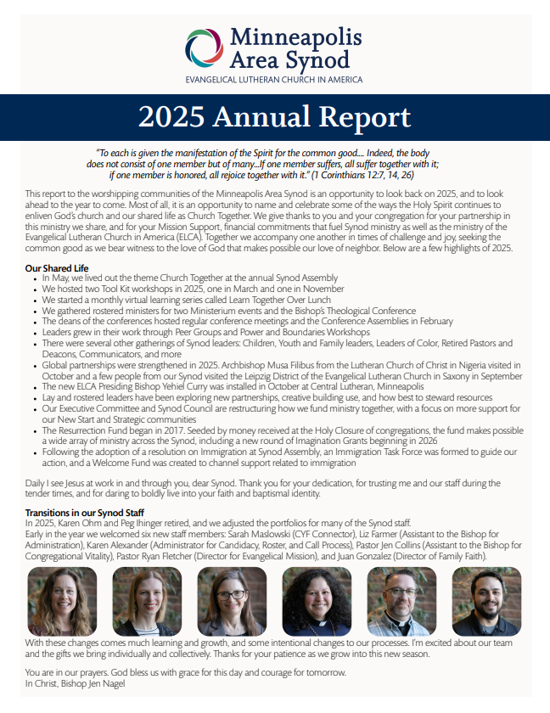
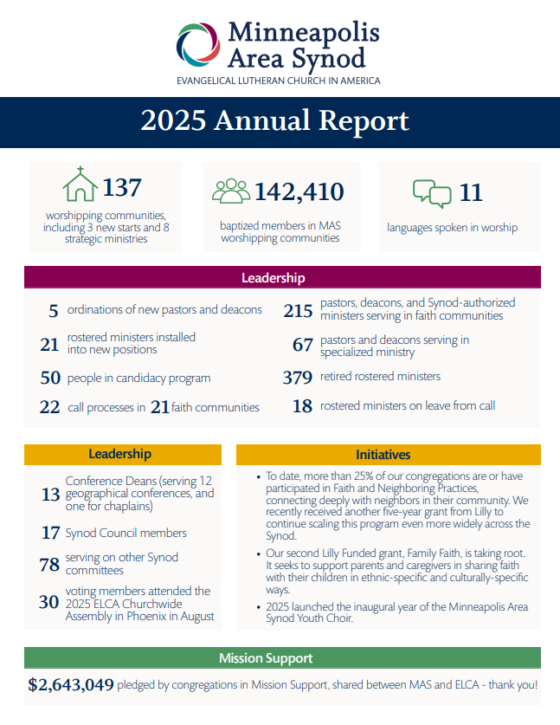
Presiding Bishop Yehiel Curry Report

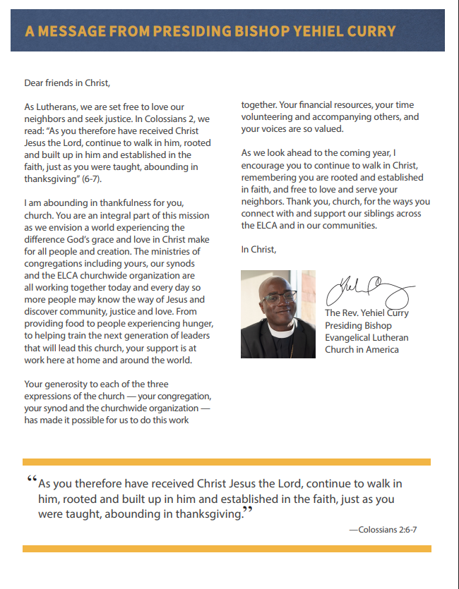

Membership Statistics

Baptized Members, as of May 2026: 263

Confirmed Members, as of May 2026: 229

Average Sunday Worship Attendance (In Person): 86

Average Sunday Worship Attendance (On Youtube Live): 7

3 Baptized from May 2025 - May 2026
Audrey Melby Stetler
Samuel Schoenfeld Lesewski
Brookes Delavane Rohrer

4 Confirmed Members on October 26, 2025
Evelyn Anderson
Liam Foy
Colby Hovde
Noah Mikelson

3 Deaths from May 2025 - May 2026
Joseph Mann
Robert “Bob” Gerber
Martin “Marty” Fergus

23 New Members from May 2025 - May 2026

Carolyn Schueller
Grant Martin
Tyler Martin
Andrew Loose
Lisa Rothschild
Gildas Dabe
Marv Spaetz
Terri Spaetz
Jonathan Moore
Thad Radel
August Radel-Moore
Marco Riley Bingea
Sarah Riley Bingea
Lucia Riley Bingea
Adeline Riley Bingea
Kirsten Styer
Sue Trosvig
Mandy Queitzsch
Sven Queitzsch
Nelson Queitzsch
Chris Queitzsch
Barb Stadie
Michael Stadie

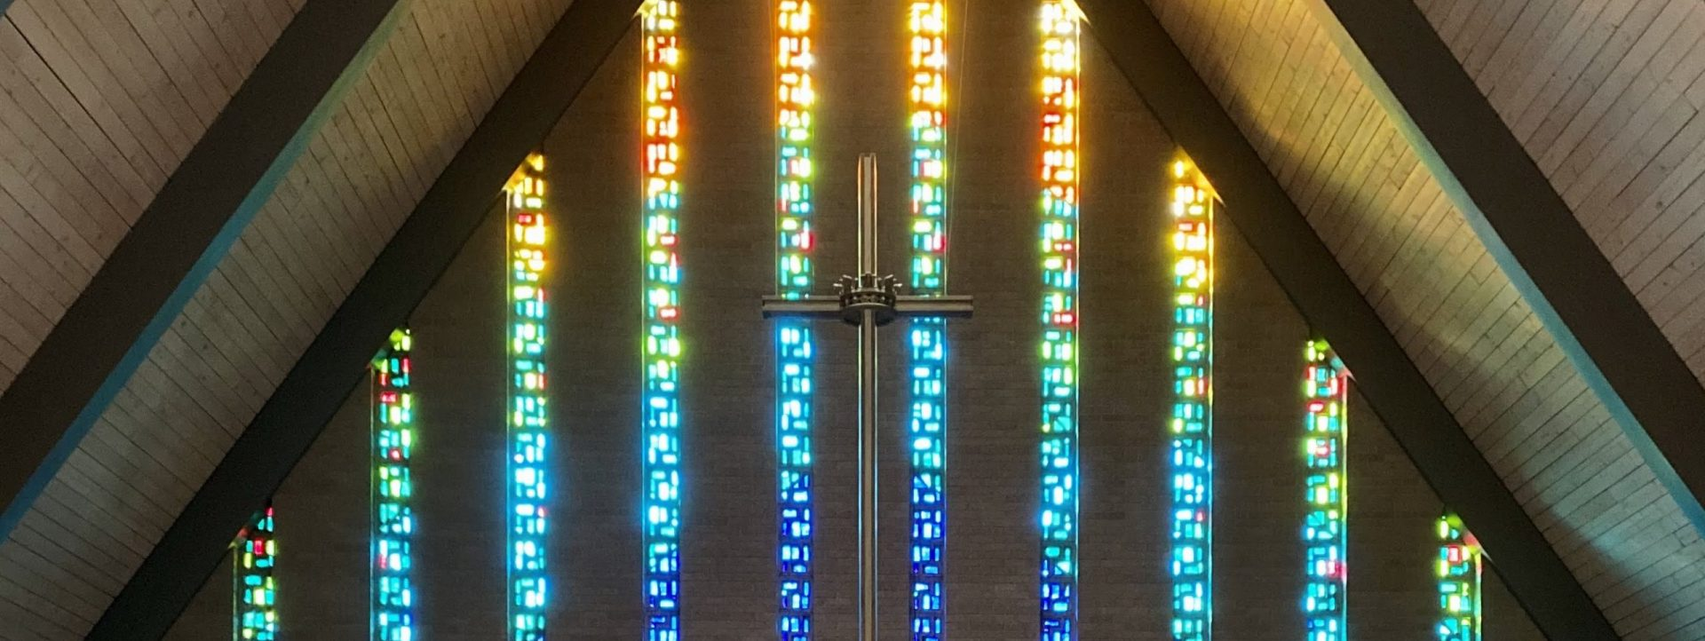

Agenda for May 17, 2026 Annual Meeting

Location: Hybrid-ZOOM & VoP Fellowship Hall
Date: May 17, 2026
Time: ~11:45 am

Item | Action
Call to Order | Shennon Jay
Opening Prayer | Pastor Ashley Osborn
Entertain a motion to waive the reading of the minutes.
Capital Campaign Update | Paul Mikelson
Blessing of the Kitchen & HVAC System | Pastor Ashley Osborn
2026 Ballot | Shennon Jay
Celebration & Installation | Pastor Ashley Osborn
Adjournment | Jim Jasper

Mission Statement

Living in God’s love and compassion, we are called and sent by God to be disciples of Jesus Christ, as the Holy Spirit works through us for healing, justice, and peace.

Reconciling In Christ Statement

We recognize that each person is a unique creation of God and, by grace, is called a child of God, without exception and regardless of gender, race, national origin, sexual orientation, gender identity, physical or mental ability, age, station in life, or political affiliation.

----------------------------------------------------------------------------
For more information and a calendar of activities visit www.valleyofpeace.org
----------------------------------------------------------------------------

Valley of Peace Staff

