Valley of Peace Lutheran Church
Sunday, May 17, 2026 - Sunday, May 24, 2026

Sunday, May 17  9:00 am Adult Faith Formation  9:00 am Children’s Faith Formation  9:45 am Chancel Choir Practice  10:15 am Worship  11:30 am Annual Meeting in Fellowship Hall  Tuesday, May 19  6:15 pm Council Meeting  Wednesday, May 20  4:00 pm VOP Staff Meeting  5:45 pm Pray Without Ceasing  7:00 pm Chancel Choir Rehearsal &  End of the Year Party | Thursday, May 21  10:00 am Text Study  (Acts 2:1-21; Philippians 4:4-7)  Saturday, May 23  10:00 am Marty Fergus Funeral  Sunday, May 24  No Adult Faith Formation  No Children’s Faith Formation  9:30 am Worship

Our Mission  Living in God’s love and compassion, we are called and sent by God to be disciples of Jesus Christ, as the  Holy Spirit works through us for healing, justice, and peace. | Valley of Peace is committed to  Racial Justice and is a Reconciling  in Christ Church. | Contact Us  763-588-4611  www.valleyofpeace.org  4735 Bassett Creek Drive,  Golden Valley, MN 55422

Altar Flowers given on 5/17/25 by Kari Roll in honor of her parent’s,
Mary Hovden & John Roll’s 40th wedding anniversary!

Annual Meeting 2026- TODAY!
Join us after worship today for our 2026 Annual Meeting. An extra special Annual Meeting as we will be having it in the newly remodeled Fellowship Hall! Hope to see you there!

Worship Time Change
Friendly reminder that our first summer worship will begin on Sunday, May 24.
Summer worship service will begin at 9:30 am. See you then!

Musicians Needed!
Our wonderful organist will be on sabbatical for several Sundays this summer.
We will need people to play for the services. We are open to anything, organ, piano, guitar, etc.

We will need people for the following dates:
June 28, July 5, July 12, July 19, July 26, August 2 and August 9.

If you are interested please contact Christine Weatherman at music@valleyofpeace.org or 612-834-3228.

Summer Volunteering
With summer on the horizon, you may be wanting to switch up your volunteering. Perhaps trying a volunteer position you haven’t tried before! Or maybe you’ve taken a pause from volunteering and want to ease back into it before the fall time, either way, please let us know so we can get you on the correct volunteer list or train you in a new role! Thank you!

Blessings Box & PRISM Donations
How about this? The next time you are at the grocery store, consider picking up ONE non-perishable food item for the Blessings Box here at church (it continues to get used so much!) AND/OR ONE something for the grocery cart on the lower level (let's make Ken Schneider have to make two trips to his car with items to deliver to PRISM!).Now that the weather is warming up, we can put things like toothpaste, soups and juice boxes in the Box and remember that cereal is always needed.

Feel free to bring items for the Blessings Box to the church office, or you may bring them to the Welcome Center. If you have any questions, please let me know.

Sally Daniels Herron
sally.danielsherron@gmail.com

Chancel Choir Concert
You are invited to join the choir at Park’s Place on Wednesday, May 27 at 6:30 pm for a brief concert and sing a long with the residents. Marv Lofquist, long time VOP member, is a resident there. The address is 18040 Medina Road, Plymouth, MN 55446.

VOP at Golden Valley PRIDE
Join Valley of Peace at Golden Valley Pride!
We are thrilled to announce that Valley of Peace will be hosting a booth again this year at the 10th Anniversary Golden Valley Pride Festival! We invite you to join us for a day of celebration, connection, and community building as we share our spirit of inclusion with our neighbors.

Date: Saturday, June 13, 2026 at 12:00 PM – 6:00 PM
Location: Brookview Park, Golden Valley

Our booth will be a hub of activity and hospitality. By popular demand, we are bringing back our PRIDE-themed bracelet-making station! We will also be cooling off the crowd with free lemonade and making some four-legged friends with free dog treats. We need your help to make this event a success!
We are looking for joyful volunteers to support us in several ways:

-Donating and bringing supplies
-Assisting with booth setup (morning) and teardown (evening)
-Staffing the booth in 60-minute volunteer slots
If you would like to represent Valley of Peace and share in the festivities, please sign up for a time slot or supply donation here:
https://docs.google.com/spreadsheets/d/1Dl2gn9U3CxtSJeK650ILIP1SvziQs4fT7N90r53D8Us/edit?pli=1&gid=1443475417#gid=1443475417

We can't wait to see you at the park!

Java for Mama & Papa is back THIS SUMMER!
For the months of June, July, and August, Valley of Peace members will share coffee and treats with parents of All God's Children Discovery Center every Thursday morning.

We will sit outside from 7:30 - 9:00 to greet parents as they drop off, offer a space for them to enjoy a cup of coffee and treat while they connect, or share coffee and a treat for them on their way.

This has been such a meaningful way to get to know AGC families and I know that families have very much appreciated this space of care and connection!
I would love to have people join me on these Thursday mornings. If you would be willing to help set up and sit outside during this time or bring a baked good, please let me know! Thank you so much for your care and support of these young people and their families!

-Pastor Ashley

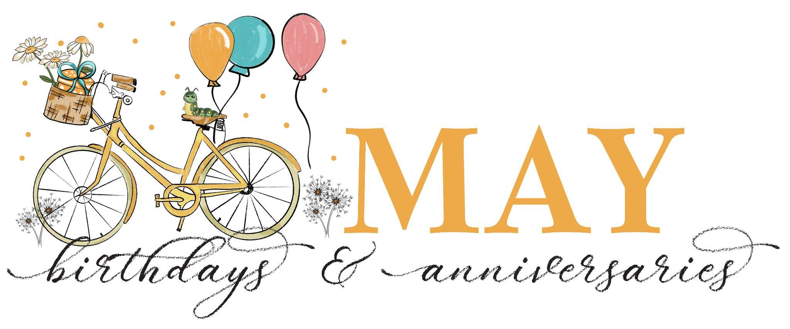

Birthdays:
5/19: Bennett Laurent; 5/20: Sabra Edwards; 5/22: August Radel-Moore;
5/22: Daniel Kempf; 5/23: Zachary Pierson; 5/23: Matt Dellwo;
5/24: Jon Ewald; 5/24: Karl Schiebe;

Anniversaries:
5/17: Mary Hovden & John Roll, their 40th;

We invite you to take the announcements home with you and remember in prayer:

The Lutheran Church of Christ in Nigeria/our Congregation partner-LCCN, St. Luke Cathedral, Mayo-Gwoi, Jalingo, Nigeria and Pastor Talmon Yakaba

The children and youth of Valley of Peace and the members of the congregation who pray for them daily.

The congregation of Valley of Peace, that we extend an open welcome to all people and model in our community the reconciling ministry of Jesus Christ.

Those who have health concerns or are receiving treatment.
Prayers for Dottie Fergus and family with the passing of Marty Fergus on April 20, 2026.
Prayers for Linda Peterson and family with the passing of Neil Peterson on May 10, 2026.
—-----------------------------------------------------------------------------------
Prayer requests are listed with permission.
If you would like to be included in the prayers please contact the church office. Names will be included for 4 weeks unless otherwise asked for. Confidential prayer support is also available.
—-----------------------------------------------------------------------------------
