Valley of Peace Lutheran Church
Easter Sunday
April 5, 2026

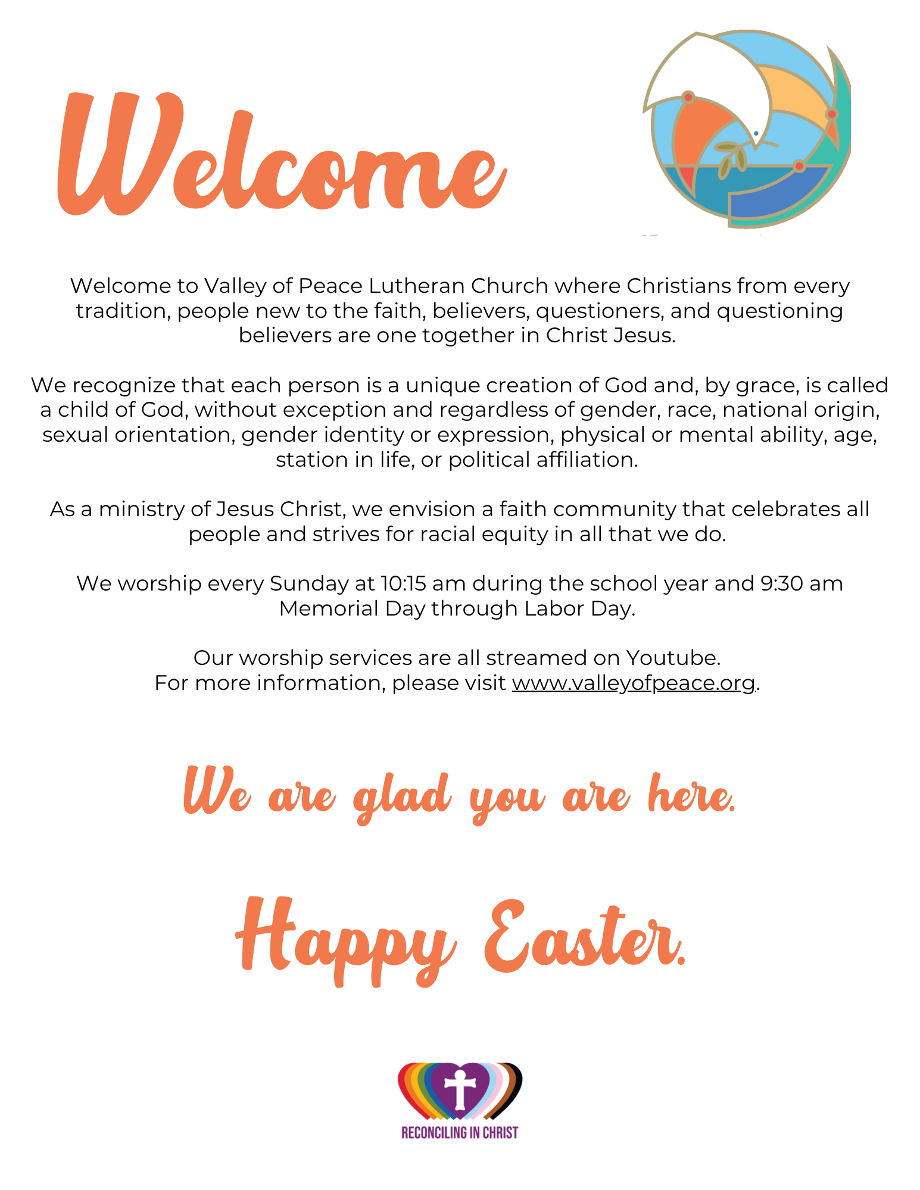

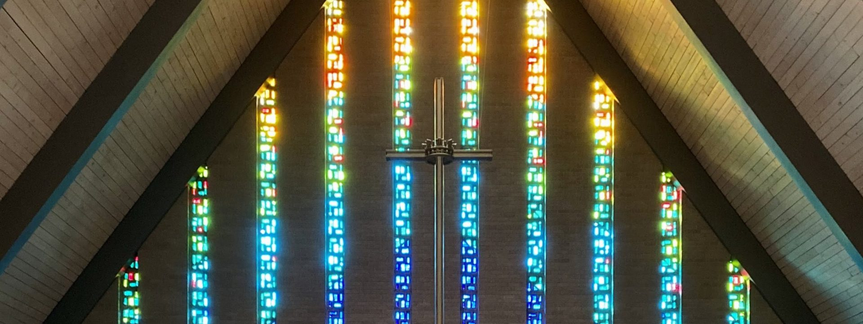
Valley of Peace Lutheran Church
April 5, 2026
10:15 am

You are invited to participate in worship by reading the BOLD print. When you see +, please stand in body or in spirit.
ELW is the red hymnal and ACS is the purple hymnal, both located in the bottom of the pew in front of you.
If you need any assistance, please ask an usher.

GATHERING MUSIC Christ is Risen! Alleluia! Donald Busarow

WORDS OF WELCOME
Alleluia! Christ is risen!
Christ is risen indeed! Alleluia!

PRELUDE Marziale in D Major Ch. H. Rinck

+CALL TO WORSHIP
This is the day:
when tears are wiped away;
shattered hearts are mended;
fears are replaced with joy.

This is the day the Lord:
rolls away the stone of fear;
throws off death's clothes;
goes ahead of us into God's future.

This is the day the Lord has made:
death has no fear for us;
sin has lost its power over us;
God opens the tombs of our hearts
to fill us with life.

Alleluia! Christ is risen!
Christ is risen indeed! Alleluia!

PROCESSIONAL HYMN RED ELW #855 Crown Him with Many Crowns

Congregation: vs. 1 & 2; Choir: vs. 3; Congregation: vs. 4 & 5

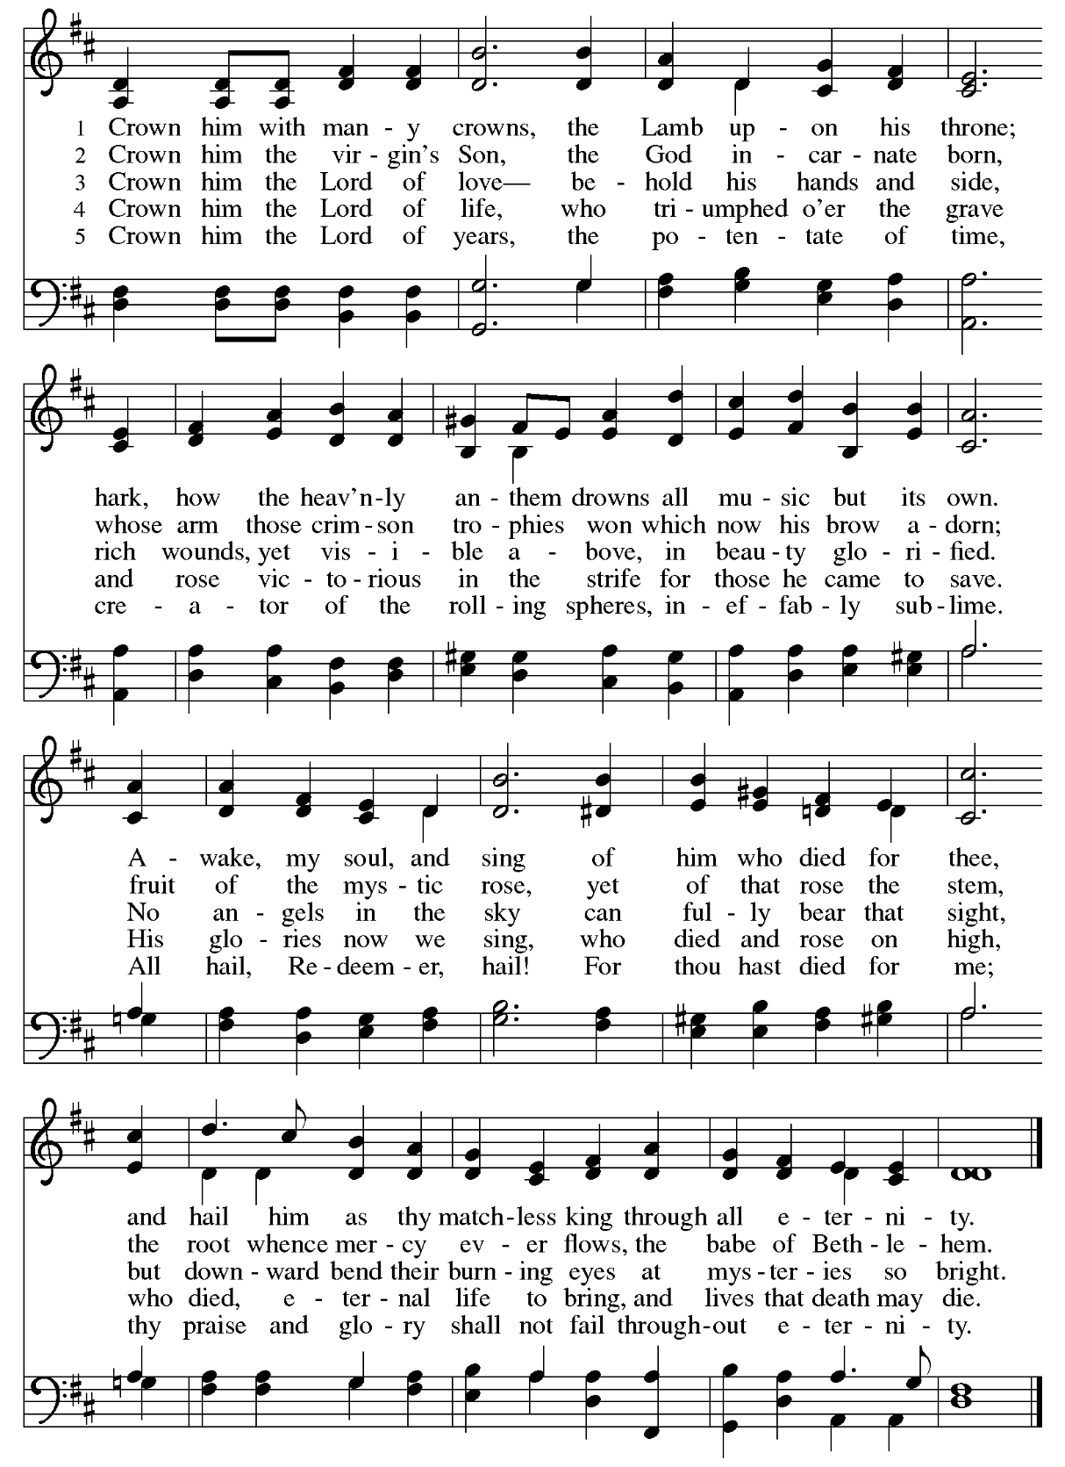

THANKSGIVING FOR BAPTISM

Let us give thanks for the gifts of baptism.

Merciful God,you are the one who was, who is, and who is to come.
You lead us beside still waters.
We thank you for the waters of creation:
morning dew, gentle rain, roaring waves.
We thank you for the waters that nourish us.
Blessed are you.
You guide us to springs of the water of life.

Jesus Christ, you are the faithful witness
who accompanies us on our journeys.
We give you thanks for your life-giving death and resurrection.
We praise you for joining us in joy and sorrow.
Blessed are you.
You guide us to springs of the water of life.

Holy Spirit, you anoint our head with oil and our cup overflows.
Break down barriers that divide us.
Fill us with the breath of peace.
Blessed are you.
You guide us to springs of the water of life.

Holy One, we thank you for the gifts and grace of baptism,and for making us a new creation.
We join with saints and angels, giving you honor and praise, now and forever. Amen.

REMINDER OF BAPTISM HYMN RED ELW #456 Baptized in Water
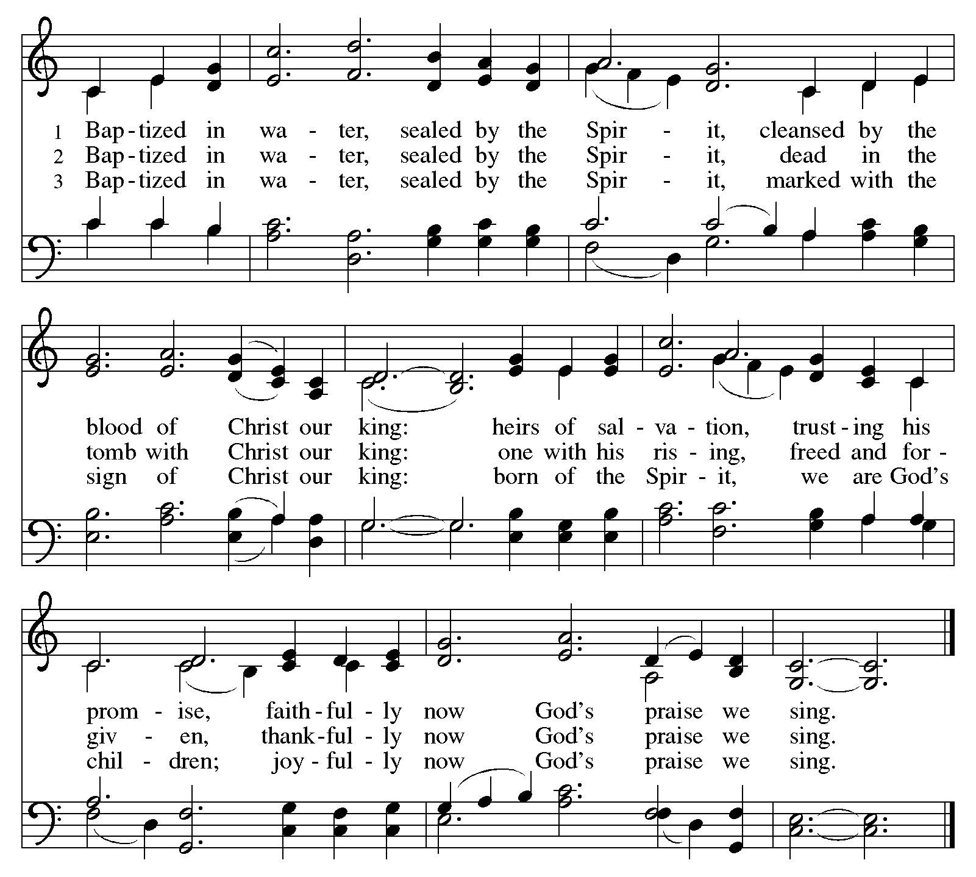

+GREETING
The grace of our risen Lord Jesus Christ, the love of God, and the communion of the Holy Spirit
be with you all. And also with you.

+PRAYER OF THE DAY
Let us pray. God of mercy, we no longer look for Jesus among the dead, for he is alive and has become the Lord of life. Increase in our minds and hearts the risen life we share with Christ, and help us to grow as your people toward the fullness of eternal life with you, through Jesus Christ, our Savior and Lord, who lives and reigns with you and the Holy Spirit, one God, now and forever. Amen.

FAITH MOMENT

FIRST SCRIPTURE READING………………………….……………………Psalm 118:1-2, 14, 19-24
Give thanks to the Lord, for the Lord is good;
God’s mercy endures forever.
Let Israel now declare,
“God’s mercy endures forever.”
The Lord is my strength and my song,
and has become my salvation.
Open for me the gates of righteousness;
I will enter them and give thanks to the Lord.
“This is the gate of the Lord;
here the righteous may enter.”
I give thanks to you, for you have answered me
and you have become my salvation.
The stone that the builders rejected
has become the chief cornerstone.
By the Lord has this been done;
it is marvelous in our eyes.
This is the day that the Lord has made;
let us rejoice and be glad in it.

GOSPEL ACCLAMATION RED ELW #535 (refrain 2x)

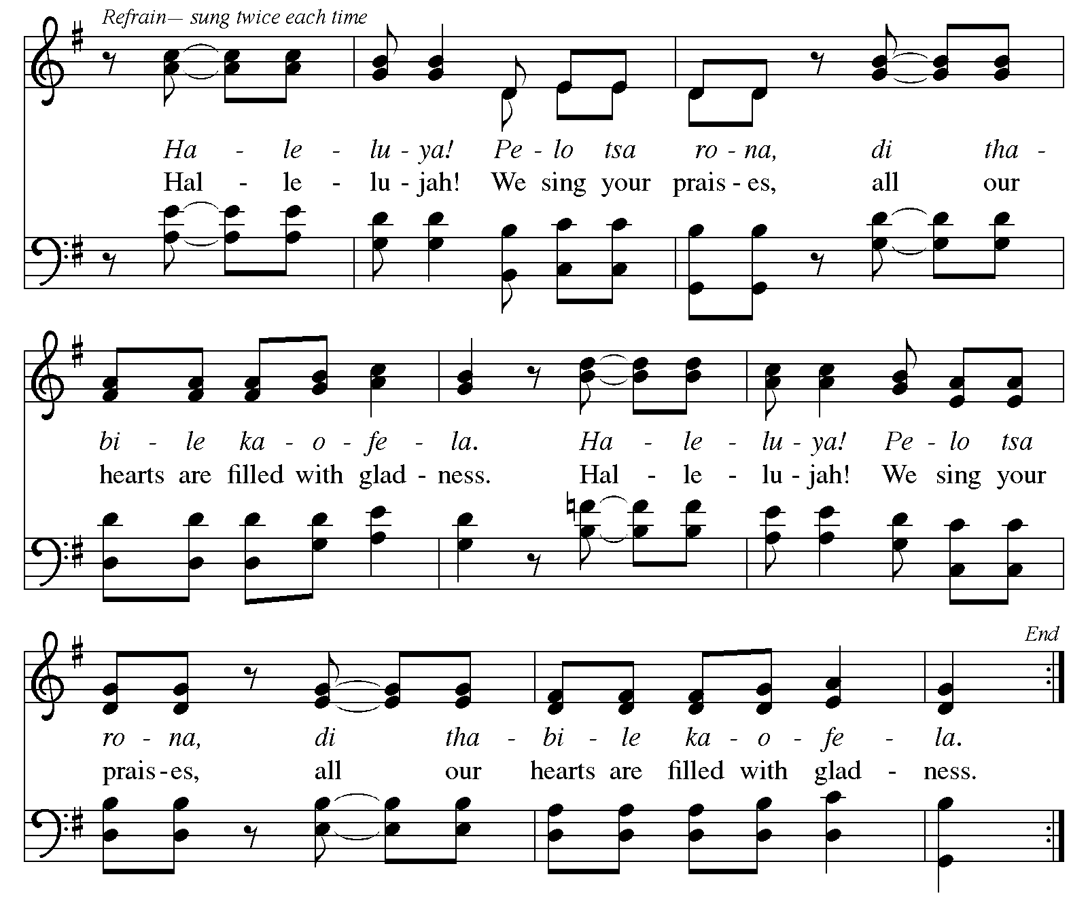

EASTER GOSPEL READING……………………………………...……………………..John 20:1-18

GOSPEL ACCLAMATION RED ELW #535 (refrain 2x) (see above)

SERMON

+HYMN OF THE DAY Red ELW #365 Jesus Christ is Risen Today

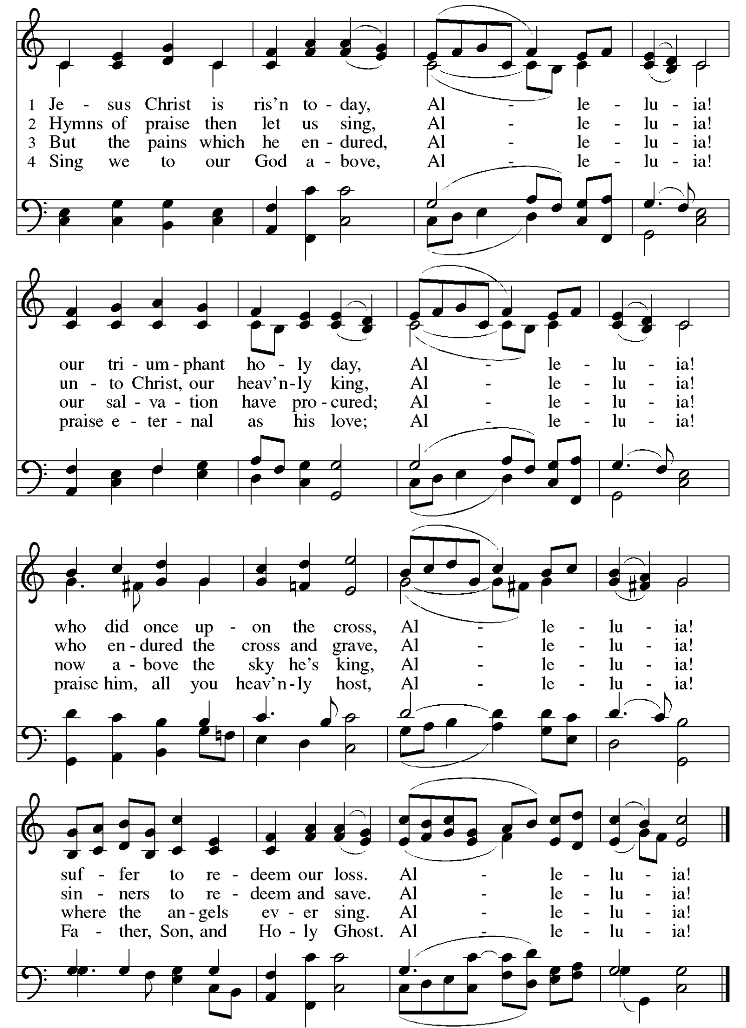

APOSTLES’ CREED
I believe in God, the Father Almighty,
creator of Heaven and Earth.
I believe in Jesus Christ, God’s only Son, our Lord,
who was conceived by the Holy Spirit,
born of the Virgin Mary,
suffered under Pontius Pilate,
was crucified, died and was buried;
he descended to the dead.
On the third day, he rose again;
he ascended into heaven,
he is seated at the right hand of the Father,
and he will come to judge the living and the dead.
I believe in the Holy Spirit,
the Holy Catholic Church,
the Communion of Saints,
the forgiveness of sins,
the resurrection of the body,
and the life everlasting.
Amen.

PRAYERS OF THE PEOPLE
Response- God of mercy and grace, We lift our prayers to you.

+SHARING OF CHRIST’S PEACE
The peace of Christ be with you always. And also with you.

OFFERING

SPECIAL MUSIC Sing We With A Merry Heart R. Wetzler
Sing we with a merry heart, for Christ is risen from the dead,
God raised him from the tomb in three days time as he has said.
Suffering and death are conquered, he of all is now the head,
Sing we with a merry heart for Christ is risen from the dead.
Shout we with a lusty cry that death is broken on this day,
Blow the horn, and sound the trumpet; he took sin away.
Free by his death for us, our hearts are full, our hearts are gay,
Shout with a lusty cry, shout we on this day.
Sing we with a merry heart for God has giv’n to us his Son,
The pain of Calv’ry which he bore instead of us is done.
The tomb is empty, bare, and clean; his Church is now begun,
Sing we with a merry heart, God has won.
Sing we with a merry heart for Christ has risen from the dead,
God raised him from the tomb in three days time as he had said.

+OFFERTORY RESPONSE
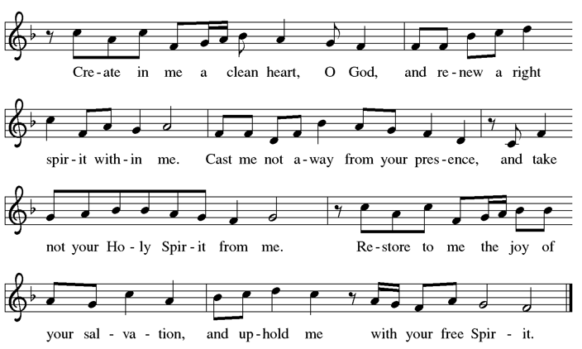

+OFFERTORY PRAYER
Let us pray. Risen One, with gratitude and boundless joy we offer our gifts to you. Use them for the sake of your good work in the world, that all might know and celebrate your incredible life and love. We pray in Jesus’ name. Amen.

+HOLY COMMUNION
The Lord be with you.
And also with you.
Lift up your hearts.
We lift them to the Lord.
Let us give thanks to the Lord our God.
It is right to give our thanks and praise.
This is the day that you have made, O God.
a day of joy and gladness for all creation.
For early in the morning Mary came to the garden,
and the stone had been rolled away.
In her grief you met her with new life,
calling her by name,
and sending her to proclaim the good news:
“I have seen the Lord.”
This is the day you have made.
The stone the builders rejected has become the cornerstone.
The stone of death has been rolled away,
and your mercy endures forever.
Joy and gladness are our song, redeeming God,
for in the death and rising of Jesus
we see the promise of every hope placed in you.
Hope and glory are our breath, merciful God,
for you have rolled away the stone;
the stone of despair,
the stone of oppression,
the stone of lament,
the stone of grief,
the stone of fear,
the stone of sin,
the stone of death.
Come among us in the power of your Holy Spirit.
Stand among us as the risen Christ stood among his disciples.
Breathe on us your peace.
Breathe on us your courage.
Breathe on us your new life.

That this bread and cup may become for us
the body and blood of Jesus Christ,
who on the night before he died took bread, gave thanks,
broke it, and gave it to his disciples, saying:
Take and eat; this is my body, given for you.
Do this for the remembrance of me.
Again, after supper he took the cup, gave thanks,
and gave it for all to drink, saying:
This cup is the new covenant in my blood,
shed for you and for all people for the forgiveness of sin.
Do this for the remembrance of me.
Great is the mystery of faith:
Christ has died.
Christ is risen.
Christ will come again.

Send now your Holy Spirit upon us, O God.
Revive us with the body and blood of our risen Savior.
Shape your church to be the body of the risen Christ.
Make our scars beautiful like his scars.
Make our lives life-giving like his life.

And let all who labor, all who stumble,
all who hunger, and all who fall
meet Christ in the breaking of the bread
and be lifted up by his touch.
Keep us in communion with all your saints
until the day when we share the feast of your kingdom.
All holy and gracious God,
Creator, Redeemer, and Sustainer,
we bless your salvation,
we sing of your mercy,
and we praise your victory through all time and space.
For Christ is risen.
Christ is risen indeed. Amen.

+LORD’S PRAYER
Let us pray as Jesus first taught us:
Our Father in heaven,
hallowed be your name,
your kingdom come,
your will be done,
on earth as in heaven.
Give us today our daily bread
Forgive us our sins
as we forgive those
who sin against us.
Save us from the time of trial
and deliver us from evil.
For the kingdom, the power,
and the glory are yours,
now and forever.
Amen.

+INVITATION TO COMMUNION
Come to the table of new life.
Receive the risen Lord.

COMMUNION DISTRIBUTION & HYMNS
All are welcome to receive communion at Valley of Peace. We serve communion every Sunday by intinction. After the pastor speaks the words of distribution to online worshipers, the ushers will then invite worshipers physically present to receive communion.

If you are receiving communion by intinction, there will be bread and gluten-free wafers available. As you come forward to receive communion, a communion server will serve you your preference. Please take the bread or wafer and dip it into your preference of either wine or juice. The first chalice will contain red wine and the second chalice will contain white grape juice.

If you prefer to not receive communion by intinction there are pre-packaged communion kits with a gluten-free wafer and grape juice. You may pick this up on your way to communion. If you prefer not to receive communion at all, please come forward with your hands across your chest and you will receive a blessing. If you are unable to come forward or do not want to be visible on the live-stream, please let an usher know and communion will be brought to you.

Red ELW #382 Christ is Risen! Alleluia!
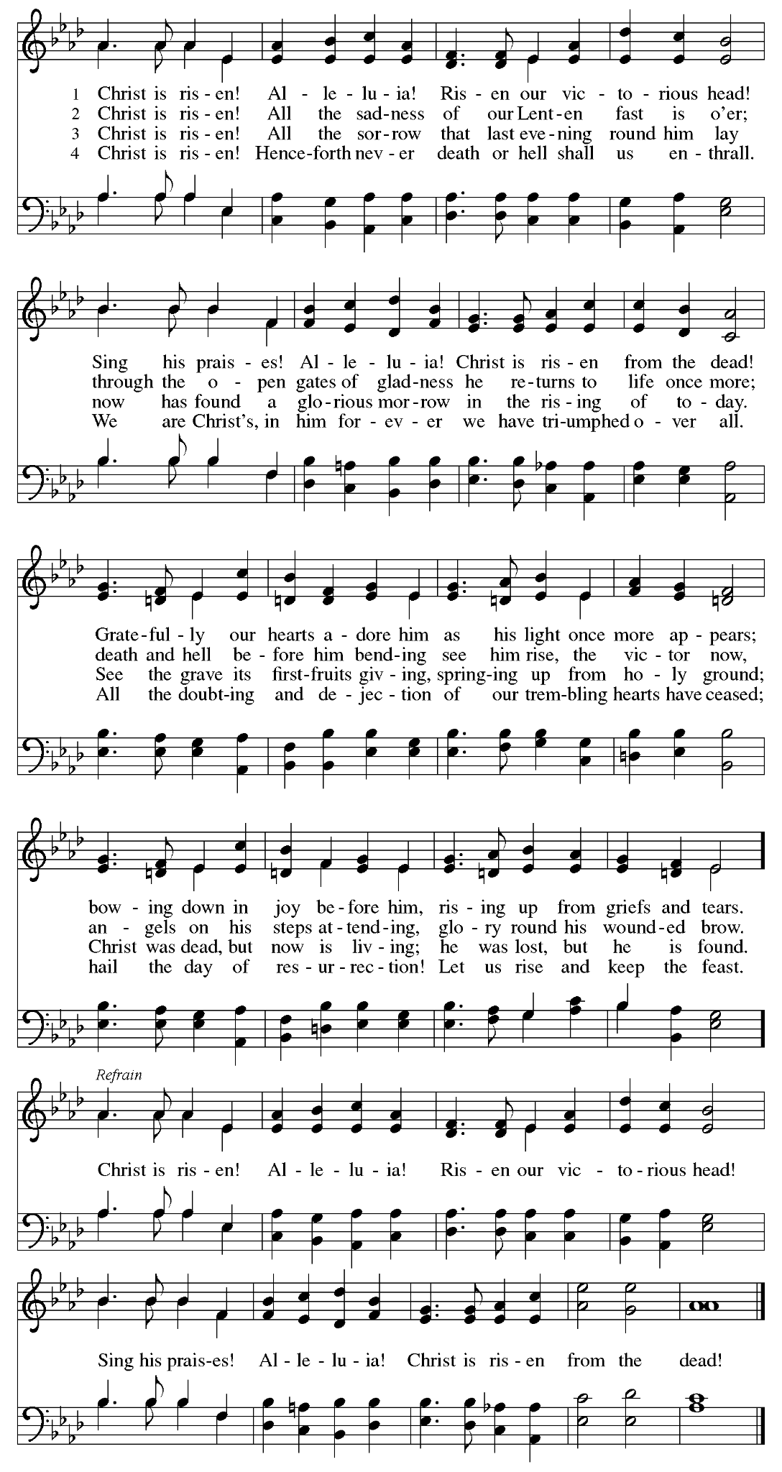

Red ELW #364 Christ Has Arisen, Alleluia
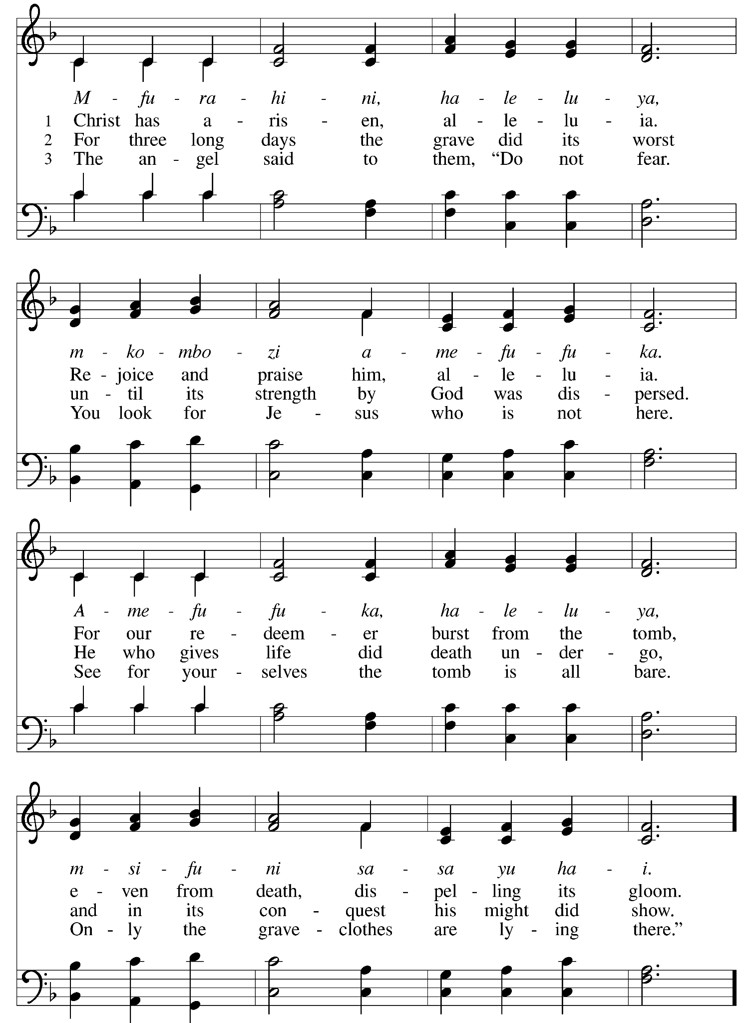

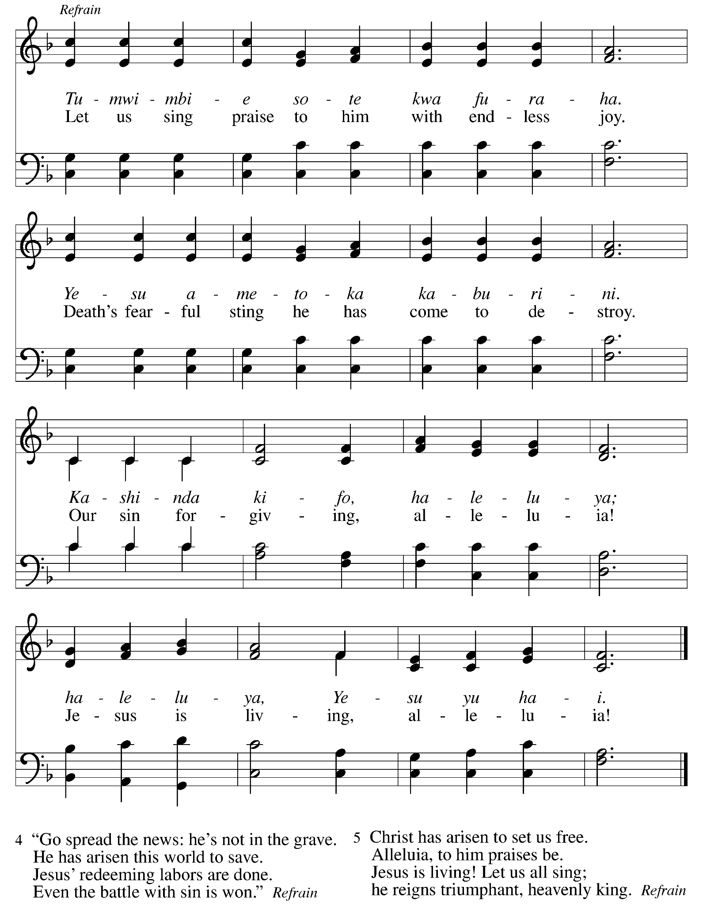

Red ELW #389 Christ is Alive! Let Christians Sing
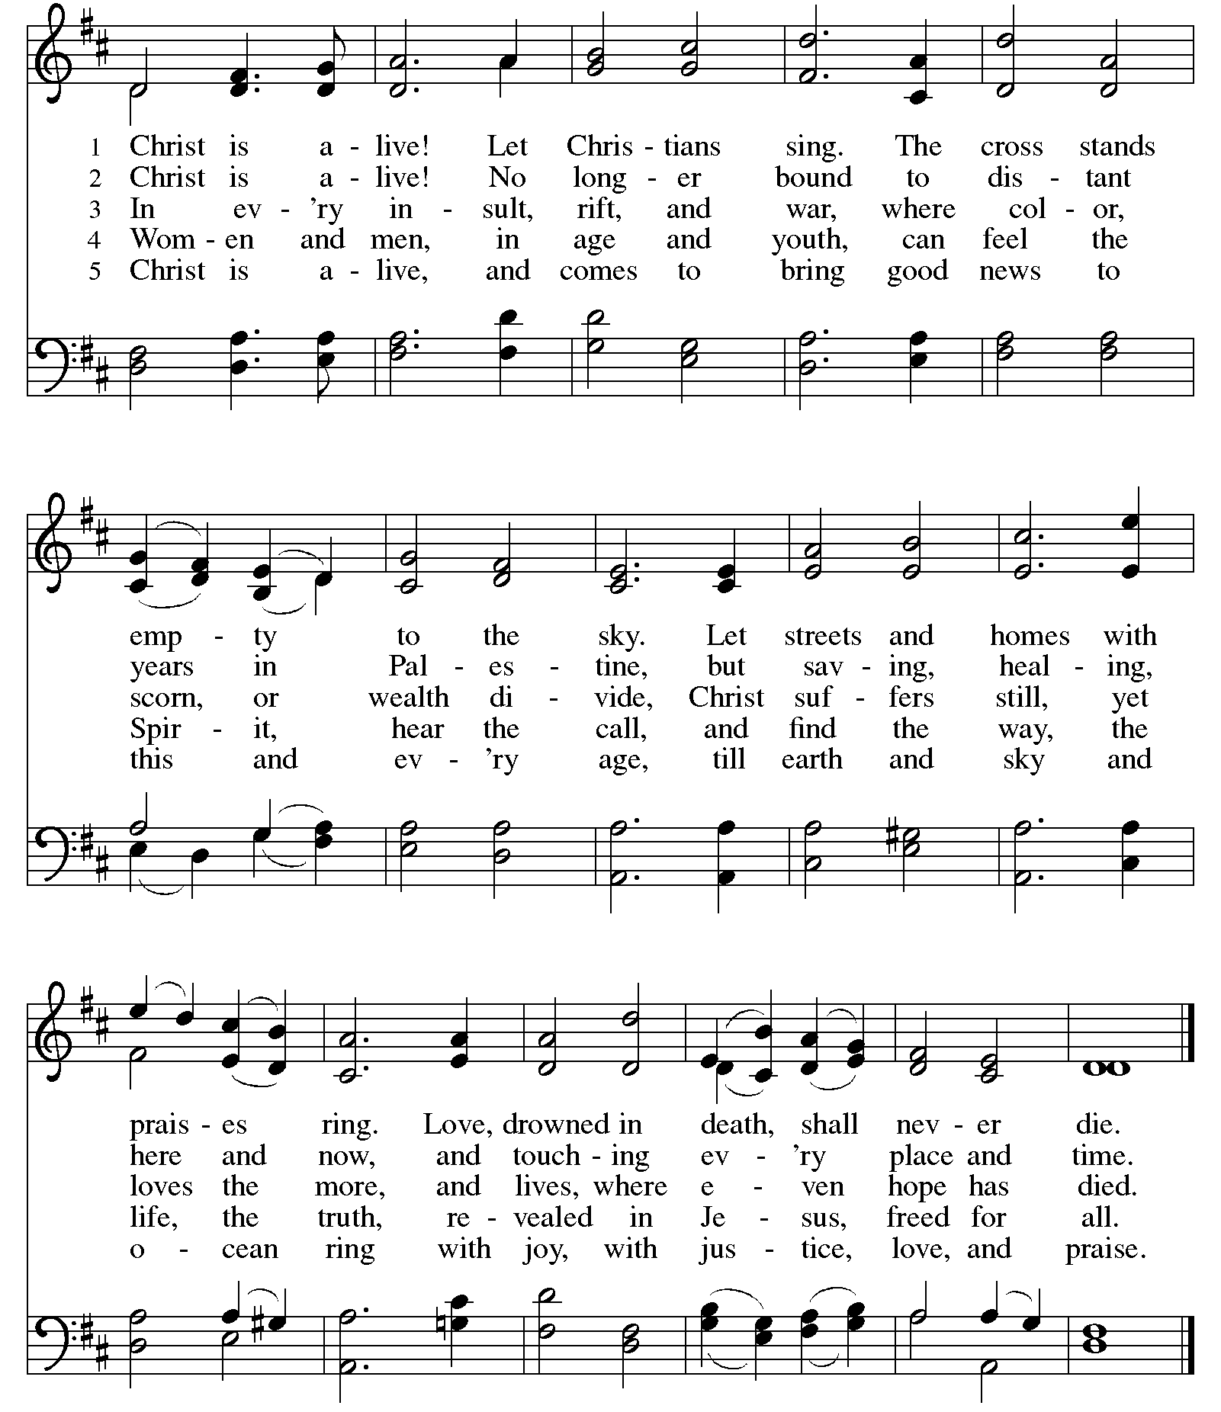
+COMMUNION BLESSING

+PRAYER AFTER COMMUNION
Holy One, through this meal you have made your home among us and are making all things new. Send us now to speak peace to anxious hearts, to love our enemies, and to bring your healing to the nations. In the name of Jesus, Amen.

+BLESSING

+SENDING HYMN Red ELW #376 Thine is the Glory
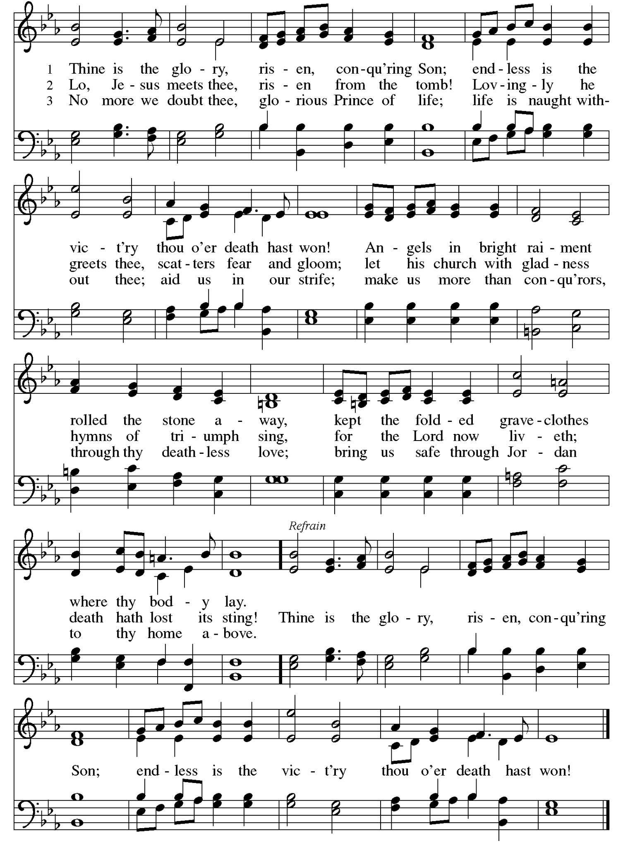
+DISMISSAL
Alleluia! Christ is risen. Christ is risen indeed! Alleluia!
Go in peace. In Christ you are made new. Alleluia! Alleluia!
Thanks be to God! Alleluia! Alleluia!

POSTLUDE He’s Risen, He’s Risen Kenneth T. Kosche

Words for worship used by permission under Augsburg Fortress Liturgies Annual License #SAS103663 and Clergy Stuff Resources.
Bible readings from New Revised Standard Version Bible, Copyright 1989.
Music printed and live-streamed with permission from One License #A719979 and CCLI License #2176842.

Worship Volunteers
 | Sun. April 5, 2026 at 10:15 am  Easter Sunday | Sun. April 12, 2026 at 10:15 am | Sun. April 19, 2026 at 10:15 am
Presider/Preacher | Pastor Ashley Osborn | Pastor Wes Syverson | Pastor Laurie Eaton
Opener/Closer | Ruth Larson & Jon Larson | OPEN | Jim Jasper
Greeter | Elaine Lofquist | Linda Franz | Kathy Boesen
CYF Greeter | Darcie Rodman | Lona Froyum | Shennon Jay
Welcome Center | Sally Daniels Herron | Abby Stetler, Matthew Stetler & Audrey Stetler | Diane Hinderlie
Ushers | Dee Kendall, Wes Syverson,  Ann Dybvig & Andy Dybvig | Sally Daniels Herron,  Casey Balint, Skip Humphrey  & Sten Pearson | Lauren Pockl, Shannon Jay,  Dee Kendall & Heidi Boesen
Worship Assistant | Tara Kuckkan | Kirsten Kessel | Sara Hoge
Reader | Barb Mikelson | OPEN | Sally Daniels Herron
Communion Servers | Ruth Larson, Jon Larson,  Laurie Eaton & Mary Hovden | Gina Privratsky,  Diane Hinderlie, Barb Mikelson & Paul Mikelson | Anna Campbell, Darcie Rodman, Melissa Dellwo & Dan Johnson
Faith Moment | Dan Miller | Jon Larson | Barb Mikelson
Technology | Naomi Dybvig | Melissa Dellwo | Pam Syverson
Coffee Cart | Chrys Johnson | Jim Jasper | Lisa Rothschild
Altar Care | Claudia Aronsohn | Claudia Arohnson | Claudia Arohnson


Reconciling In Christ Statement

We recognize that each person is a unique creation of God and, by grace, is called a child of God, without exception and regardless of gender, race, national origin, sexual orientation, gender identity, physical or mental ability, age, station in life, or political affiliation.

For more information and a calendar of activities visit www.valleyofpeace.org

