


Welcome to Valley of Peace.
We are glad you are here.

We give thanks to God for all people and want all people to feel comfortable participating in worship. If you need any assistance, please let our Ushers know. We are happy to offer hearing assistance devices, move chairs to make worship feel more accessible for you, and offer any other support that would be meaningful for you in this space.

All ages are welcome to worship at Valley of Peace and we give thanks for the voices of our littlest ones. If you feel that your little one is wiggly, you are welcome to go with them to stretch their legs in the Narthex where there is a small area with books and toys and you can hear the worship service. There are also bags available for you to put toys and books in and bring them into the sanctuary space.

And again, welcome to worship this day. This is the day the Lord has made, let us rejoice and be glad in it.

Interested in becoming a Member? Let Pastor Ashley know by October 5, 2026.
Our next New Member Class is: Sunday, October 11, 2026 after worship.

--------------------------------------------------------------------------------

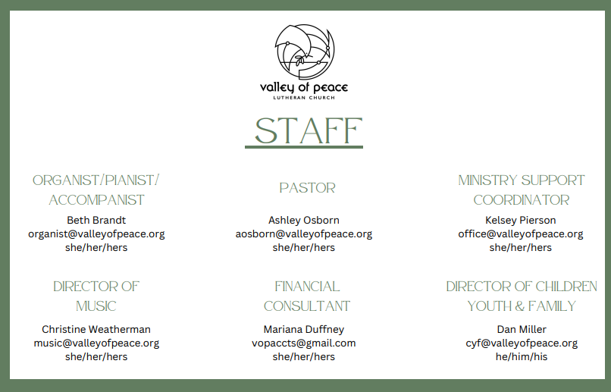

Reconciling In Christ Statement

We recognize that each person is a unique creation of God and, by grace, is called a child of God, without exception and regardless of gender, race, national origin, sexual orientation, gender identity, physical or mental ability, age, station in life, or political affiliation.


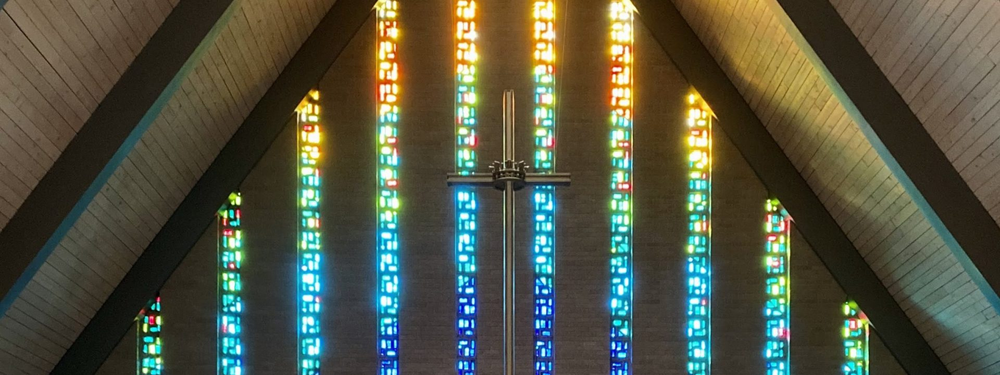
Valley of Peace Lutheran Church
Palm Sunday - March 29, 2026
10:15 am

Palm Sunday marks the beginning of Holy Week.
Today we remember Jesus’ triumphant entry into Jerusalem. The people of Jerusalem shout cries of “Hosanna!” and it is a cry for help; the Hebrew word “Hosanna” means “Save us, now!” At first, the crowds celebrate the saving presence of Jesus but, in a matter of days, the same shouts of joy will turn into cries of condemnation as Jesus is betrayed and crucified by the people. We remember the human capacity and complexity to love as well as create pain.

You are invited to participate in worship by reading the BOLD print. When you see +, please stand in body or in spirit.
ELW is the red hymnal and ACS is the purple hymnal, both located in the bottom of the pew in front of you.
If you need any assistance, please ask an usher.

GATHERING MUSIC Hosanna, Loud Hosanna Pierre La Plante

WORDS OF WELCOME

PRELUDE Prelude in Bb Major J. Zangl

NEW MEMBER WELCOME

SPECIAL MUSIC Ho Ho Ho Hosanna Children of VOP

PALM SUNDAY SCRIPTURE READING: Matthew 21:1-11 from the Children’s Spark Story Bible
FAITH MOMENT

+BLESSING OF THE PALMS
Blessed is the one who comes in the name of the Lord! Hosanna in the highest!
The Lord be with you. And also with you.
Let us pray. We praise you, O God, for redeeming the world through our Savior Jesus Christ. Today he entered the holy city in triumph and was proclaimed messiah and king by those who spread garments and branches along his way. Bless these branches and those who carry them. Grant us grace to follow our Lord in the way of the cross, so that, joined to his death and resurrection, we enter into life with you; through the same Jesus Christ, who lives and reigns with you and the Holy Spirit, one God, now and forever. Amen.
Blessed is the one who comes in the name of the Lord! Hosanna in the highest!

+PROCESSION & HYMN RED ELW #344 All Glory Laud and Honor
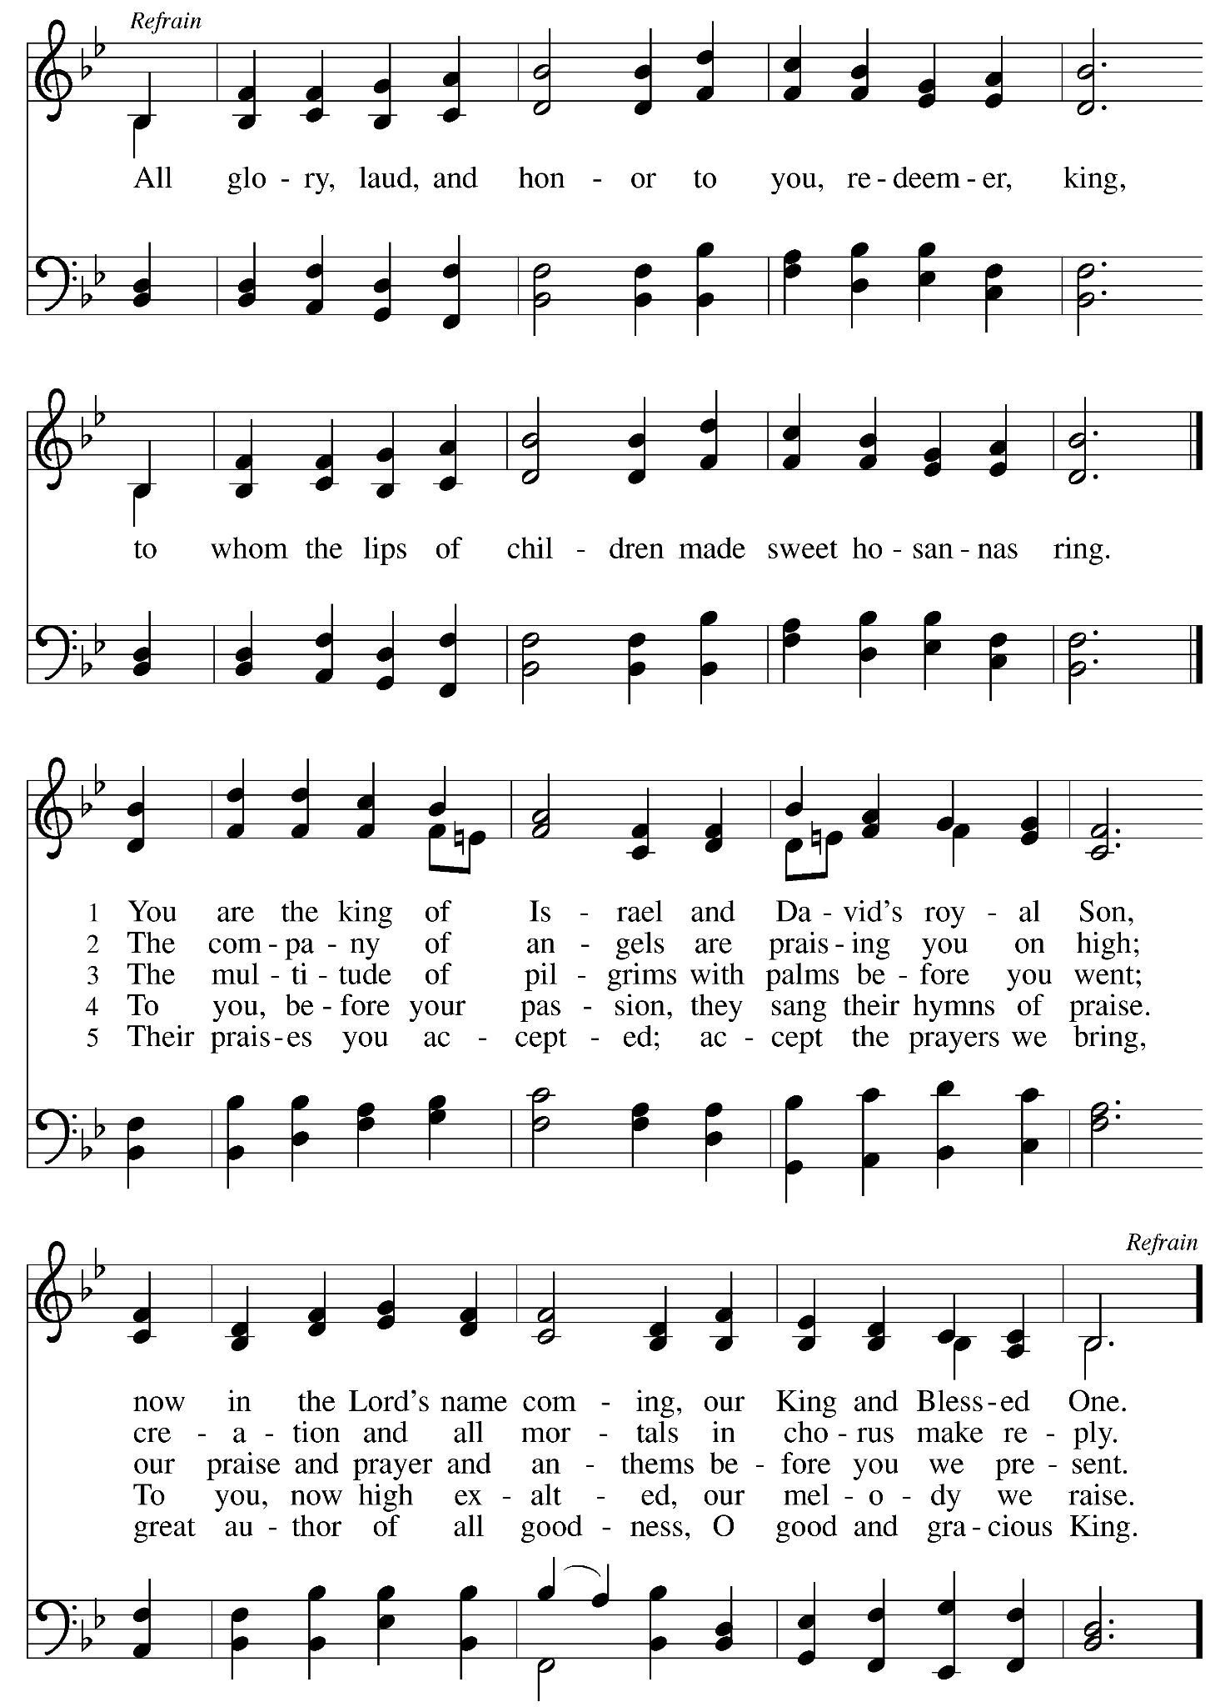
+GREETING
The grace of our Lord Jesus Christ, the love of God,
and the communion of the Holy Spirit be with you all.
And also with you.

+PRAYER OF THE DAY
Righteous God, you brought your son Jesus into Jerusalem to show people the radical grace of your love. Show us this grace, and give us eyes to see your goodness. We pray these things in the name of Jesus Christ, our Savior and Lord. Amen.

REFLECTION

READERS THEATRE PART 1
Donkey Seller: Kari Roll
Disciple: Dan Miller

+HYMN OF THE DAY RED ELW #197 Hosanna, Loud Hosanna
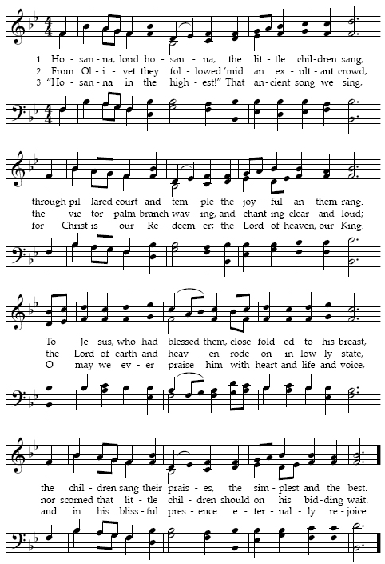

PRAYERS OF THE PEOPLE
Response- God of mercy and grace, We lift our prayers to you.

+SHARING OF CHRIST’S PEACE
The peace of Christ be with you always. And also with you.

READERS THEATRE PART 2
Roman Soldier: Dave Gilyard
Child: Nelson Queitzsch

OFFERING Hosanna to the Son E. Harris

Hosanna to the Son, Hosanna to the Son of David,
hosanna to the Holy One; hosanna to the Son,
the long awaited One, hosanna to the Holy Son.

O blessed is He that cometh in the name of the Lord;
O blessed is He that cometh in the name of the Lord,
O blest is He, blest is He, Hosanna in the highest, hosanna.

+OFFERTORY RESPONSE Create in Me a Clean Heart
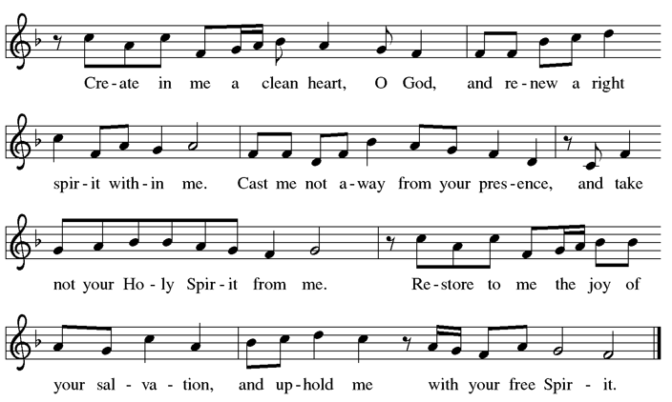

+OFFERTORY PRAYER
O God, maker of heaven and earth, your steadfast love embraces all creation. You send rain and sunshine to nourish the earth and bring forth its bounty. Through these gifts of bread and wine, draw us into the death and life of your Son, who calls us to bear witness to his saving work. We ask this in Jesus’ name. Amen.

READERS THEATRE PART 3
Pontius Pilate: Steve Collin
Parent: Mandy Queitzsch

+HOLY COMMUNION
The Lord be with you. And also with you.
Lift up your hearts. We lift them to the Lord.
Let us give thanks to the Lord our God. It is right to give our thanks and praise.

Hosanna is our cry, Blessed One.
Your Son comes on a donkey in your name.
As Jesus entered Jerusalem to bear our sorrows and suffer for our sins, enter our hearts and confront our waywardness today.
Send your Holy Spirit upon us, that we may be your Son’s crucified and risen body.
Send your Spirit upon this bread that it may be living bread, and on this wine that it may be the cup of salvation, that together they may be for us the body and blood of your Son Jesus Christ; who, at supper with his disciples, took bread, gave you thanks, broke the bread, and gave it to them, saying, “Take, eat: this is my body which is given for you; do this in remembrance of me.”

Again he gave you thanks, and gave it to his disciples, saying, “Drink this, all of you: this is my blood of the new covenant, which is shed for you and for many for the forgiveness of sins. Do this, as often as you drink it, in remembrance of me.”

Great is the mystery of faith.
Christ has died; Christ is risen; Christ will come again.

Humble God, your Son did not exploit his status but emptied himself. Pour out your Spirit on all who are exploited, in the world or church, on all who are humbled, by status or employer or family member, on all who are emptied of hope, faith, or love.

As you highly exalted your Son who had become a servant, highly exalt your children who suffer for righteousness, or grieve those they have cherished, or bend the knee to one who does not honor them.

Fill the earth with your justice and peace, until every heart shall sing and every tongue confess that you are the joy of their desiring Creator, Redeemer and Sustainer, ever one God, in all ages and forever. Amen.

+LORD’S PRAYER
Let us pray as Jesus first taught us:
Our Father in heaven,
hallowed be your name,
your kingdom come,
your will be done,
on earth as in heaven.
Give us today our daily bread
Forgive us our sins
as we forgive those
who sin against us.
Save us from the time of trial
and deliver us from evil.
For the kingdom, the power,
and the glory are yours,
now and forever. Amen.

+INVITATION TO COMMUNION
This is the body of Christ, given for you. This is the cup of grace, poured out for you. Come with
empty hands. Come with honest hearts. Come, and be renewed for the way ahead.

COMMUNION DISTRIBUTION & HYMNS

All are welcome to receive communion at Valley of Peace. We serve communion every Sunday by intinction. After the pastor speaks the words of distribution to online worshipers, the ushers will then invite worshippers physically present to receive communion.

If you are receiving communion by intinction, there will be bread and gluten-free wafers available. As you come forward to receive communion, a communion server will serve you your preference. Please take the bread or wafer and dip it into your preference of either wine or juice. The first chalice will contain red wine and the second chalice will contain white grape juice.

If you prefer to not receive communion by intinction there are pre-packaged communion kits with a gluten-free wafer and grape juice. You may pick this up on your way to communion. If you prefer not to receive communion at all, please come forward with your hands across your chest and you will receive a blessing. If you are unable to come forward or do not want to be visible on the live-stream, please let an usher know and communion will be brought to you.

RED ELW #359 Where Charity and Love Prevail
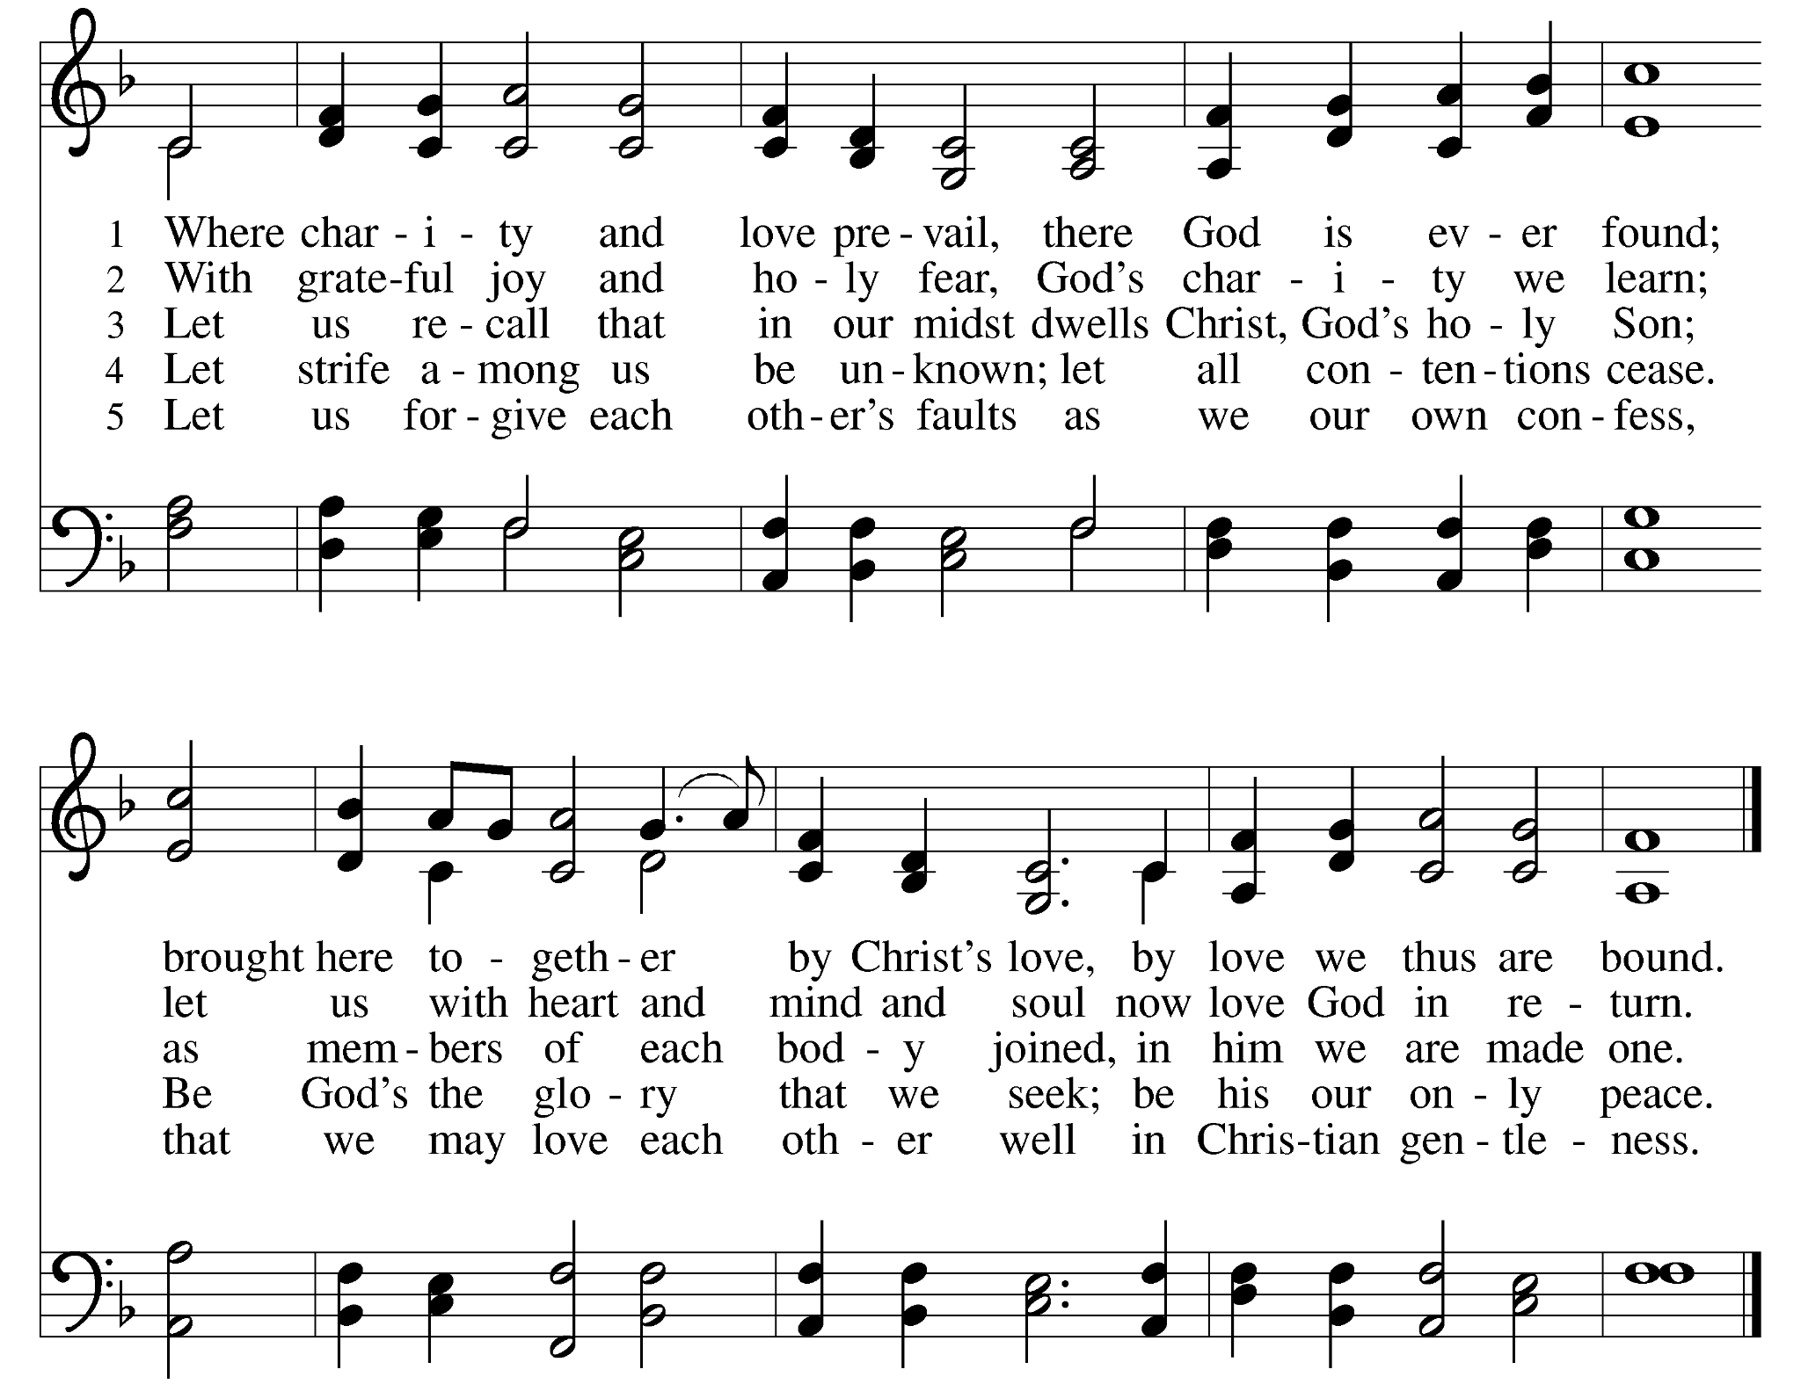

RED ELW #474 Bread of Life from Heaven
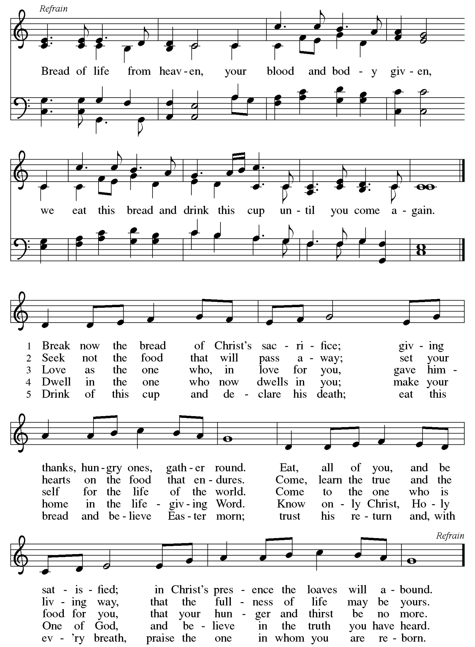

+COMMUNION BLESSING

+PRAYER AFTER COMMUNION
Compassionate God, you have fed us with the bread of heaven. Sustain us in our Lenten pilgrimage: may our fasting be hunger for justice; our alms a making of peace; and our prayer the song of grateful hearts, through Jesus Christ our Savior and Lord. Amen.

+PALM SUNDAY SENDING LITURGY
O give thanks to God, for God is good.
God’s steadfast love endures forever!
Blessed is the one who comes in the name of our God.
Hosanna in the highest heaven!
Let us sing praises to our God.
With all creation we cry out in joy.
Jesus fulfills God’s promises to us.
Hosanna to our blessed Savior!

READERS THEATRE PART 4
Pharisee: Paul Mikelson

+BLESSING

+SENDING HYMN RED ELW #723 Canticle of the Turning

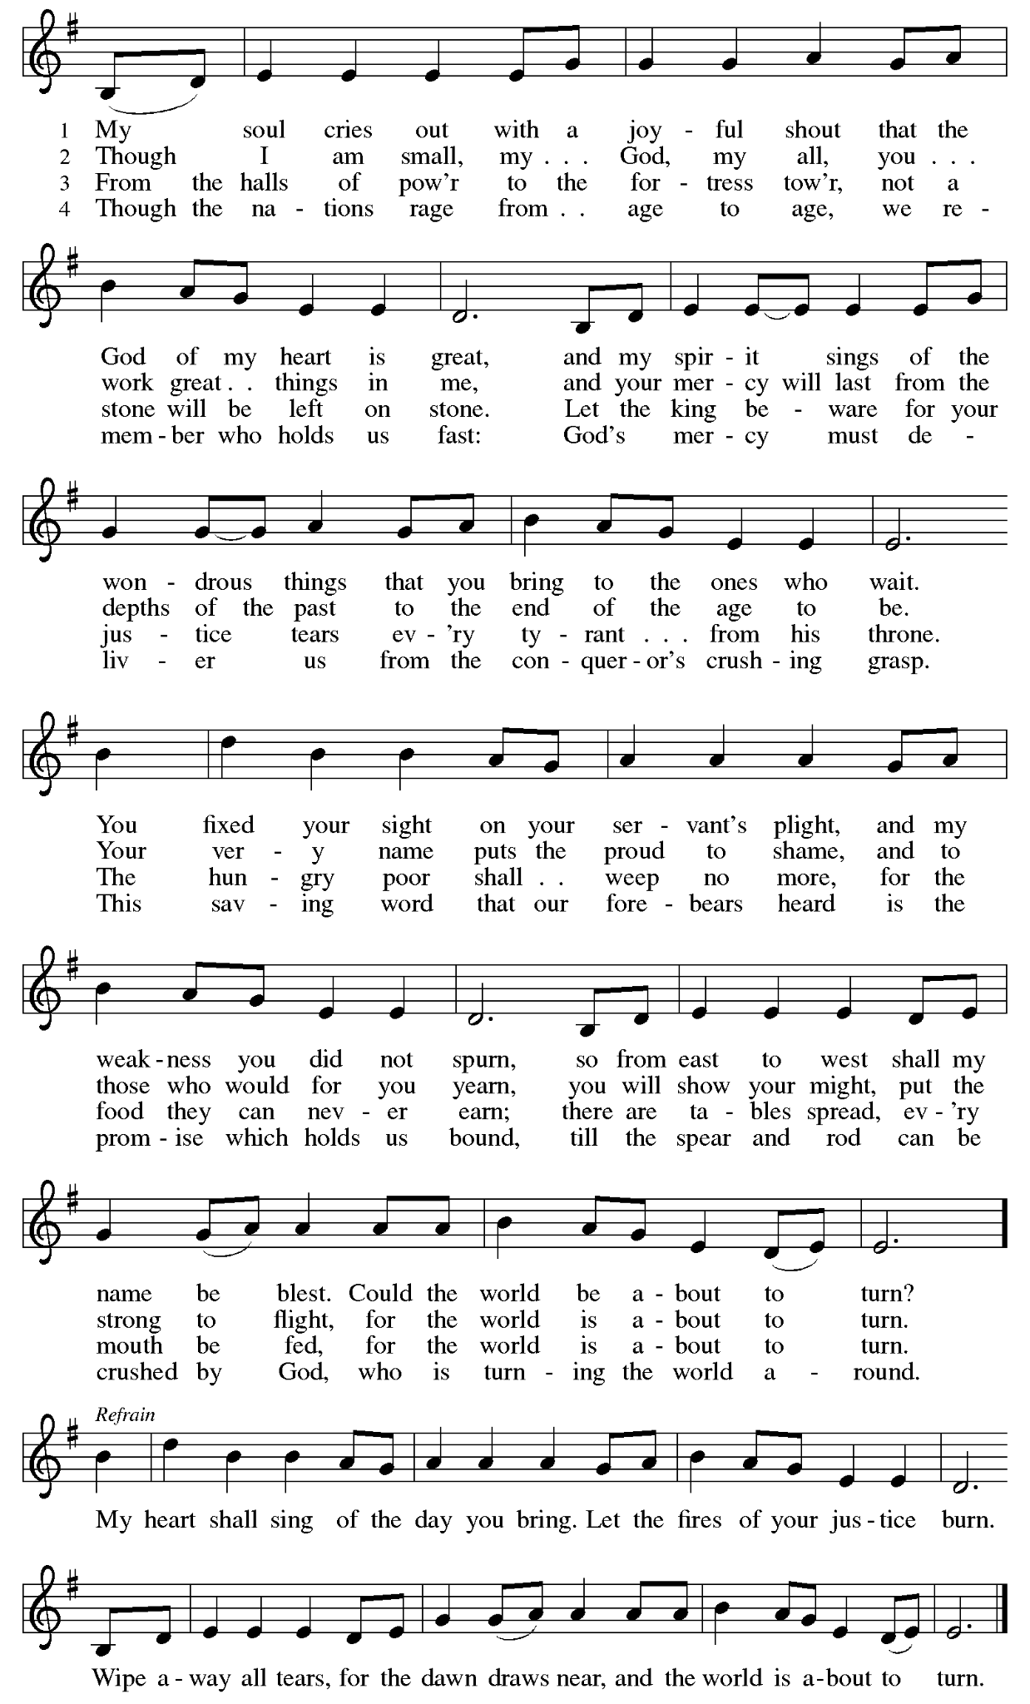

+DISMISSAL
Go in peace. Believe the good news. Thanks be to God!

POSTLUDE All Glory, Laud, and Honor arr. Cindy Berry

Words for worship used by permission under Augsburg Fortress Liturgies Annual License #SAS103663 and Clergy Stuff Resources. Bible readings from New Revised Standard Version Bible, Copyright 1989.Music printed and live-streamed with permission from One License #A719979 and CCLI License #2176842.

Our Holy Week journey continues with Maundy Thursday Worship
at 6:30 pm on Thursday, April 2.

Valley of Peace Lutheran Church
Maundy Thursday - April 2, 2026
6:30 pm


Maundy Thursday is the day on which we remember Jesus’ final night with his disciples prior to his betrayal and arrest. The name Maundy Thursday comes from the Latin word mandatum, which means mandate, or command. Today we reflect on the mandatum nova- the new command:
“A new command I give you: Love one another, as I have loved you, so you must love one another. By this everyone will know that you are my disciples, if you love one another.” (John 13:34-35)
Jesus gives this command during the Lord’s Supper, just after washing the disciples’ feet and declaring to them that they are to follow his example in serving one another.

You are invited to participate in worship by reading the BOLD print. When you see +, please stand in body or in spirit.
ELW is the red hymnal and ACS is the purple hymnal, both located in the bottom of the pew in front of you.
If you need any assistance, please ask an usher.

GATHERING MUSIC Gethsemane David Paxton

WORDS OF WELCOME

PRELUDE Andante in G Minor Ch. H. Rinck

+OPENING HYMN RED ELW #349 Ah Holy Jesus
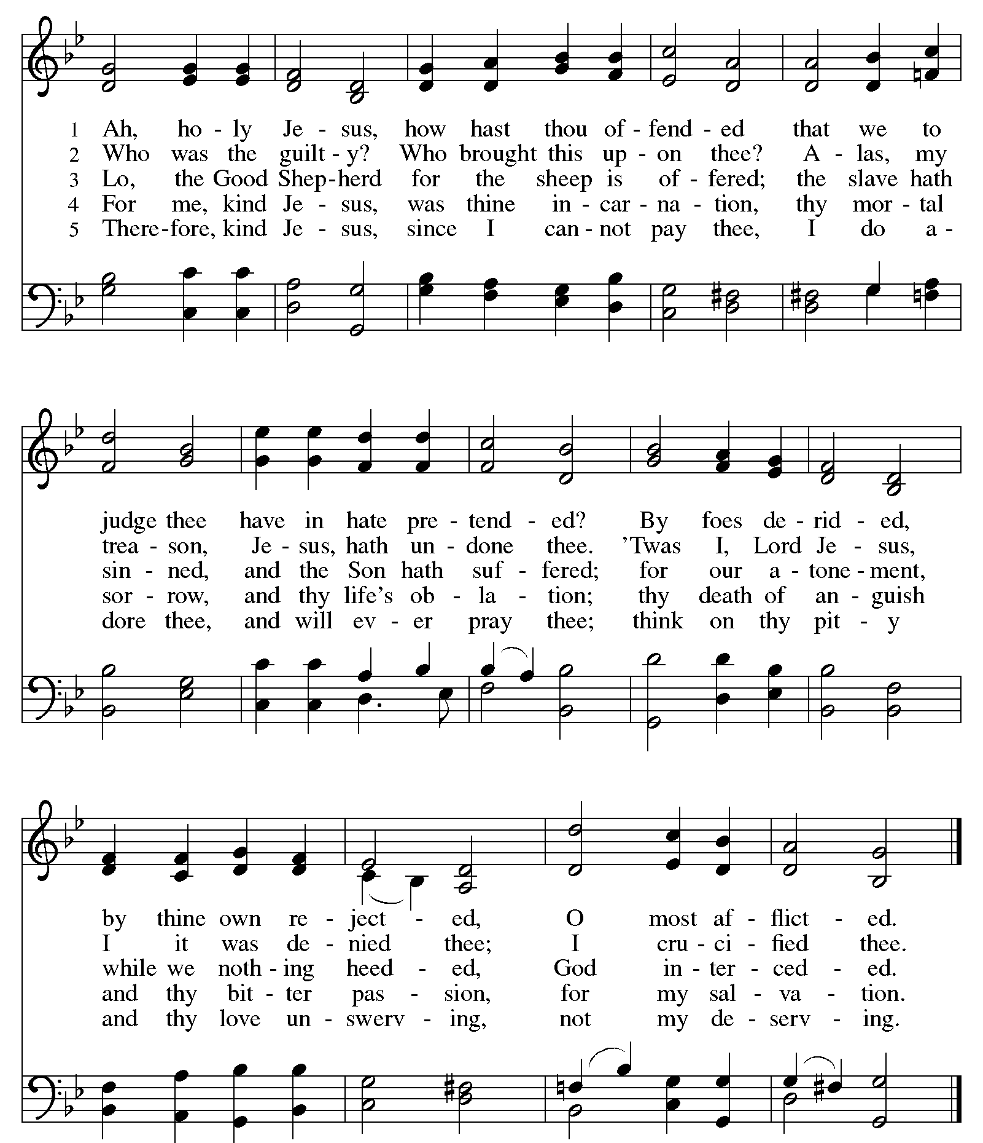

+CONFESSION & FORGIVENESS
Friends in Christ, in this Lenten season we have heard our Lord’s call to struggle against sin, death,
and the devil - all that keeps us from loving God and loving each other. This is the struggle to which we were called at baptism.
Within the community of the church, God never wearies of forgiving sin and giving the peace of reconciliation. On this night let us confess our sin against God and our neighbor, and enter the celebration of the great Three Days reconciled with God and with one another.

Most merciful God,
We confess that we are captive to sin and cannot free ourselves. We have sinned against you in thought, word, and deed by what we have done and by what we have left undone. We have not loved you with our whole heart; we have not loved our neighbors as ourselves.

For the sake of your Son, Jesus Christ, have mercy on us. Forgive us, renew us, and lead us, so that we may delight in your will and walk in your ways, to the glory of your holy name. Amen.

In the mercy of almighty God, Jesus Christ was given to die for us, and for his sake God forgives us all our sins. As a called and ordained ministry of the church of Christ, and by his authority, I therefore declare to you the entire forgiveness of all your sins, in the name of the Father, and of the ☩ Son, and of the Holy Spirit. Amen.

In obedience to the command of our Lord Jesus Christ, I forgive you all your sins.

+GREETING
The grace of our Lord Jesus Christ, the love of God, and the communion of the Holy Spirit be
with you all. Amen.

+PRAYER OF THE DAY
Let us pray. Holy God, on this night you draw us to the table with bread and cup, knowing our fear, our faith, and our fragility. As you give yourself for us, open our hearts to receive your grace, bind us together as one body, and teach us to follow you in love that serves and does not turn away. Through Jesus Christ, our Lord. Amen.

SCRIPTURE READING…………………………………………………………………Mark 14:12-26

SERMON

+HYMN OF THE DAY RED ELW #461 All Who Hunger, Gather Gladly
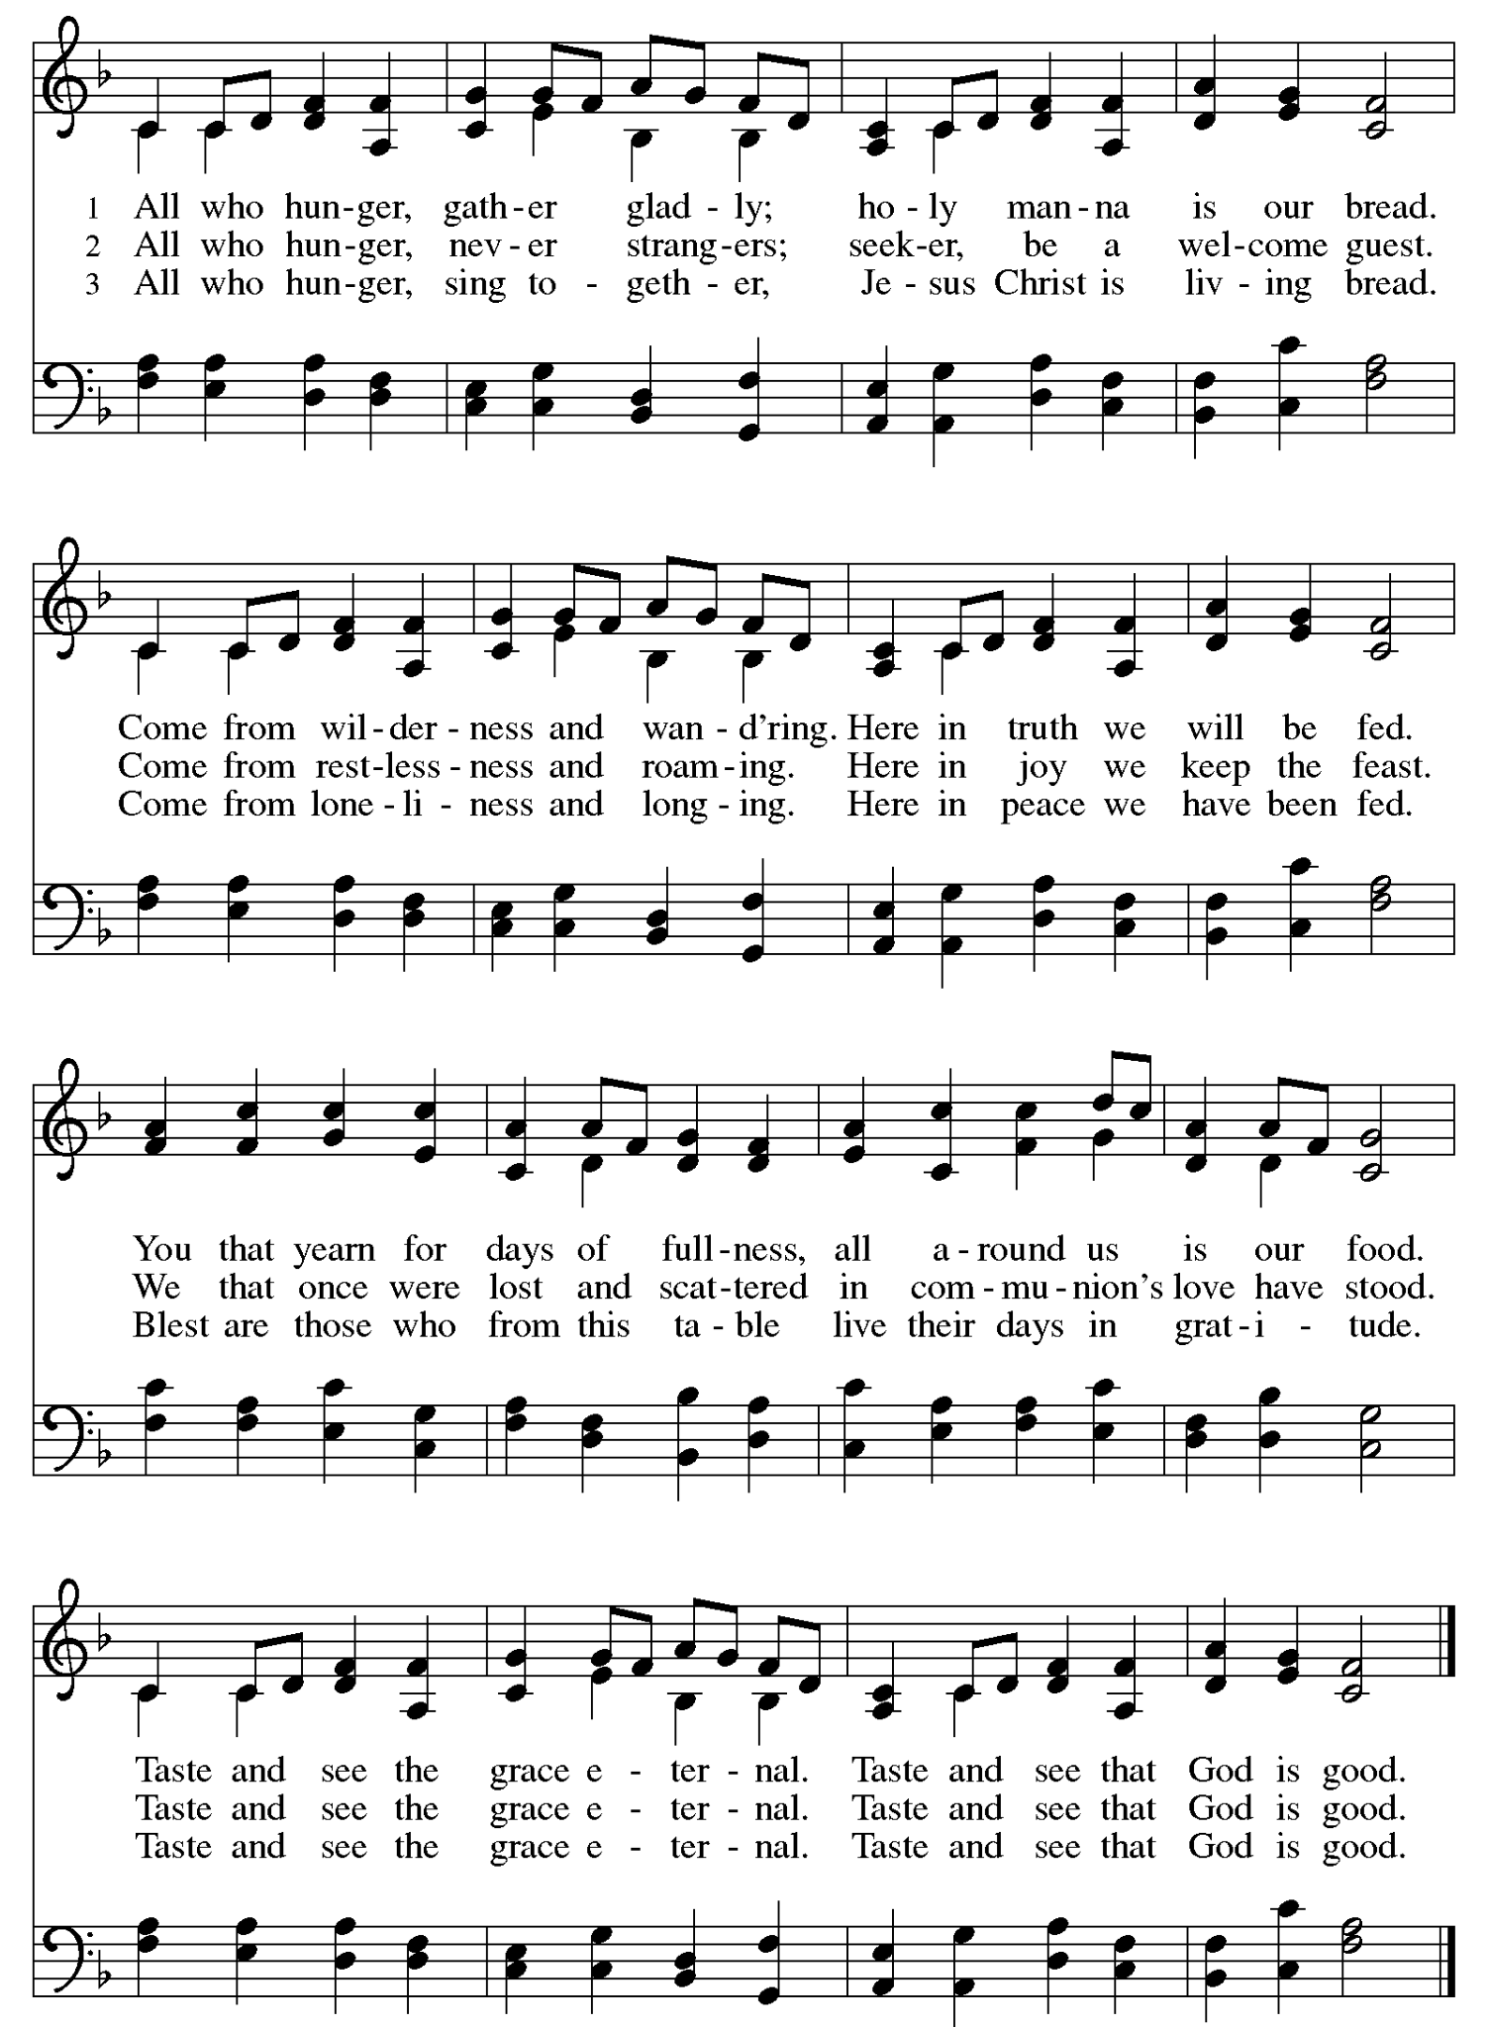

PRAYERS OF THE PEOPLE
Response- God of mercy and grace, We lift our prayers to you.

+SHARING OF THE PEACE
The peace of Christ be with you always. And also with you.

OFFERING No Rose Bloomed in Gethsemane Martin & Paige

No rose bloomed in Gethsemane, no fragrance in the garden found.
Twisted thorns at the feet of the King awaited to be His crown.
No bird sang in Gethsemane, no song of comfort on the breeze.
Silence fell like the hush of a tomb under the olive trees.
Tomorrow the rooster will call, the scent of myrrh will flow.
The mourning dove will sing her song and another garden’s breeze will blow.

+OFFERTORY RESPONSE Create in Me a Clean Heart
+OFFERTORY PRAYER
God our provider, you have not fed us with bread alone, but with words of grace and life. Bless us and these your gifts, which we receive from your bounty, through Jesus Christ our Lord. Amen.

+HOLY COMMUNION
The Lord be with you. And also with you.
Lift up your hearts. We lift them to the Lord.
Let us give thanks to the Lord our God. It is right to give our thanks and praise.
It is indeed right…and wide enough to hold us all. Amen.

+LORD’S PRAYER
Let us pray as Jesus first taught us:
Our Father in heaven,
hallowed be your name,
your kingdom come,
your will be done,
on earth as in heaven.
Give us today our daily bread
Forgive us our sins
as we forgive those
who sin against us.
Save us from the time of trial
and deliver us from evil.
For the kingdom, the power,
and the glory are yours,
now and forever. Amen.

+INVITATION TO COMMUNION
COMMUNION DISTRIBUTION & MUSIC

Today we celebrate those who are receiving and serving their first communion:
Harlowe Moravec, Clara Osborn & Henry White

All are welcome to receive communion at Valley of Peace. We serve communion every Sunday by intinction. After the pastor speaks the words of distribution to online worshipers, the ushers will then invite worshipers physically present to receive communion.

If you are receiving communion by intinction, there will be bread and gluten-free wafers available. As you come forward to receive communion, a communion server will serve you your preference. Please take the bread or wafer and dip it into your preference of either wine or juice. The first chalice will contain red wine and the second chalice will contain white grape juice.

If you prefer to not receive communion by intinction there are pre-packaged communion kits with a gluten-free wafer and grape juice. You may pick this up on your way to communion. If you prefer not to receive communion at all, please come forward with your hands across your chest and you will receive a blessing. If you are unable to come forward or do not want to be visible on the live-stream, please let an usher know and communion will be brought to you.

PURPLE ACS #966 Loaves Were Broken
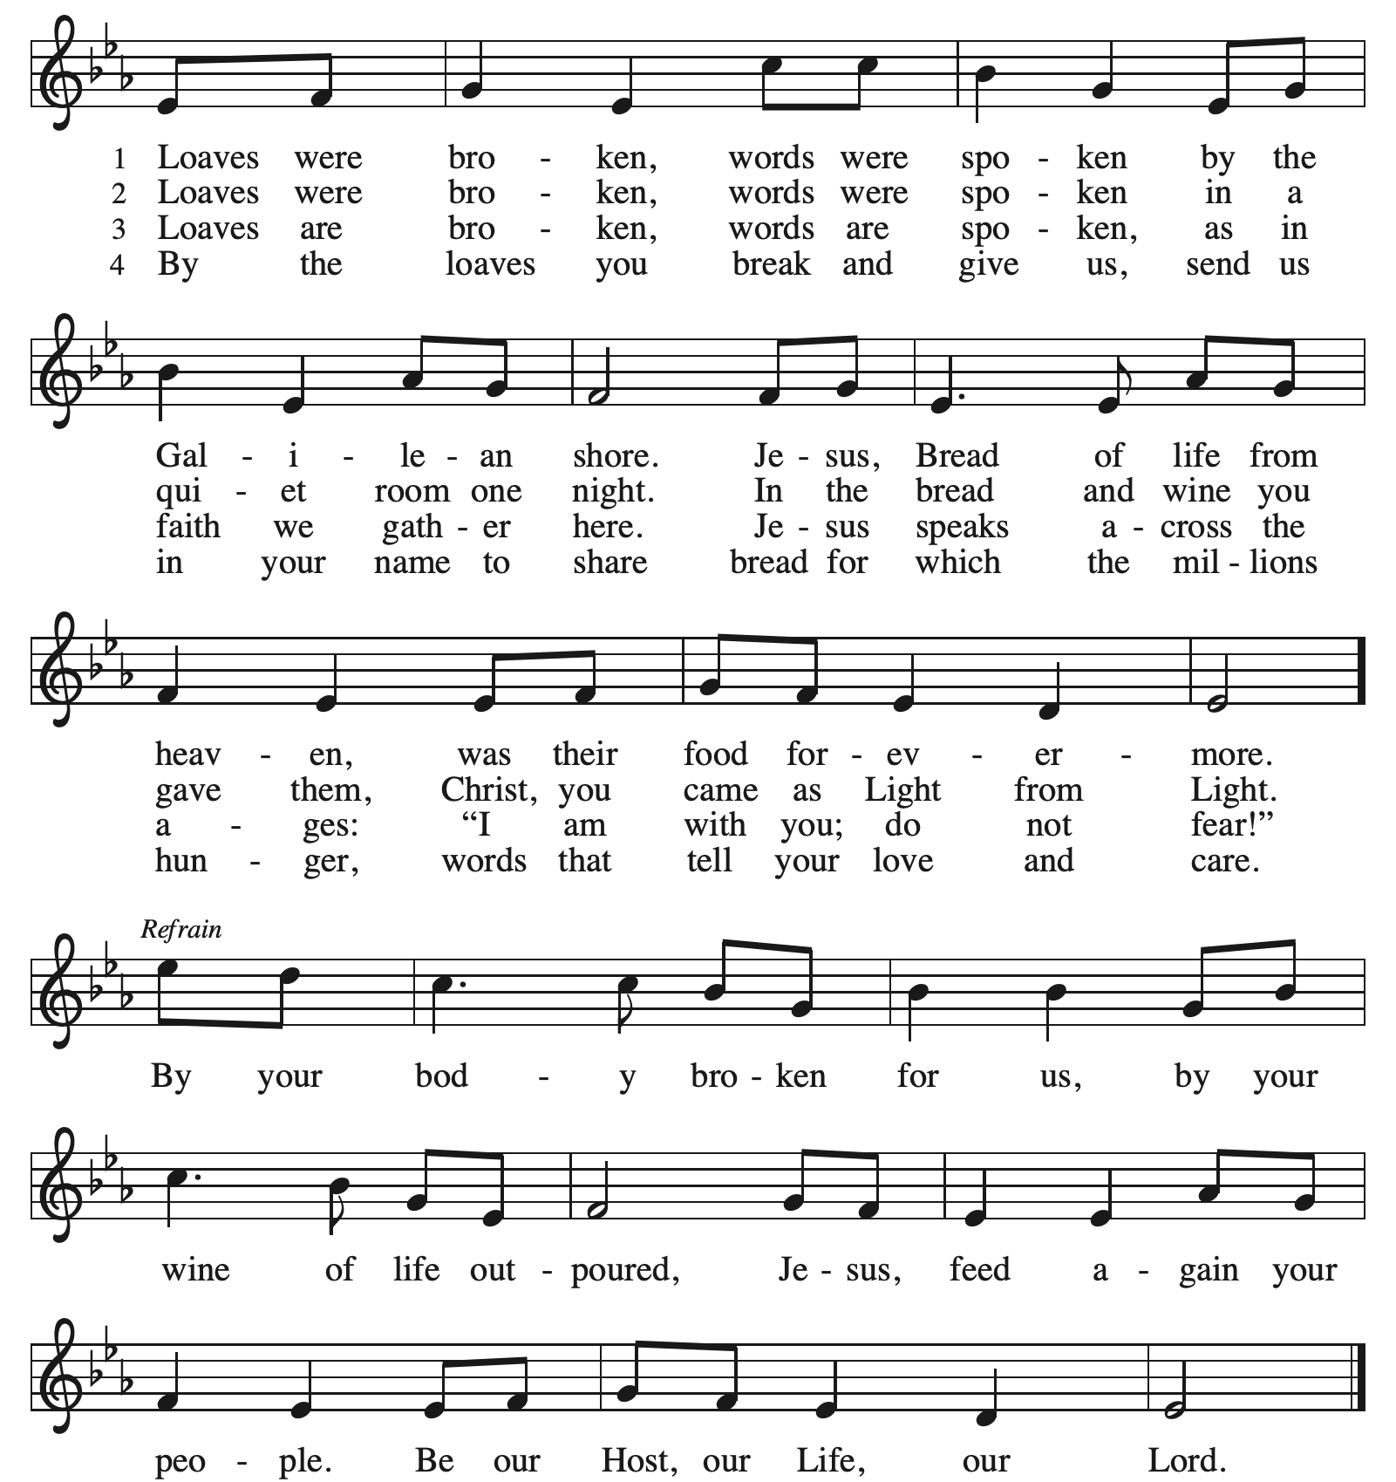

PURPLE ACS #930 Three Holy Days
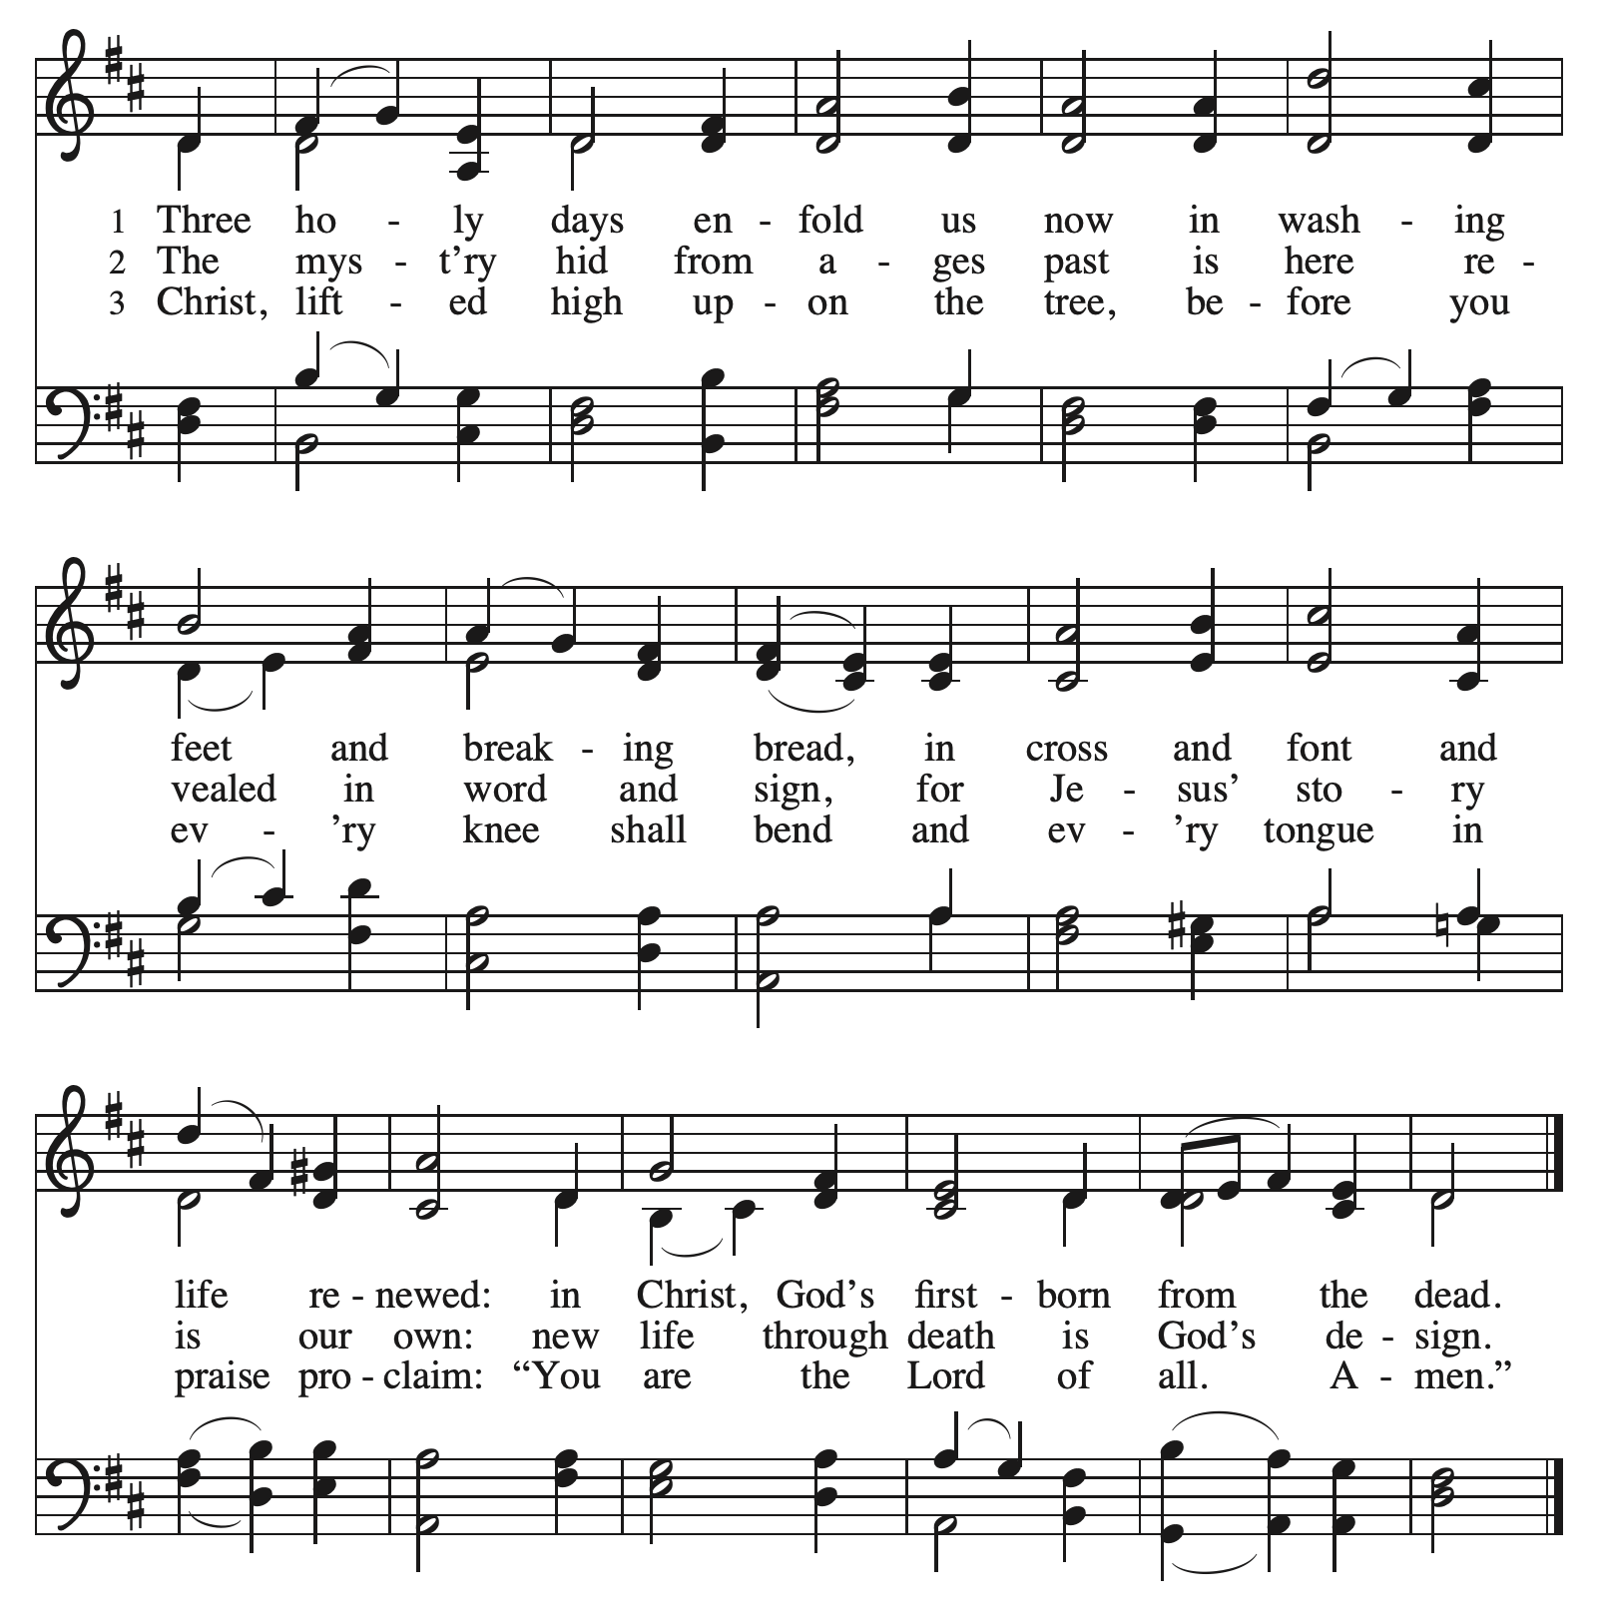

+COMMUNION BLESSING
+PRAYER AFTER COMMUNION
Gracious God, we thank you for this meal of love and mercy. You have fed us, named us, and claimed us as your own. As the table is cleared and the sanctuary grows bare, stay with us in the silence and the sorrow. Strengthen us to remain with Christ, to love as we have been loved, and to trust your grace even as the night deepens. Amen.

STRIPPING OF THE ALTAR
+SENDING HYMN RED ELW #348 Stay With Me

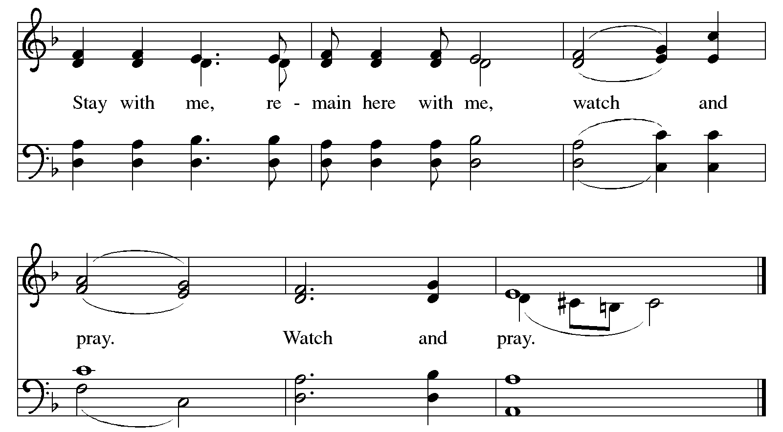

+DISMISSAL
May Jesus Christ, who for our sake became obedient unto death, even death on a cross, keep you and strengthen you this night and forever. Amen.

The congregation departs in silence.

Our Holy Week journey continues with Good Friday Worship
at 6:30 pm on Friday, April 3.

Valley of Peace Lutheran Church
Good Friday - April 3, 2026
6:30 pm


The word tenebrae comes from the Latin word meaning “darkness” or “shadows.” This Good Friday service draws on that ancient tradition, inviting us into a space where light gradually fades and we journey together through the final hours of Jesus’ life.

As the service unfolds, the lights will dim and the music will grow more sparse. Scripture, prayer, and silence guide us step by step toward the cross. The silences themselves lengthen, giving space to sit with what is heavy and unfinished.

At the beginning of worship, each person is given a stone. You are invited to hold it in your hand, to feel its weight, and to place upon it the worries you carry. These stones can become many things for us: worry stones, reminders of burdens we bear, markers of moments when we encounter God, or even signs of remembrance—like the stones left at gravesites to honor the dead.

Throughout the service, we listen to Jesus’ final words, each followed by prayer, silence, and song. These moments invite us not only to hear the story, but to enter it—bringing our own lives, griefs, and longings into the presence of God.

As the service concludes, you are invited to leave your stone on a table at the back of the sanctuary. In doing so, you may release what weighs on you, mark this moment of encounter, and honor Jesus in his time in the tomb.

We depart in silence, holding the tension of Good Friday—grief and love, sorrow and hope—trusting that even in the deepest shadows, God is present, and that the story is not yet finished.

You are invited to participate in worship by reading the BOLD print. When you see +, please stand in body or in spirit. ELW is the red hymnal and ACS is the purple hymnal, both located in the bottom of the pew in front of you. If you need any assistance, please ask an usher.

GATHERING MUSIC Pleading Savior Gilbert M. Martin

WORDS OF WELCOME

PRELUDE Larghetto A.W. Gottschalg

GATHERING WORDS
All who pass this way
Look and see, the shadow of sin
All you who pass this way
Look and see, the weight of the world
All you who pass this way
Look and see, the suffering of our Savior
All you who pass this way
Look and see, the sorrow of Jesus Christ
Behold, the Lamb of God, who takes away the sins of the world.

SPECIAL MUSIC O Love, How Deep, How Broad, How High L. Larson

O love, how deep, how broad, how high,
that God would come to earth to die;
to take the form of humankind,
the Son of God, O love divine!

Christ bore our sins, He bore our shame,
a Man of sorrows, bless His name!
For by His stripes our hearts are healed,
and by His blood our souls are sealed!

How marvelous, how wonderful! And my song shall ever be;
how marvelous, how wonderful is my Savior’s love for me.

O love, how deep, how broad, how high,
the Lamb of God is crucified.
For me He died upon the cross;
for me he suffered pain and loss.

How marvelous, how wonderful! And my song shall ever be;
how marvelous, how wonderful is my Savior’s love for me.

O the deep, deep love of Jesus, vast,
unmeasured, boundless and free.
O love, how deep, how broad how high,
the Son of God, O love divine!

SHADOW OF CONDEMNATION
READING: LUKE 23:32-34
PRAYER: Forgiving Christ, when the world condemns us, when wrong is done to us, when we
carry the weight of things that are too much to forgive, come alongside us in the
darkness, and give us the grace to be forgiven and forgiving.
SILENCE
SONG RED ELW #347 Go to Dark Gethsemane vs. 1 & 2
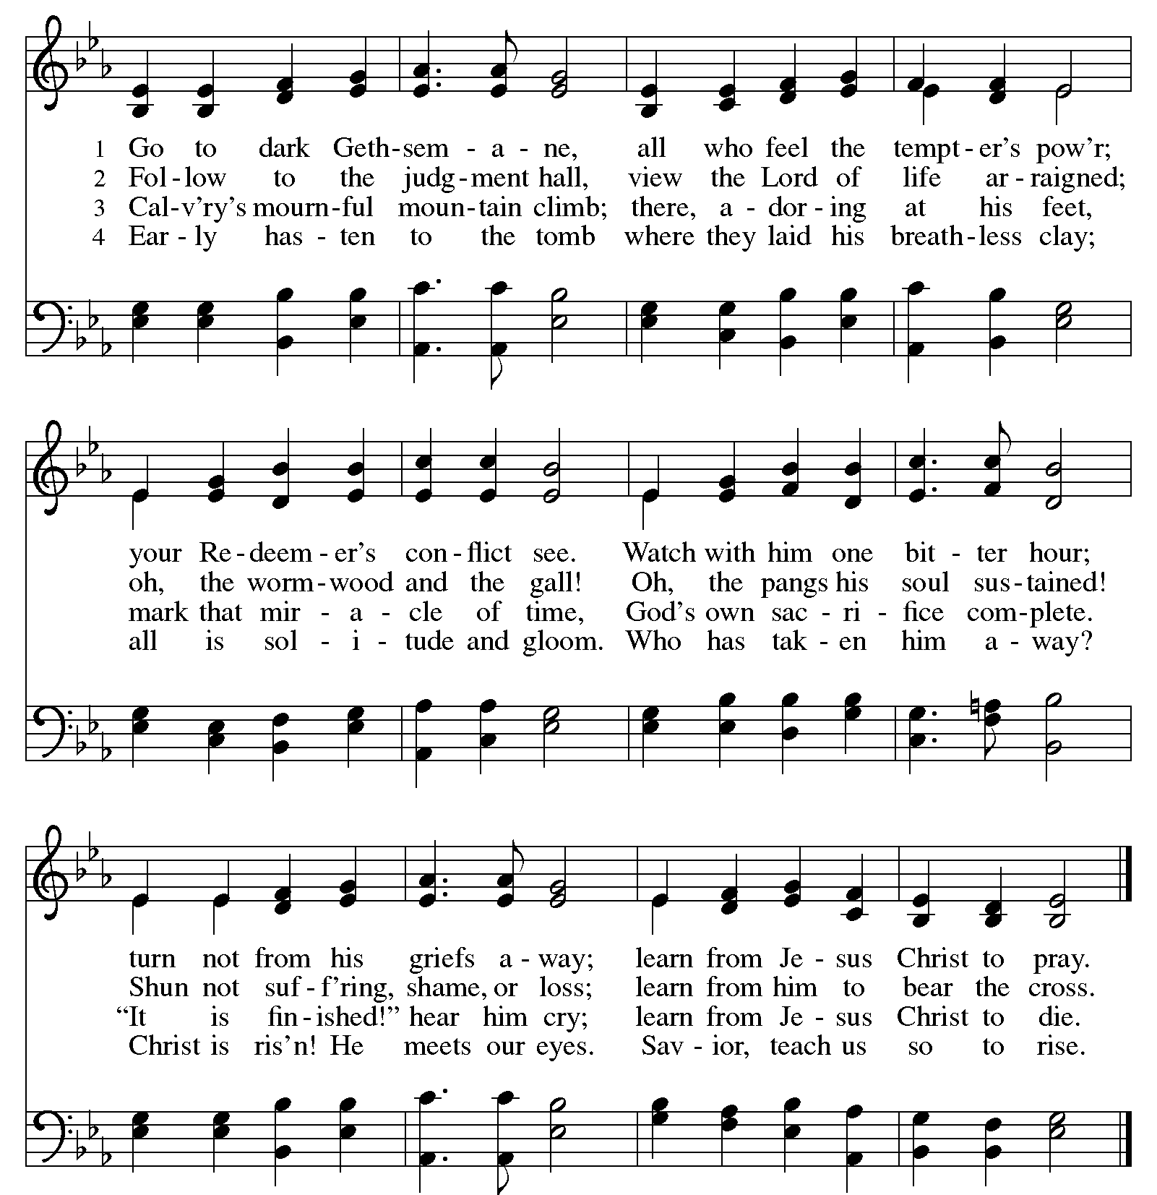

SHADOW OF SEPARATION
READING: LUKE 23:35-43
PRAYER: Reconciling Christ, we are weighed down by sin and separation, a world that is not at
peace, people who are not whole. You reached out to the thief, you welcomed him to
God’s side. Come alongside us in the darkness, and bring grace and peace to everything
that is broken.
SILENCE
SONG RED ELW #616 Jesus Remember Me (x3)
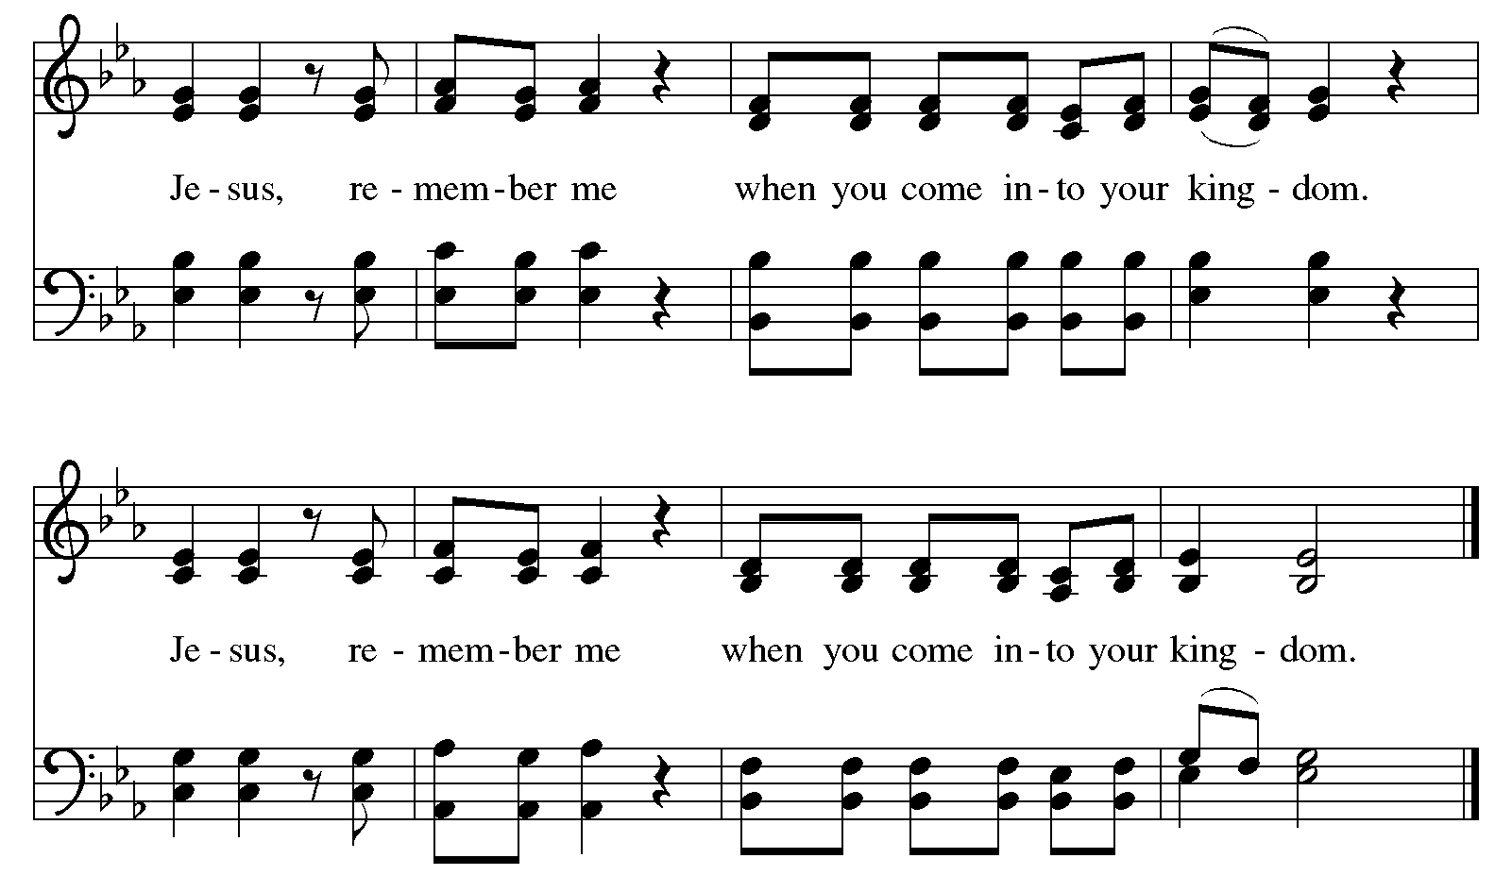

SHADOW OF SORROW
READING: JOHN 19:25b-27
PRAYER: Loving Jesus, we carry the weight of the people we love, concern for their sorrows and
suffering. Our care for them is deep, and sometimes there is not much we can do. Come
alongside us in the darkness, and cradle the ones we love in your strong hands.
SILENCE
SONG RED ELW #803 When I Survey the Wondrous Cross vs. 1, 2, & 3

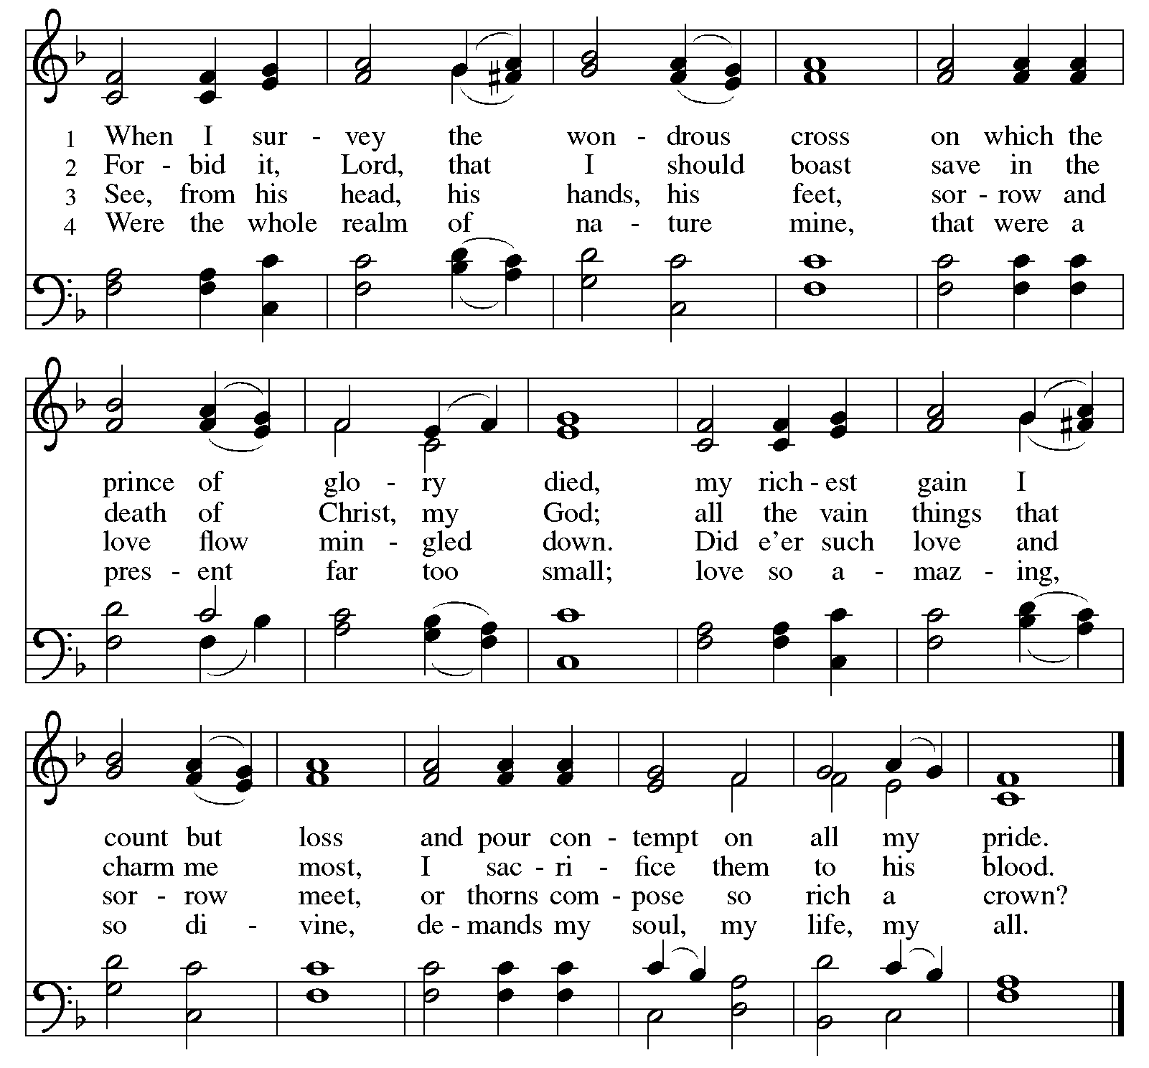

SHADOW OF DESPAIR
READING: MARK 15:33-34
PRAYER: Lord Jesus Christ, you know what it is to feel that God is far away. You know what it is
to call out for God’s presence. Come alongside us in the darkness, and help us call out
for God.
SILENCE
SONG RED ELW #351 O Sacred Head, Now Wounded vs. 1, 2, 3 & 4
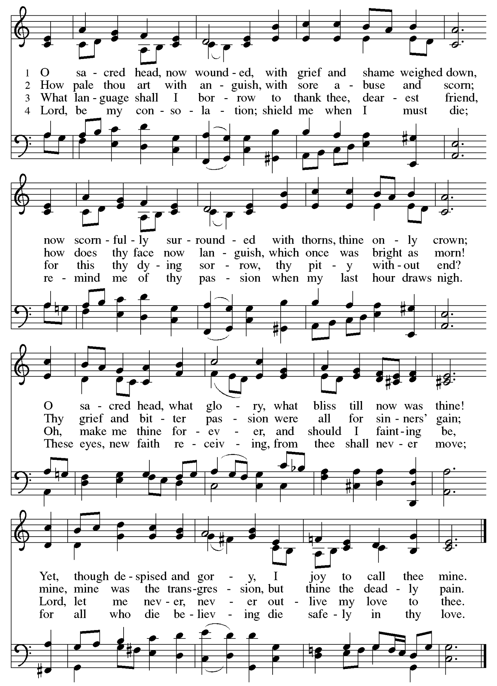

SHADOW OF SUFFERING
READING: JOHN 19:28-30
PRAYER: Suffering Savior, in all our thirst, in all our sickness, in all our longing, in all our pain,
you are there. Come alongside us in the darkness, and walk with us through all our suffering.

SILENCE
SONG RED ELW #337 Alas! And Did My Savior Bleed vs. 1, 2 & 3
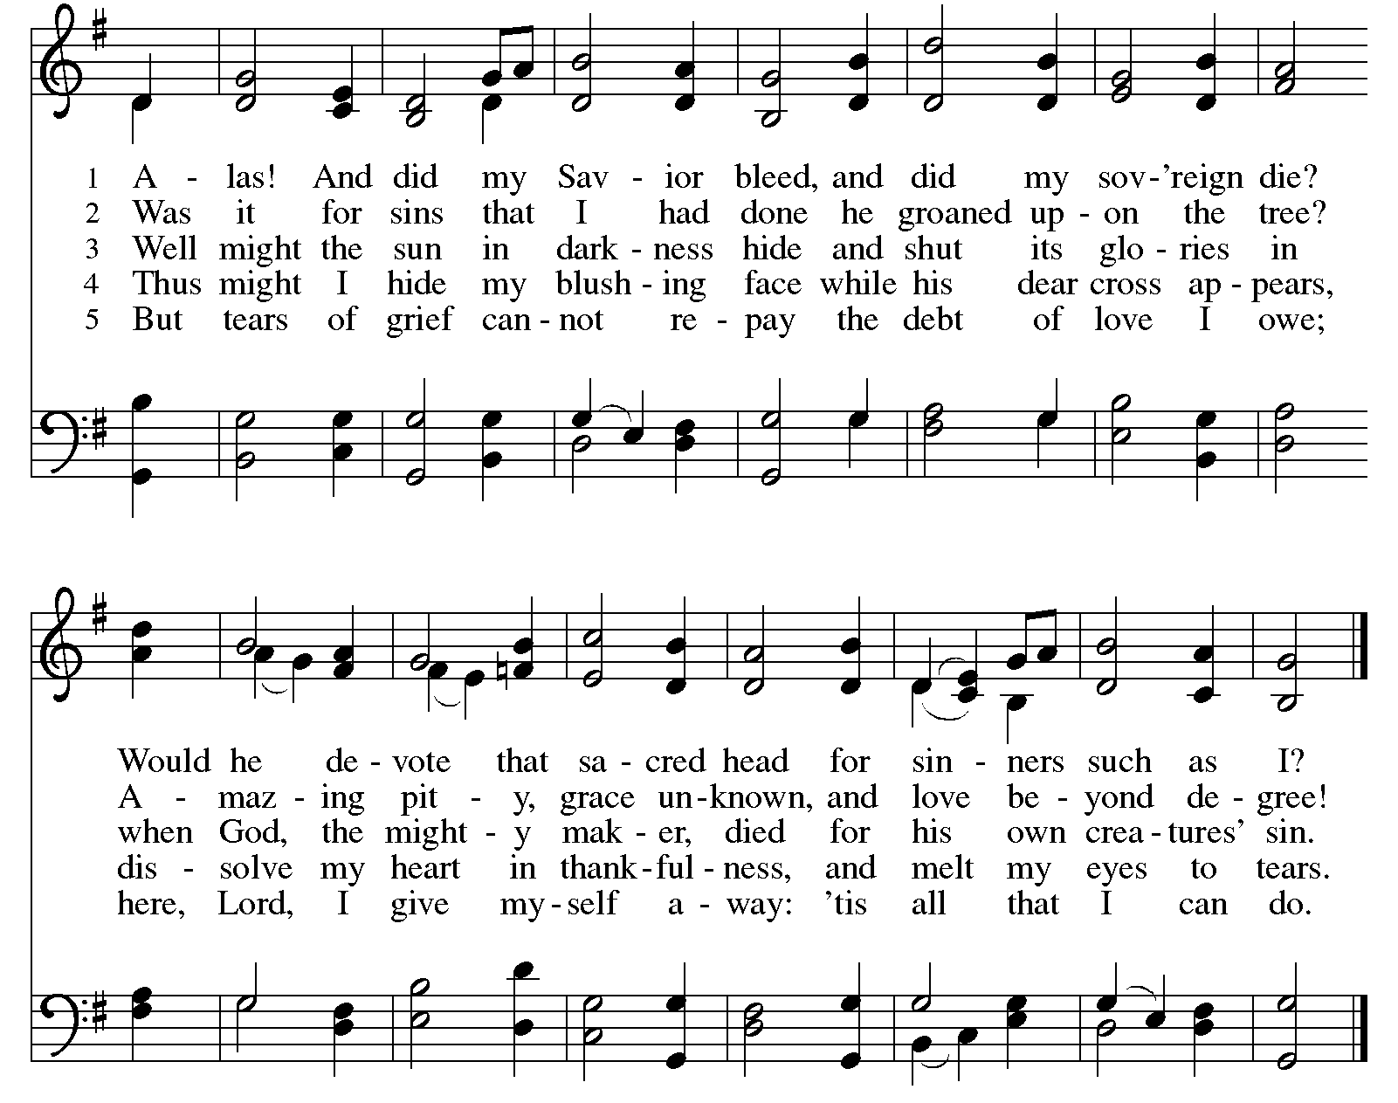

SHADOW OF DEATH
READING: LUKE 23:44-49
PRAYER: Dearest Jesus, even in death you are there. When we mourn, when we are afraid, when
we come to our own end, you have been there, too. Come alongside us in the darkness,
and carry us through death to life.
SILENCE
SONG RED ELW #353 Were You There vs. 1-5
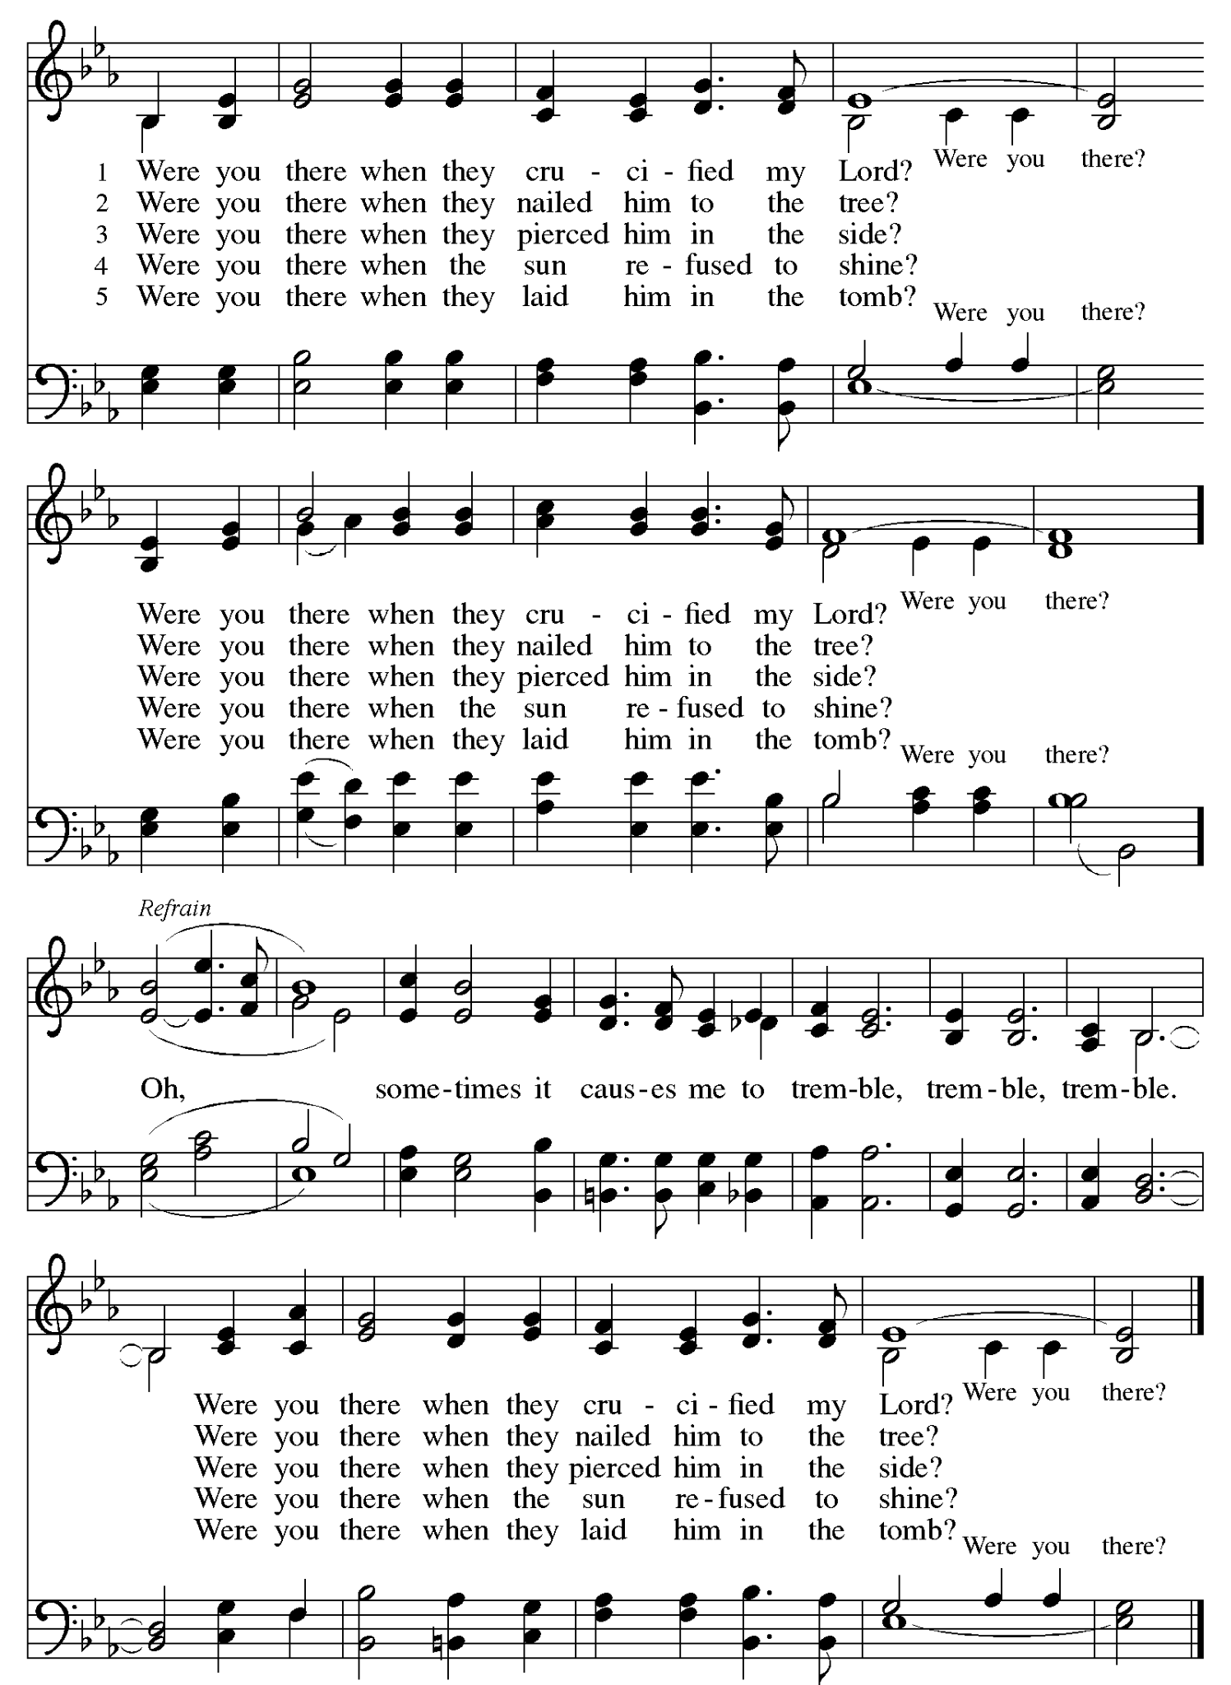

BENEDICTION- SERVICE OF SHADOWS AND STONES
All you who pass this way,
look and see.
See the shadow.
Feel the weight in your hand.
The stone you carry —
the grief, the regret, the worry,
the love that aches,
the prayers that feel unanswered.
Tonight we do not fix these things.
We do not rush toward morning.
We stand in the darkness
with the One who has entered it fully.
As the cross goes before you,
remember:
Christ has gone into every shadow —
condemnation, separation, sorrow, despair,
suffering, even death.
There is no darkness you will enter
where he has not already been.
When you are ready,
leave your stone.
Leave what weighs you down
near the sign of his love.
Not because it no longer matters,
but because you do not carry it alone.
Go now in silence.
Go in the shadow.
Go trusting that even in the grave,
God is at work.
Amen.

The cross is recessed out. People leave in silence.
Please leave your stones at the foot of the cross.

Our Holy Week journey continues with Easter Sunday Worship
this Sunday, April 5 at 10:15 am.
All are welcome.

Worship Volunteers
 | Sun. March 29, 2026 at 10:15 am | Thurs. April 2 at 6:30 pm | Fri. April 3 at 6:30 pm
Presider/Preacher | Pastor Ashley Osborn | Pastor Ashley Osborn | Pastor Ashley Osborn
Opener/Closer | Paul Mikelson | Pat McGraw | Jim Jasper
Greeter | Erik Daniels | Kathy Boesen | OPEN
CYF Greeter | Darcie Rodman | n/a | n/a
Welcome Center | Lisa Rothschild | n/a | n/a
Ushers | Lynn Schneider, Ken Schneider, Darlene Lamker & Dean Lamker | OPEN | OPEN
Worship Assistant | Becca Anderson | Tara Kuckkan | n/a
Reader | Kiki DiPietro | Barb Mikelson | Barry Terrass
Communion Servers | Diane Hinderlie, Heidi Boesen,  Anna Campbell & Darcie Rodman | Harlow Moravec, Clara Osborn, Henry White & Jon Larson | n/a
Faith Moment | Pastor Ashley Osborn | n/a | n/a
Special Music | VOP Children’s Choir  Chancel Choir | Chancel Choir  Mary Hovden, flute | Chancel Choir
Technology | Evelyn Anderson | OPEN | Andy Dybvig
Coffee Cart | n/a | n/a | n/a
Altar Care | Kathy Boesen | Claudia Aronsohn | Claudia Aronsohn

For more information and a calendar of activities visit www.valleyofpeace.org

Pietro



